MI - ACE Conference Self-Care Resource Guide
🧡Personally vetted by Dr. Aesha Mustafa

🎧 Podcast

Enlighten U 🧡
Enlighten U is Eastern Michigan University’s award-winning student mental health podcast, co-hosted by Professor Lolita Cummings and Melissa Thrasher, with Dr. Aesha Mustafa as the resident mental health expert. Each episode features a new student guest and centers candid conversations that aim to reduce stigma, build community, and offer practical strategies for emotional well-being.
🌐 [Search “Enlighten U” on your favorite podcast app.]

Therapy Practices

Integrative Empowerment Group (IEG) 🧡
A trauma-informed therapy practice co-owned by Dr. Aesha Mustafa, IEG offers therapy for individuals, couples, and families. IEG specializes in serving BIPOC, LGBTQIA+, neurodivergent individuals, kink/polyamorous communities, and those seeking
gender-affirming care.
- In-person (Ypsilanti, MI) & telehealth options.
- Most insurances are accepted, including several Medicaid plans.

Roots to Rise Somatics 🧡
Somatic therapy for complex trauma, racial identity issues, and chronic pain in person in Ann Arbor and online across Michigan.
📸 Instagram: @roottorisesomatics
🎙 Enlighten U Podcast – Self-Care strategies for college students: Feel your best this summer. Watch the episode on YouTube

Academic Wellness Coaches
Aurora Chang 🧡
Transformational academic writing and holistic support for marginalized scholars who refuse to be marginalized.
- Developmental Editing
- Academic Coaching
- Writing Retreats
- Workshops & Speaking Engagements
- Justice-Focused Scholarship Support

Well Academic 🧡
Supports academics through coaching, community, and wellness programming. Prioritizes sustainable success and emotional well-being in higher ed.
- Semester Writing Community

- Personalized Coaching

- Promotion & Tenure Support

- Women of Color (WOC) Faculty Retreats

- Campus Workshops & Groups

Mental Health & Crisis Support Lines
BlackLine - A hotline for Black, Brown, and Indigenous individuals with an emphasis on those facing violence or crisis.
📞 800-604-5841
DEQH Helpline (Desi LGBTQ+)
📞 908-367-3374

LGBT National Hotline
📞 888-843-4564

National Suicide & Crisis Lifeline
☎ Dial 988 — free, 24/7 confidential support for anyone in emotional distress or suicidal crisis.

Thrive Lifeline
Text-based peer support prioritizing the needs of marginalized communities.
📱 Text "THRIVE" to (313) 662-8209
Trans Lifeline - Peer support by and for trans people.
📞 877-565-8860

FACULTY NOURISHING ACTION PLAN
THE ASK/OPPORTUNITY:
-----------------------------------

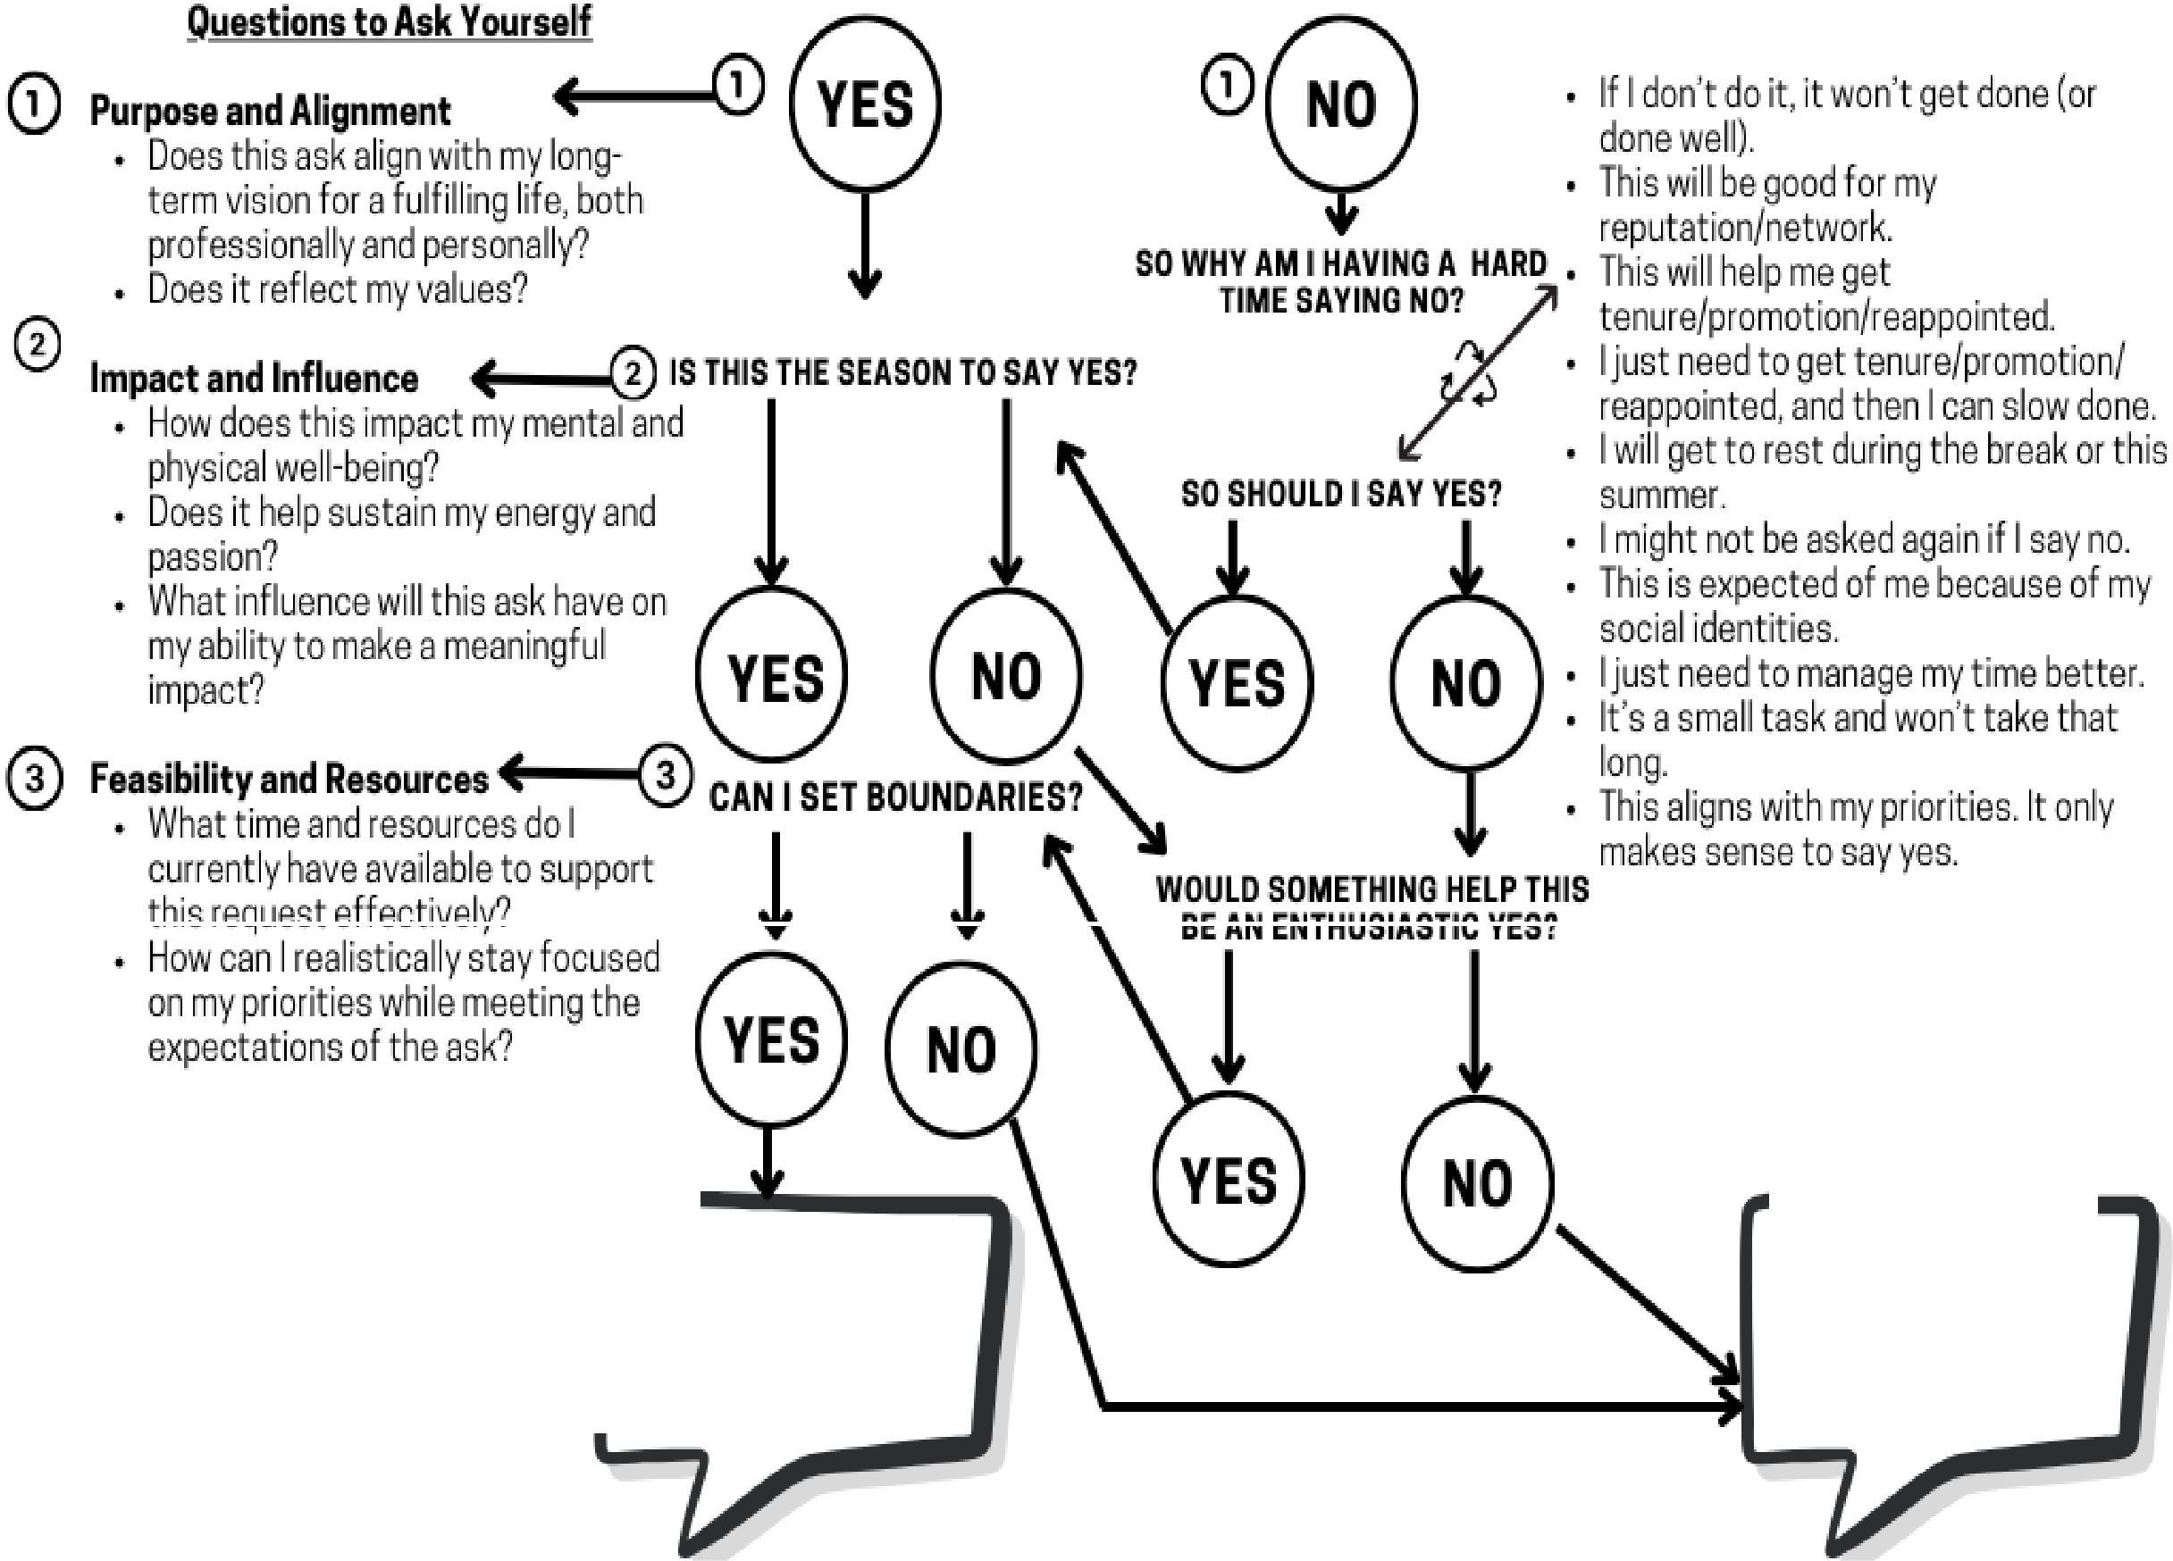
Common Unhelpful Thoughts

Other Questions to Ask Self
IT SOUNDS LIKE I SHOULD SAY NO OR NOT RIGHT NOW.

Mustafa, Mackerl-Cooper, and McCallum (2024) Nurturing Purpose, Enacting Practice Developing a Nourishing Action Plan (NAP) for Faculty and Staff of Color. Presented at the National women's Studies Association, Detroit, Ml.

SAY YES; I AM INTERESTED IN LEARNING MORE; I NEED XTO SAY YES.

