Academic Senate

Student Advisory Committee (SAC) Minutes
August 25, 2022 Meeting

The Academic Senate Student Advisory Committee (SAC) met for their first meeting of Fall 2022 via WebEx on August 25, 2022, 11:30 a.m. to 12:30 p.m.

Members present: Veronica Wilkerson-Johnson (Chairperson), Fran Krempasky (Subcommittee on Web Resources Chair), Alex Azima, Joann Silsby, Armando Arevalo, Louise Rabidoux, Bruce Mackley, and Dean Ronda Miller. Absent: Ashlee Stokes, Linda Hamlin, and Christopher Smelker.

The 08/25/22 SAC Committee highlights are as follows, Minutes provided by Senator Joann Silsby and Fran Krempasky.

- Welcome
  - Veronica Wilkerson Johnson welcomed everyone to the meeting.
Veronica started the meeting by applauding the work of Fran, Joann, and Ashlee who launched, with the help of so many others, the student resources web page. Veronica said it looks spectacular, it looks like it has always been there, a marvelous accomplishment. She thanked the SAC Subcommittee on Student Resources for working on this throughout the summer to have it ready for Fall semester.

- Report from Fran Krempasky, SAC Technology Subcommittee Chair
- Fran thanked the SAC Subcommittee on Student Resources for working on this endeavor. She said that the SAC committee is where the ideas for the student resource page were brainstormed and we moved fully forward developing a page based on the Maricopa College model. It was decided to revise the current student services web page and make it the student resources page. With the guidance of the chair and SAC members, who provided good direction, the subcommittee worked hard to get this done, and getting all the feedback needed to be incorporated into the website. We are proud of the web page in that it will benefit students and those inside and outside of the college. A feedback loop has been incorporated into the site. Students who can’t find what they are looking for can ask their question on the site via a convenient form. Fran worked with Nick Myers from the LCC web team to make sure the site is linked from the LCC home page, and therefore enables students to find it from the home page. Veronica stated that this will make life easier for students and will help everyone at the college. She added that this site opens the door for LCC to streamline and model the other ways we access information internally at LCC, and aids those outside the college to connect in more seamlessly.
- Fran also thanked Bruce Mackley for his invaluable direction in this process from start to finish. Also working with a member of his web team, Nick, the webmaster, who developed the page and made the process smooth. Fran commented that it was the smoothest process she has ever gone through at the college. Kudos to Bruce Mackley in Marketing and Nick Myers, Webmaster on the Web Team!
- Bruce added that anything that respects student time and cuts through the clutter, and demystifies the process, he is all for it…100% on board. So, the effort was very well spent because it looks great. He was happy to help. Veronica added that she can’t wait to hear the feedback from students as they start to dive into the web page throughout the semester.
- Fran stated some upcoming tasks for the Subcommittee.
  - They will be looking at the user feedback (anything that is appropriate for us to see).
  - The subcommittee will be meeting again a couple more times to help them develop guidelines on how to maintain the page as it needs updates.
  - Look at the usage stats.
Nick will have all that information to share with us. Then we can report back to SAC maybe quarterly on the progress for that page and try to develop some kind of mechanism within SAC. It will be an ongoing process for whoever is on the SAC team.
  - If anyone has any more feedback or receive from others, please let the subcommittee know.
Student Resources page

Veronica mentioned that she likes the review process idea, and stated that at each SAC meeting we will take time to review and report on the resource page progress, and address any changes needed. She will report out to the Academic Senate when needed on this, and was glad to see it was in the recent issue of THE STAR, which provided the web link to the student resources page.

3. Armando Arevalo, Student Success Coach – update
a. The success coaches are meeting with students in the new lounge setting, improving interaction and accessibility for students as a whole.
b. Food Pantry – They did food carts through spring and summer since the Marketplace is no longer available. They are working on improving food pantry options, and will keep our committee informed. He added that some money has been allocated in this endeavor,

4. Dean Ronda Miller – update on Food Pantry
- Dean Miller report that she handed over the food pantry proposal and data to Felipe Lopez Sustaita, Associate Dean for the Center for Student Support. She said that some resources that had originally been identified are no longer available, and that Felipe is working on revamping and further establishing a food pantry.
- Dean Miller stated, that as Armando mentioned, some money has been allotted in the Student Affairs budget that was originally dedicated to the food carts which have been discontinued. It became evident that the food carts were not a viable option, but were used in the absence of The Marketplace at the Gannon Bldg.
- In the space where the Gannon Marketplace existed, food vending machines, similar to those at the TLC Bldg., have been installed. However, in both settings the vending items are very costly. The TLC vending machine has a swipe card system for credit and debit cards. After swiping you retrieve the items from the coolers and it charges the card accordingly. At the Gannon Marketplace setting you retrieve items and then do a self-checkout. Dean Miller observed some students making purchases, and noted that the total for two items came close to $16.00, and the items were not of the quality of health conscious, sustainable foods.
- Dean Miller had a discussion with Sarah Garcia-Linz and Felipe about this system, and the potential for more food pantry options going forward. In the past, some monies were allocated to buy food and provide a system similar to the LCC West campus sack lunches provided for students. A similar system existed on Main campus as well, but feedback she received in Student Affairs was that students would go through the bag and pick out what they wanted, and throw away the rest. There have not been any hot/microwavable items. When talking to Sarah about this, the idea of having bins where students can come in and choose items they want is a viable idea. She said Student Affairs would have to manage it and identify an area best accessible for students. The Commons would make sense. However, this system once implemented may take business away from the vending areas. No other news on this, but something needs to get rolling and marketed in mid-September to aid students facing food insecurity on all of the LCC campuses. Dean MIller will keep us posted on the updates.
- Veronica liked the idea of there being bins for students to pick and choose items. She asked how and where would the students access the bins? Dean Miller said another college she visited had a room set up for students requesting access, using a form they submitted for permission to enter. Reusable bags were provided for them to go in the food pantry and gather items to put in their bag. The pantry had refrigeration, and provided eggs, cheese, vegetables, frozen chicken breasts, and meats. That school invested the higher subsidies needed to provide these items, and there was no stigma in using this program. Also, in the foyers around the food pantry were baskets full of bagels, “take one” free, and granola bars, chips, and other snacks students could take without needing to go through the form process.
- Veronica mentioned THE STAR article that the two LCC vending sites at TLC and Gannon, but it did not mention the cost or the types or quality of foods that are offered. Dean Miller said the items have a long shelf life too, which means they have a lot of preservatives. She added that they will address getting healthy food options with good nutritional content, although they will be doing so with limited monies available.
- Veronica said that SAC will stand behind what Dean Miller, Felipe Lopez Sustaita and Sarah Garcia-Linz do in inspired leadership to take a deeper look at the food pantry initiative with the hope of helping students at the Main campus and all of the LCC campuses.
- Dean Miller also mentioned that there will be a clothing drive by Career Unemployment Services once it is approved by LCC Facilities. They will be looking for new or gently worn clothes that are of current updated styles, laundered and in good condition. Veronica asked if those who donate can get a receipt or acknowledgement. Dean Miller will check on this and report back.
- Louise Rabidoux stated that there are always students who are food insecure, but since the LCC success coaches came, many are seen by the coaches, and they may not come directly to counseling. She therefore may not know about the numbers of current students who are food insecure since they do not always come to her regarding that concern. She said there is a challenge between meeting the immediate need of someone who is presently hungry and someone who has chronic, long-term food insecurity needs. It could mean, for example, connecting them with social services, food stamps and food pantries in the community.
- She added that it is a balancing act that the college faces. We need to meet the immediate need but also refer them, if needed, to more long-term sustainable options.
- Veronica added that all of these services and expertise represented among the members of our committee aid in many human factors, and we are engaged in helping our students live better lives as they learn and seek academic success.

5. Linda Hamlin, Director of eLearning – eLeaning updates:
Linda Hamlin provided the committee the following updates from eLearning:
- Badges and Certificates have been implemented for students and faculty (follow-up agenda item)
- We have been meeting with key student areas this fall in sharing how eLearning can assist students with D2L: Library, Learning Commons and Success Coaches
- Below is the communication students received from eLearning for the start of Fall Semester
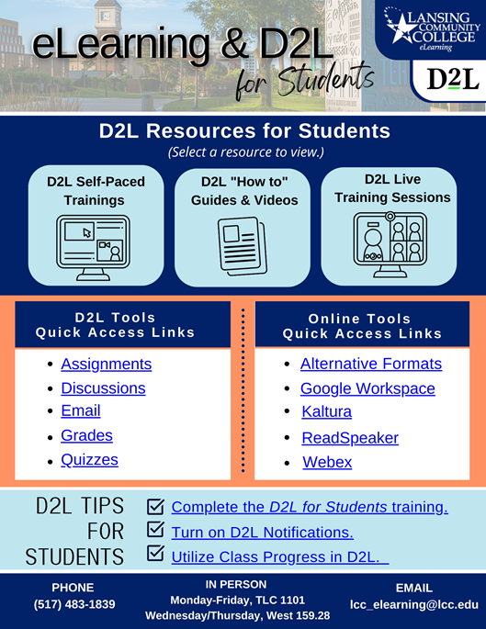

5. SAC Discussion of Ongoing student projects – Veronica Wilkerson-Johnson
- Ongoing student projects in tandem with our SAC members who administer Student Services, eLearning, Marketing, Technology, Career Unemployment Services and others as requested.
  - New web site – Student Resources website, gather feedback and updates
  - Food Pantry – Encourage and assist food pantry development and marketing to students facing food insecurity.
  - Clothing drive – Assist Career Unemployment Services with this effort as is helpful.
- Veronica stated that as an advisory voice for students, we will continue in student leadership development.
Student Recruitment:
(4) Alex Azima mentioned that we need more students on SAC.
Veronica agreed, is actively committed to this goal, and is reaching out to students across the campus to become a part of SAC. A number have expressed interest and will receive invitations. She said it was inspiring to see the welcoming meet and greet that President Robinson hosted for students at the start of the semester.
She has connected with the Student Athlete Advisory Council and soon will meet with new students on campus.
  - Dean Miller mentioned that she and her Student Services staff held a kickoff event for new students, and 197 attended. Veronica will begin reaching out, in tandem with campus leaders and departments. Updates will be provided to the committee soon.

  - Armando said it would be good to recruit students with disabilities as well. Louise Rabidoux will reach out to the Center for Student Access for students who may be interested in joining our committee.
SAC Meeting Dates
- The next SAC meeting is Thursday, September 22 at 11:30 am to 12:30 p.m. via WebEx.
- Future meetings: October 20, November 17, and December 15 (12/15 is tentative). Mtgs. are 11:30 am-12:30 pm.

Respectfully submitted,
Veronica Wilkerson-Johnson, Chairperson

Scribes:
Joann Silsby and Fran Krempasky

