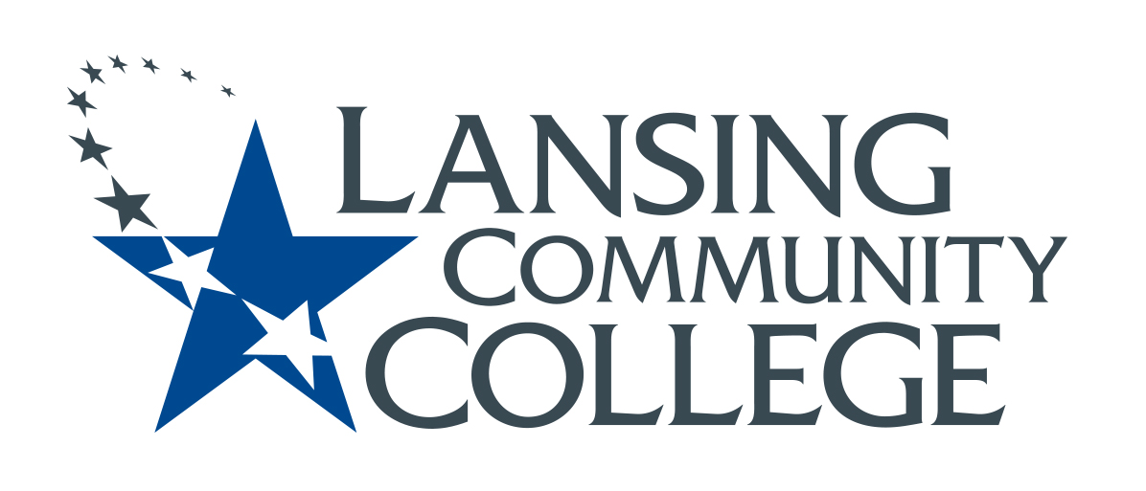

APPLIED HUMANITIES
(NON-MTA) COURSE

RECOMMENDATION FORM

COURSE:

☐ Official Course Syllabus (OCS) and any OCS updates for the coming Fall

☐ Appropriate Basic Skills Level(s)

☐ Reading Level of 5 or higher (including, if appropriate, corequisite remediation)

☐ Minimum of 3 semester credit hours

☐ Transferable as an equivalent course or as general credit designated for Gen Ed to at least 4 of our top 8 public university transfer partners: CMU, EMU, FSU, GVSU, MSU, UM-Ann Arbor, UM-Flint, WMU.
(Informational only – not required for approval)

☐ Average number of sections of course that run Fall & Spring Semesters

CONTACT:

Contact person: Click or tap here to enter text.

Phone: Click or tap here to enter text.

E-Mail: Click or tap here to enter text.

Date submitted: Click or tap to enter a date.

Non-Michigan Transfer Agreement (non-MTA) courses for LCC’s General Education – Applied Degrees should be appropriate choices for applied and technical degrees, but they might not have high transferability as general education choices at four-year institutions. Examples include career-focused courses such as Helpdesk Support Specialist, Introduction to the Deaf Community, Electrical Mathematics, Business Mathematics, Metallurgy & Heat Treatment, Diversity in the Workplace, Introduction to Criminal Justice, etc.

Any General Education course must apply to one or more of LCC’s four Essential Learning Outcomes (ELOs) derived from the American Association of Colleges & Universities (AAC&U):

Knowledge of Human Cultures and the Physical World
- Through study in the sciences and mathematics, social sciences, humanities, histories, languages, and the arts
Focused by engagement with big questions, both contemporary and enduring.

Intellectual and Practical Skills, Including
- Inquiry and analysis
- Critical and creative thinking
- Written and oral communication
- Quantitative literacy
- Information literacy
- Teamwork and problem solving
Practiced extensively, across the curriculum, in the context of progressively more challenging problems, projects, and standards for performance.

Personal and Social Responsibility, Including
- Civic knowledge and engagement—local and global
- Intercultural knowledge and competence
- Ethical reasoning and action
- Foundations and skills for lifelong learning
Anchored through active involvement with diverse communities and real-world challenges.

Integrative and Applied Learning, Including
- Synthesis and advanced accomplishment across general and specialized studies
Demonstrated through the application of knowledge, skills, and responsibilities to new settings and complex problems.
If a course transfers directly as a general education course (not just major-specific credit) or as general credit designated as Gen Ed to at least 4 of our Top 8 Public Partners (CMU, EMU, FSU, GVSU, MSU, UM-Ann Arbor, UM-Flint, WMU), then it should be proposed for MTA instead.

MTA courses by definition already are applicable to both Applied and Transfer degrees, so approved MTA courses do not need to be proposed for General Education – Applied Degrees.

RECOMMENDERS:
Show evidence that the course’s student learning outcomes are aligned to one or more of LCC’s ELOs. In addition to a narrative description, please provide specific examples by citing the particular portion of the syllabus, explaining assignments, and/or assessments tools, etc.

- Student Learning Outcomes & ELOs – Show how specific student learning outcomes align to one or more of LCC’s ELOs. If you have any updated Course Learning Outcomes for the coming Fall, please included these updates.

- Instructional Methods – Illustrate how the course enables students to fulfill specific LCC ELOs; e.g., What instructional methods are used?

NOTE: Instructional Methods are likely to vary across sections.

- Assessment Tool(s) – Describe & provide examples of the assessment tools that measure each of the student learning outcomes aligned to specific LCC ELOs across all sections of the course. Include the standards/level of outcome attainment.

NOTE:
- As you address the bulleted items above on the attached pages, please label the outcomes, methods, and/or assessments that were not part of any earlier-submitted course.

- Please submit any data you may have gathered on still-relevant outcomes.

- All documents need to be submitted through the 5-star ticket for review with the Curriculum Committee.

CURRICULUM COMMITTEE RATING:
1. = adequate/acceptable
2. = inadequate/subject to improvement
3. = unacceptable/inappropriate

LCC provides equal opportunity for all persons and prohibits discriminatory practices based on race, color, sex, age, religion, national origin, creed, ancestry, height, weight, sexual orientation, gender identity, gender expression, disability, familial status, marital status, military status, veteran’s status, or other status as protected by law, or genetic information that is unrelated to the person’s ability to perform the duties of a particular job or position or participate in educational programs, courses, services or activities offered by the College.
The following individuals have been designated to handle inquiries regarding the nondiscrimination policies: Equal Opportunity Officer, Washington Court Place, 309 N. Washington Square Lansing, MI 48933, 517-483-1730; Employee Coordinator 504/ADA, Administration Building, 610 N. Capitol Ave. Lansing, MI 48933, 517-483-1875; Student Coordinator 504/ADA, Gannon Building, 411 N. Grand Ave. Lansing, MI 48933, 517-483-1885; Human Resource Manager/Employee Title IX Coordinator, Administration Building, 610 N. Capitol Ave. Lansing, MI 48933, 517-483-1879; Student Title IX Coordinator, Gannon Building, 411 N. Grand Ave. Lansing, MI 48933, 517-483-9632.

