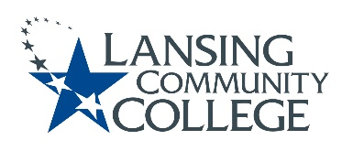

Curriculum Committee Report for the
Academic Senate

Date: 09/15/2022

The following items were reviewed by the Curriculum Committee and no objections were received.
For those interested in examining the CC documents, they can be found in the folder for Academic Senate review.

Proposed Expedited Course Revisions:
- HUMS 120 – Masterpieces of Art & Music
- HUMS 216 – Contemporary Art

Next Curriculum Committee meeting will meet on Wednesday, September 21, 2022, from 2:30-4:30 pm on WebEx.

Respectfully submitted,

Tamara McDiarmid
Curriculum Committee Chair

