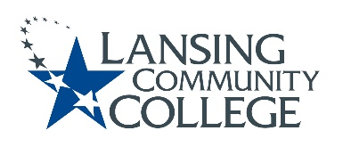

Curriculum Committee Report for the
Academic Senate

Date: 07/26/2022

The following items were reviewed by the Curriculum Committee and no objections were received.
For those interested in examining the CC documents, they can be found in the folder for Academic Senate review.

Proposed Expedited Course Revisions:
- AVAF 126 – Aircraft Systems II
- AVAF 127 – Aircraft Systems III
- AVAF 134 – Aircraft Instruments
- AVAF 208 – Aircraft Structures I
- AVAF 209 – Aircraft Structures II
- AVAF 210 – Aircraft Structures III
- AVAF 211 – Aircraft Electrical I
- AVAF 212 – Aircraft Electrical II
- AVEL 202 – Flight Line Testing
- AVGM 112 – Aviation General II
- AVGM 114 – Materials and Processes
- AVPP 241 – Reciprocating Engine
- AVPP 251 – Reciprocating Engine Systems
- AVPP 253 – Reciprocating Ignition Systems
- AVPP 255 – Reciprocating Induction Sys
- AVPP 257 – Aircraft Propeller Systems
- AVPP 265 – Powerplant Instruments

Next Curriculum Committee meeting will meet on Wednesday, September 21, 2022, from 2:30-4:30 pm on WebEx.

Respectfully submitted,

Tamara McDiarmid
Curriculum Committee Chair

