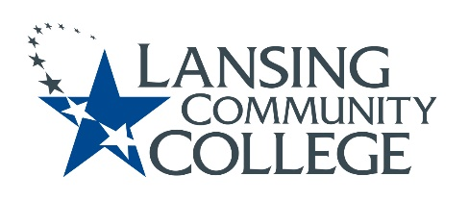

Curriculum Committee Report for the
Academic Senate

Meeting date: 3/15/2023

The Curriculum Committee meets on the 1st and 3rd Wednesday of each academic calendar month.

The following items were discussed and reviewed at the Curriculum Committee Meeting of 03/15/2023.

For those interested in examining the CC documents, they can be found in the folder for Academic Senate review.

Proposed New Program(s) of Study:
- n/a

Proposed New Courses:
- n/a

Proposed Course Revisions:
- n/a

Proposed Expedited Course Revisions:
- n/a

Proposed Program of Study Discontinuations:
- n/a

Proposed Course Discontinuations:
- n/a

Other business:
- Chair Elect: The proposed Term Limit language was agreed upon by the Curriculum Committee and is being submitted for approval.

- General Education – MTA Humanities Courses Approved:
  - HUMS 223-The Western World to 1500
  - HUMS 224-The Western World since 1500

- CIMT Course Revision Approvals:
  - LEGL 207/227
  - AVGM 111
  - AVGM 112
  - AVGM 113
  - AVGM 114

  - Canceled Course:
    - LEGL 110

Next Curriculum Committee will meet on Wednesday, April 5, 2023, from 2:30-4:30 pm on WebEx.

Respectfully submitted,

Tamara McDiarmid
Curriculum Committee Chair

