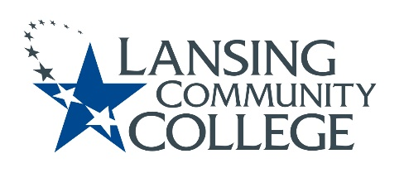

Curriculum Committee Report for the
Academic Senate

Meeting date: 2/15/2023

The Curriculum Committee meets on the 1st and 3rd Wednesday of each academic calendar month.

The following items were discussed and reviewed at the Curriculum Committee Meeting of 02/15/2023.

For those interested in examining the CC documents, they can be found in the folder for Academic Senate review.

Proposed New Program(s) of Study:
- Social Sciences, General Associate

Proposed New Courses:
- n/a

Proposed Course Revisions:
- n/a

Proposed Expedited Course Revisions:
- ENGL 098 – Integrated Reading/Writing I

Proposed Program of Study Discontinuations:
- Social Sciences, AA (0121)

Proposed Course Discontinuations:
- n/a

Other business:
- CIMT Course Revisions APPROVED:
  - CJUS 131
  - CJUS 255
  - HUMS 140
  - WELD 105

Next Curriculum Committee will meet on Wednesday, March 1, 2023, from 2:30-4:30 pm on WebEx.

Respectfully submitted,

Tamara McDiarmid, Curriculum Committee Chair

