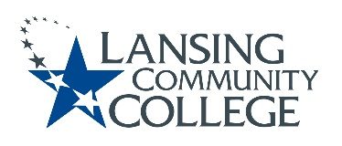

Curriculum Committee Report for the
Academic Senate

Meeting date: 07/11/2022

The Curriculum Committee meets on the 1st and 3rd Wednesday of each academic calendar month.

The following items were discussed and reviewed at the Curriculum Committee Meeting of 7/11/2022.

For those interested in examining the CC documents, they can be found in the folder for Academic Senate review.

Proposed New Program(s) of Study:
- n/a

Proposed New Courses:
- TECH 100 – Safety-OSHA 10

Proposed Course Revisions:
- n/a

Proposed Expedited Course Revisions:
- n/a

Proposed Program of Study Discontinuations:
- n/a

Proposed Course Discontinuations:
- n/a

Other business:
- MTA Guidelines & MTA Recommendations form: Language regarding direct transfer vs general credit clarification
- Curriculum Committee 2022-23 Meeting Schedule

Next Curriculum Committee will meet on Wednesday, September 21st, 2022, from 2:30-4:30 pm on WebEx.

Respectfully submitted,

Tamara McDiarmid
Curriculum Committee Chair

