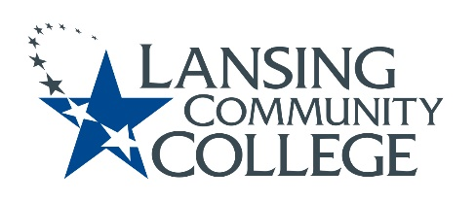

Curriculum Committee Report for the
Academic Senate

Meeting date: 11/18/2022

The Curriculum Committee meets on the 1st and 3rd Wednesday of each academic calendar month.

The following items were discussed and reviewed at the Curriculum Committee Meeting of 11/16/2022.

For those interested in examining the CC documents, they can be found in the folder for Academic Senate review.

Proposed New Program(s) of Study:
- n/a

Proposed New Courses:
- ACCG 215 – Financial Data Analytics
- ARTS 202 – Design for Innovation
- CHDV 132 – Leadership Early Childhood Ed

Proposed Course Revisions:
- ACCG 160 – Payroll Systems and Taxes
- ACCG 260 – Accounting Systems
- COMM 280 – Intercultural Communication
- HUSE 100 – Introduction to Human Services
- LEGL 215 – Business Law

Proposed Expedited Course Revisions:
- BIOL 127 – Cell Biology

Proposed Program of Study Discontinuations:
- n/a

Proposed Course Discontinuations:
- n/a

Other business:
- CIMT Course Revision Approvals:

  - LEGL 110
  - LEGL 125
  - LEGL 211
  - LEGL 212
  - LEGL 216
  - LEGL 217
  - LEGL 218
  - LEGL 219
  - LEGL 222
  - LEGL 223
  - LEGL 229
  - PFKN 201

Next Curriculum Committee will meet on Wednesday, December 7th, 2022, from 2:30-4:30 pm on WebEx.

Respectfully submitted,
Tamara McDiarmid
Curriculum Committee Chair

