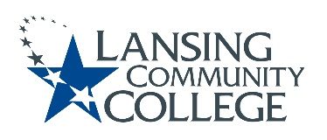

Curriculum Committee Report for the
Academic Senate

Meeting date: 09/21/2022

The Curriculum Committee meets on the 1st and 3rd Wednesday of each academic calendar month.

The following items were discussed and reviewed at the Curriculum Committee Meeting of 9/21/2022.

For those interested in examining the CC documents, they can be found in the folder for Academic Senate review.

Proposed New Program(s) of Study:
- n/a

Proposed New Courses:
- n/a

Proposed Course Revisions:
- n/a

Proposed Expedited Course Revisions:
- HUMS 211 – Art History to the Renaissance
- HUMS 212 – Art History from the Renaissance

Proposed Program of Study Discontinuations:
- n/a

Proposed Course Discontinuations:
- n/a

Other business:
- General Education – MTA Natural Science Lab Course (reinstated) Approved:
  - PHYS 200 – Intro to Applied Physics
- General Education – MTA Humanities Courses Approved:
  - RELG 210 – Comparative Religions
  - RELG 230 – Introduction to Christianity
  - RELG 232 – Introduction to Islam
- Charter Updated Approved:
  - Remove Term Limits and Rotation
  - Add to Resources:
    - Accreditation Liaison Officer
- New Sub-committee created to design a process for establishing assignment of credit hours for courses per HLC requirement and including the Gen Ed-MTA/Applied requests to the New Course Proposal submission.
- CIMT Course Revisions Approved:
  - ARTH – New Course/Subject Code
  - CJUS 270
  - CJUS 271
  - DENT 270
  - HUMS 120 to ARTH 120
  - HUMS 211 to ARTH 211
  - HUMS 212 to ARTH 212
  - HUMS 216 to ARTH 216

Next Curriculum Committee will meet on Wednesday, September 21st, 2022, from 2:30-4:30 pm on WebEx.

Respectfully submitted,

Tamara McDiarmid
Curriculum Committee Chair

