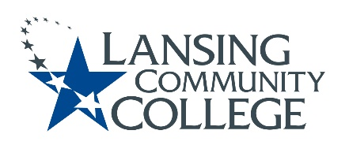

Curriculum Committee Report for the
Academic Senate

Meeting date: 11/17/2021

The Curriculum Committee meets on the 1st and 3rd Wednesday of each academic calendar month.
The following items were discussed and reviewed at the Curriculum Committee Meeting of 11/17/2021.
For those interested in examining the CC documents, they can be found in the folder for Academic Senate review.

Proposed New Program(s) of Study:
- n/a

Proposed New Courses:
- n/a

Proposed Course Revisions:
- COMM 110 – Communication in the Workplace
- INSU 110 – Personal Insurance
- PHOT 114 – Advanced Photographic Imaging

Proposed Expedited Course Revisions:
- COMM 120 – Dynamics of Communication
- COMM 240 – Interpersonal Communication
- COMM 270 – Mass Communication
- ENGL 290 – Shakespeare
- MASG 110 – Massage for Non-Majors
- MASG 231 – Massage II
- MASG 232 – Massage III
- PHYS 200 – Intro to Applied Physics

Proposed Program of Study Discontinuations:
- n/a

Proposed Course Discontinuations:
- n/a

Other business:

CIMT Course Revisions (Credit) Approved:
- MASG 139
- MASG 139A
- MASG 139B
- MUSC 193
- MUSC 237
- PHOT 113
- THEA 131
- THEA 143
- THEA 160
- THEA 173
- THEA 220
- THEA 285
- THEA 233
- PHOT 213
- CHEM 152
- ISCI 122

CIMT Courses (Non-Credit) Reviewed:

- NCBD 102
- NCCT 400
- NCCT 700
- NCHE 101
- NCHE 103
- NCHE 104
- NCHE 105
- NCHE 120
- NCHE 210
- NCHE 211
- NCHE 230
- NCHE 235
- BSEM 100
- CSEM 100
- GSEM 100
- QSEM 100
- TSEM 100

Next Curriculum Committee will meet on Wednesday, December 1st, 2021, from 2:30-4:30 pm on WebEx.

Respectfully submitted,

Tamara McDiarmid
Curriculum Committee Chair

