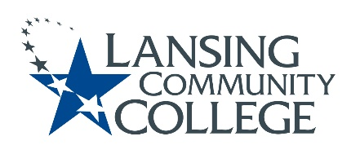

Curriculum Committee Report for the
Academic Senate

Meeting date: 10/20/2021

The Curriculum Committee meets on the 1st and 3rd Wednesday of each academic calendar month.
The following items were discussed and reviewed at the Curriculum Committee Meeting of 10/20/2021.
For those interested in examining the CC documents, they can be found in the folder for Academic Senate review.

Proposed New Program(s) of Study:
- n/a

Proposed New Courses:
- n/a

Proposed Course Revisions:
- BUSN 150 – Legal Issues: Start Small Busn
- ENGL 098 – Integrated Reading/Writing I
- PSYC 180 – Intro to Positive Psychology

Proposed Expedited Course Revisions:
- MUSC 163 – Aural Skills I
- MUSC 164 – Aural Skills II
- MUSC 240 – Musical Cultures to 1750
- MUSC 241 – Musical Cultures 1750-Present
- SOCL 255 – Contemporary Social Problems

Proposed Program of Study Discontinuations:
- n/a

Proposed Course Discontinuations:
- n/a

Other business:

CIMT Course Revisions Approved:
• BIOL 229
• BUSN 155
• BUSN 157
• BUSN 260
• BUSN 261
• BUSN 285
• MGMT 223
• MGMT 224
• MGMT 228
• NCSS 101
• PHOT 228
• THEA 223

Next Curriculum Committee will meet on Wednesday, November 3rd, 2021, from 2:30-4:30 pm on WebEx.

Respectfully submitted,
Tamara McDiarmid, Curriculum Committee Chair

