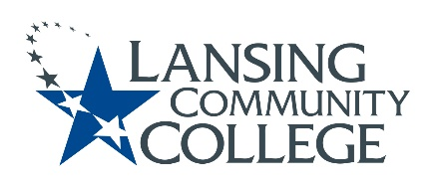

Curriculum Committee Report for the
Academic Senate

Meeting date: 10/06/2021

The Curriculum Committee meets on the 1st and 3rd Wednesday of each academic calendar month.

The following items were discussed and reviewed at the Curriculum Committee Meeting of 10/06/2021.

For those interested in examining the CC documents, they can be found in the folder for Academic Senate review.

Proposed New Program(s) of Study:
- n/a

Proposed New Courses:
- n/a

Proposed Course Revisions:
- n/a

Proposed Expedited Course Revisions:
- n/a

Proposed Program of Study Discontinuations:
- n/a

Proposed Course Discontinuations:
- n/a

Other business:

CIMT Course Revisions Approved:
- THEA 150
- SOCL 120
- PSYC 200
- BUSN 118

General Education – MTA Natural Science Lab Course (moved from Social Science) Approved:
- ANTH 275 - Physical Anthro & Archaeology

Next Curriculum Committee will meet on Wednesday, October 20th, 2021, from 2:30-4:30 pm on WebEx.

Respectfully submitted,
Tamara McDiarmid, Curriculum Committee Chair

