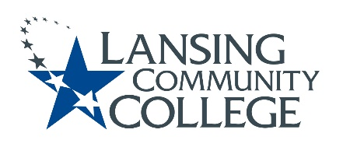

Curriculum Committee Report for the
Academic Senate

Meeting date: 09/15/2021

The Curriculum Committee meets on the 1st and 3rd Wednesday of each academic calendar month.

The following items were discussed and reviewed at the Curriculum Committee Meeting of 9/15/2021.

For those interested in examining the CC documents, they can be found in the folder for Academic Senate review.

Proposed New Program(s) of Study:
- n/a

Proposed New Courses:
- n/a

Proposed Course Revisions:
- n/a

Proposed Expedited Course Revisions:
- n/a

Proposed Program of Study Discontinuations:
- n/a

Proposed Course Discontinuations:
- n/a

Other business:

CIMT Course (Credit) Revisions Approved:
- ENGL 098
- CITN 245
- CITN 253
- CITN 256
- BUSN 118*
- PSYC 200*
- SOCL 120*
CIMT New/Revised Courses (Non-Credit) Reviewed:
- NCAS 102
- NCAS 103, 104, & 105

* Due to an adjustment to the co-reqs of the course to include an NCAS courses with ENGL 098

Next Curriculum Committee will meet on Wednesday, October 6th, 2021, from 2:30-4:30 pm on WebEx.

Respectfully submitted,
Tamara McDiarmid, Curriculum Committee Chairperson

