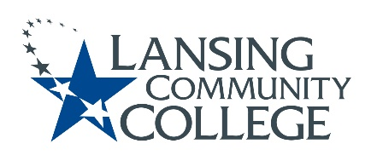

Curriculum Committee Report for the
Academic Senate

Meeting date: 07/12/2021

The Curriculum Committee meets on the 1st and 3rd Wednesday of each academic calendar month.
The following items were discussed and reviewed at the Curriculum Committee Meeting of 07/12/2021.
For those interested in examining the CC documents, they can be found in the folder for Academic Senate review.

Proposed New Program(s) of Study:
- n/a

Proposed New Courses:
- n/a

Proposed Course Revisions:
- n/a

Proposed Expedited Course Revisions:
- n/a

Proposed Program of Study Discontinuations:
- n/a

Proposed Course Discontinuations:
- n/a

Other business:
- LCC MTA Guidelines 21-22: Revision to LCC MTA Guidelines #9 (page 3)
- CIMT Course Revisions Approved:

  - FIRE 104
  - FIRE 112
  - MASG 132B
  - MASG 139B
  - MASG 151C
  - MASG 151D
  - MATH 097
  - MATH 098
  - MATH 120
  - NCCT 100
  - NCCT 200
  - NCCT 300
  - NCCT 500
  - NCHE 110
  - NCHE 212
  - NCHE 213
  - NCHE 236
  - NCHE 237
  - NCHE 260
  - NCHE 270

Next Curriculum Committee will meet on Wednesday, September 15th, 2021, from 2:30-4:30 pm on WebEx.

Respectfully submitted,
Tamara McDiarmid
Curriculum Committee Chairperson

