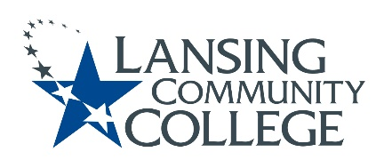

Curriculum Committee Report for the
Academic Senate

Date: 05/042022

The Curriculum Committee meets on the 1st and 3rd Wednesday of each academic calendar month.
The following items were discussed and reviewed at the Curriculum Committee Meeting of 05/04/2022.
For those interested in examining the CC documents, they can be found in the folder for Academic Senate review.

Proposed New Program(s) of Study:
- n/a

Proposed New Courses:

- n/a

Proposed Course Revisions:

- n/a

Proposed Expedited Course Revisions:

- n/a

Proposed Program of Study Discontinuations:
- n/a

Proposed Course Discontinuations:
- n/a

Other business:
CIMT Course Revisions:

- ENGL 098
- MATH 119
- STATE 170

Next Curriculum Committee will meet on Monday, July 11th, 2022, from 9:00-11:00 am on WebEx.
Respectfully submitted,
Tamara McDiarmid
Curriculum Committee Chair

