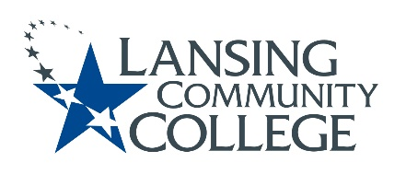

Curriculum Committee Report for the
Academic Senate

Date: 03/03/2022

The Curriculum Committee meets on the 1st and 3rd Wednesday of each academic calendar month.
The following items were discussed and reviewed at the Curriculum Committee Meeting of 03/02/2022.
For those interested in examining the CC documents, they can be found in the folder for Academic Senate review.

Proposed New Program(s) of Study:
- Cybersecurity Foundations, Certificate of Completion
- Cybersecurity, Associate of Applied Science
- World Language, Associate of Arts

Proposed New Courses:

- CITC 282 – Ethical Hacking
- CITC 285 – System Defense
- CITC 287 – Cybersecurity Incident Response
- CITC 290 – Cybersecurity Risk Management
- CITO 100 – Cloud Foundations with AWS
- CITO 120 – Cloud Architecting with AWS

Proposed Course Revisions:

- STPR 145-Foundations Sterile Processing (f/k/a CHSE 145 – Sterile Processing Tech I)

Proposed Expedited Course Revisions:

THEA 171 – Play Analysis

Proposed Program of Study Discontinuations:
- n/a

Proposed Course Discontinuations:
- n/a

Other business:
- New 5-Star Ticket process for applying for General Education-Applied Degree and General Education-Michigan Transfer Agreement (MTA) – begin in Fall 2022.

Next Curriculum Committee will meet on Wednesday March 16, 2022, from 2:30-4:30 pm on WebEx.
Respectfully submitted,
Tamara McDiarmid
Curriculum Committee Chair

