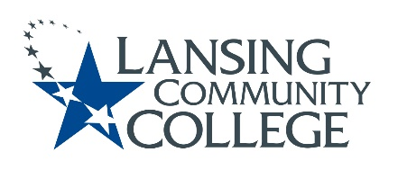

Curriculum Committee Report for the
Academic Senate

Date: 02/16/2022

The Curriculum Committee meets on the 1st and 3rd Wednesday of each academic calendar month.
The following items were discussed and reviewed at the Curriculum Committee Meeting of 02/16/2022.
For those interested in examining the CC documents, they can be found in the folder for Academic Senate review.

Proposed New Program(s) of Study:
- GSCI UAS Remote Pilot and Maintenance, Certificate of Completion
- Science and Mathematics, General Associate

Proposed New Courses:

- AVAU 100-UAS Exam-Flight Orientation
- AVAU 150-Unmanned Aircraft Sys. Maint
- AVAU 200-Advanced UAS Flight

Proposed Course Revisions:

- n/a

Proposed Expedited Course Revisions:

- n/a

Proposed Program of Study Discontinuations:
- n/a

Proposed Course Discontinuations:
- n/a

Other business:

CIMT Course Revisions Approved:
- HSKN 080
- PFKN 200
- PFKN 201
- PFKN 208
- PFKN 210

Next Curriculum Committee will meet on Wednesday March 2, 2022, from 2:30-4:30 pm on WebEx.
Respectfully submitted,
Tamara McDiarmid
Curriculum Committee Chair

