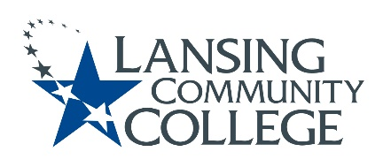

Curriculum Committee Report for the
Academic Senate

Date: 02/04/2022

The Curriculum Committee meets on the 1st and 3rd Wednesday of each academic calendar month.
The following items were discussed and reviewed at the Curriculum Committee Meeting of 02/02/2022.
For those interested in examining the CC documents, they can be found in the folder for Academic Senate review.

Proposed New Program(s) of Study:
- Communication and Language, General Associate
- Communication and Language-Enhanced, Associate Applied Arts
- Massage Therapy, Certificate of Completion
- Music, Associate of Music
- Music Education/Pre-Music Therapy, Associate of Music
- Music-Enhanced, Associate of Music

Proposed New Courses:

- HERT 160 – Equipment HVAC/Cab Controls

Proposed Course Revisions:

- n/a

Proposed Expedited Course Revisions:

- n/a

Proposed Program of Study Discontinuations:
- Music, AA (1477)

Proposed Course Discontinuations:
- n/a

Other business:

CIMT Course Revisions Approved (*-Course Code Change: Alpha changes from MASG/numerical same):
- MSGE 110*
- MSGE 131*
- MSGE 132*
- MSGE 132A*
- MSGE 132B*
- MSGE 137*
- MSGE 139*
- MSGE 139A*
- MSGE 139B*
- MSGE 141*
- MSGE 150*
- MSGE 151*
- MSGE 151A*
- MSGE 151B*
- MSGE 151C*
- MSGE 151D*
- MSGE 170*
- MSGE 231*
- MSGE 232*
- MSGE 235*
- MSGE 241*
- MSGE 242*
- MSGE 252*
- MSGE 253*
- MSGE 254*
- MSGE 256*
- MSGE 258*

Next Curriculum Committee will meet on Wednesday February 16, 2022, from 2:30-4:30 pm on WebEx.

Respectfully submitted,

Tamara McDiarmid
Curriculum Committee Chair

