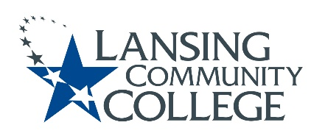

Curriculum Committee Report for the
Academic Senate

Date: 01/19/2022

The Curriculum Committee meets on the 1st and 3rd Wednesday of each academic calendar month.
The following items were discussed and reviewed at the Curriculum Committee Meeting of 01/19/2022.
For those interested in examining the CC documents, they can be found in the folder for Academic Senate review.

Proposed New Program(s) of Study:
- n/a

Proposed New Courses:

- n/a

Proposed Course Revisions:

- CHSE 131-Electronic Hlth Records
- CPSC 230-Alogrithms and Computing with C++
- CPSC 260-Computer Science Structures
- DENT 128-Dental Radiography
- FREN 121-Elementary French I
- FREN 122-Elementary French II
- FREN 201-Intermediate French I
- FREN 202-Intermediate French II
- MEDA 166-MA Clinical Procedures II
- MEDA 175-MA Certification Review
- MEDA 177-MA Practicum Immersion (fka MA Practice Immersion)
- SIGN 271-Advanced Sign to Voice
- STPR 148-Sterile Processing Externship (f/k/a CHSE 148)

Proposed Expedited Course Revisions:

- n/a

Proposed Program of Study Discontinuations:
- n/a

Proposed Course Discontinuations:
- n/a

Other business:

CIMT Course Revisions Approved (*-Title Change/Clarification):
- THEA 131
- THEA 141

Next Curriculum Committee will meet on Wednesday February 2, 2022, from 2:30-4:30 pm on WebEx.

Respectfully submitted,

Tamara McDiarmid
Curriculum Committee Chair

