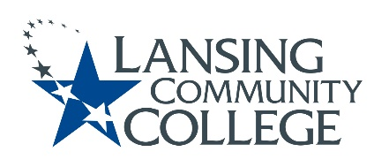

Curriculum Committee Report for the
Academic Senate

Date: 11/11/2021

The following items were reviewed by the Curriculum Committee and no objections were received.
For those interested in examining the CC documents, they can be found in the folder for Academic Senate review.

Proposed Expedited Course Revisions:
- ACAD 100 – First Year College Experience
- BIOL 128 – Organismal Biology
- CHEM 135 – Chemistry in Society
- CHEM 182 – Introductory Organic Chemistry
- DMAC 130 – Digital Video Production
- DMAC 140 – Pre-Production Design
- DMAC 231 – Digital Cinematography II
- DMAC 246 – Workshop: Video
- ENGL 122 – Composition II
- ENGL 132 – Honors Composition II
- ENGL 211 – World Literature I
- ENGL 212 – World Literature II
- ENGL 220 – Science Fiction
- ENGL 245 – Popular Culture and Mass Media
- ENGL 255 – American Lit to 1865
- ENGL 256 – American Lit 1865 to Present
- ENGL 266 – British Lit to 1800
- ENGL 267 – British Lit 1800 to Present
- ENGL 270 – Gender and Literature
Next Curriculum Committee will meet on Wednesday, November 17th from 2:30pm to 4:30pm on WebEx.

Respectfully submitted,
Tamara McDiarmid
Curriculum Committee Chair

