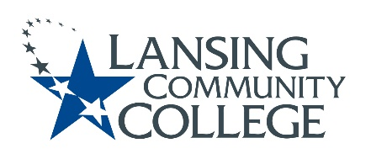

Curriculum Committee Report for the
Academic Senate

Date: 06/28/2021

The following items were reviewed by the Curriculum Committee and no objections were received.
For those interested in examining the CC documents, they can be found in the folder for Academic Senate review.

Proposed Expedited Course Revisions:
- DENT 148 - Dental Radiography
- DENT 242 – Dental Hygiene III
- DENT 176 – Dental Materials
- NURS 242 – Professional Practice

Next Curriculum Committee will meet on Monday, July 12, 2021 from 2:30pm to 4:30pm on WebEx.

Respectfully submitted,
Tamara McDiarmid
Curriculum Committee Chairperson

