LANSING COMMUNITY COLLEGE ASSESSMENT PLAN
2018-2021
By the Committee for Assessing Student Learning and
The Center for Data Science

Drafted Summer 2018
Review/Approval [body + date]
Contents
Introduction 3
LCC’s Guiding Principles of Assessment 4
LCC’s History of Assessment 5
2015-2018 Assessment Results 5
Committee for Assessing Student Learning (CASL) 6
LCC College-Wide Assessment 7
Course-Level Student Learning Assessment 8
Course-Level Tools and Templates 9
Program-Level Student Learning Assessment 10
Program-Level Tools and Templates 14
Institutional-Level Student Learning Assessment 15
Institutional-Level Tools and Templates 15
Student Learning Assessment Process Steps 16
LCC 2018-2021 Assessment Goals and Objectives 18
Assessment Strategies and Project Plan 19
Managing LCC’s Assessment Plan 21
Communication and Education 21
Assessment-Related Definitions and Terminology 22
Student Learning Assessment Tools, Templates, and Resources 26
Course-Level Assessment 26
Curriculum Map 26
Learning Outcomes Rubric 27
Program-Level Assessment 28
Program Review Questionnaire 28
Annual Improvement Plan 31
Institutional-Level Assessment 32
Essential Learning Outcomes Rubrics 32

Introduction

Lansing Community College provides high-quality education ensuring that all students successfully complete their educational goals while developing life skills necessary for them to enrich and support themselves, their families, and their community as engaged global citizens.

Lansing Community College’s mission statement, noted above, describes our primary focus on the success of our students. Lansing Community College provides equal education for all persons. Our policies and practices, inside and outside the classroom, assure that all students enjoy the same rights and opportunities across the College and are empowered to participate in an equitable world.

Lansing Community College prepares students to participate equitably in the local community and in the world by providing learning opportunities that build skills that lead to the improved lives of students and the community. These skills are identified in our learning outcomes in courses, curriculums, and across the institution.

To ensure all students are achieving learning outcomes, LCC conducts regular student learning assessment: defining what students will learn in their courses and curriculums and continuously checking in to see how we may improve student learning.

Assessment plans are developed every three years to reflect upon the successes and lessons learned from prior years and to continuously improve upon the system of assessment at the college. This current assessment plan brings the 2015-2018 assessment plan up to date to reflect improvements that have occurred since its development and identifies goals, objectives, and strategies for continuing its progress with the integration and use of student learning assessment data.

LCC’s Guiding Principles of Assessment
In response to Lansing Community College’s goal to explore innovative and rigorous approaches for determining the impact of student learning, this assessment plan seeks to support and blend evidence-based decision-making, program improvement, and accountability, as well as provide a sound vehicle for determining what works, for whom, under what circumstances.

Integrated assessment systems have been shown to have a positive impact on institutional and student performance, and, as such, the purpose of this assessment plan is to translate and adapt principles from the performance improvement field, as well as performance measurement principles to design, implement, and evaluate an integrated assessment system that improves institutional, program, and student performance by providing timely and relevant data regarding student learning and its impact at the course, program, and institutional levels.

The design of an integrated assessment system is a long-term endeavor with implementation best supported with a shared understanding of how and why such practices are useful and meaningful to students. As such, LCC applies the following guiding principles of assessment:

- The primary purpose of assessment is improvement of student learning.
- Assessment of student learning depends on clear statements of expected outcomes.
- Effective assessment attends not only to outcomes, but also to the experiences that lead to those outcomes.
- Assessment works best when it recognizes that learning is complex and multidimensional, occurring in a variety of settings.
- Assessment is more meaningful and likely to lead to improvement when students are committed to learning and the faculty and staff who deliver the programs and services own the process.
- Assessment works best when it is designed to be meaningful, manageable, and sustainable.
- Clear statements of expected student learning outcomes will guide the design and ongoing review of programs.
- LCC is committed to an ongoing program of assessment of student learning.

Adapted from the American Association for Higher Education. (1992). 9 Principles of good practice for assessing student learning.

LCC’s History of Assessment
Throughout its history, the College has engaged in the assessment of student learning and continues to make strides through a continuous improvement design and process, as, for example, establishing the committee for assessing student learning (CASL) as a standing committee of the Academic Senate.
The academic senate appointed the first CASL members in August, 2015 and approved the charter in September, 2015. CASL’s charter communicates its purpose to provide leadership and support to academic and co-curricular areas for continuous improvement of student learning.

CASL is comprised of faculty representatives and administrators from academic and non-academic areas across the college. Focused efforts and support on improving college-wide assessment began in the summer of 2015 with members of CASL and the Guided Pathways initiative attending the HLC and
Assessment Workshop in St. Charles, Illinois. Since then, CASL has organized the identification, collection, analysis, and review of outcomes at the program of study and institutional levels, develops tools and processes for student learning assessment, and conducts faculty engagement and outreach. Most importantly, in collaboration with the academic senate and the director of assessment, CASL actively participates in the development of college-wide assessment plans.

2015-2018 Assessment Results
The 2015-2018 assessment plan identified performance indicators and targets that were used to inform progress of the assessment plan. The following table provides a summary of the results. Detailed reports are accessible through the committee for assessing student learning web page on lcc.edu.
Indicator | Target | 2015-2016 | 2016-2017 | 2017-2018
Programs of study report program-level student learning outcome statements | ≥87% | 86% | 98% | 93%
Programs of study report alignment from program-level student learning outcomes to institutional-level student learning outcomes | ≥85% | 78% | 92% | 97%
Moderate level cognitive skills are required of LCC program graduates | ≥50% | 53% | 59% | 59%
Programs of study report methods of assessment | ≥85% | 88% | 90% | 90%
Selected assessment methods are aligned to the student learning outcome statement | ≥80% | 76% | 95% | 95%
Programs of study have plans for collecting, compiling, analyzing, and using student learning outcome evidence | 100% | New measure | 40% (4/10) | 41% (9/22)

Committee for Assessing Student Learning (CASL)

Edwin Bryant
Science Faculty, A&S

Kara Christensen
CMS Instructional Design Specialist, eLearning

Dana Cogswell (Ex-officio)
Director of Institutional Research, CDS

Michelle Curtin (Chair)
Nursing Faculty, HHS

Dale Franks
Collision Technology Faculty, Technical Careers

Nikki Gruesbeck
Fitness/Health/Kinesiology Faculty, HHS

Karen Hicks (Ex-officio)
Director of Assessment, CDS

Joseph Long
Surgical Technology Faculty, HHS

Zach Macomber
Economics Faculty, A&S

Rafeeq McGiveron
Project Manager, Academic Affairs

Rob McLoone
Writing Faculty, A&S

Lisa Nienkark
Integrated English

Lori Orr
Nursing Faculty, HHS

Glenys Warner
Director, Lifelong Learning, Community Education & Workforce Development

CASL Membership
2018- 2021
The purpose of this Standing Committee of the Academic Senate is to provide leadership and support to assist faculty and staff in their efforts of continuous improvement of student learning.

Charter
CASL’s charter describes committee’s purpose, functions, and responsibilities and is reviewed and approved by the Academic Senate. (Charter last reviewed and approved Spring, 2018).
- Clearly define roles of faculty, staff, and administrators in the outcomes mapping process
- Guide the process of mapping individual Course Outcomes to Program of study Outcomes to Institutional Outcomes in order to ensure interconnectedness.
- Assist in creating a culture of evidence-based decision making.
- Create a learning-centered culture that focuses on the results of the teaching-learning process.
- Review evidence of outcomes and how those outcomes are measured for all Programs of Study on a 3-4 year staggered cycle.
- Review and recommend proposed policies and procedures related to measurement and evaluation of Programs of Study outcomes.
- Establish general criteria for new Programs of Study.
- Perform annual review of CASL’s progress, retain meeting minutes, and accomplished tasks; maintain appropriate and representative membership.
- Provide timely updates to the Academic Senate in support of ongoing accreditation standards as set forth by the Higher Learning Commission.

Membership
- Co-Chairs (1 Administrator and at least 1 Faculty)
- 60-70% faculty (Full-time and Part-time)
- 10-15 faculty including one non-teaching faculty
- A minimum of 2 Academic Senators
- A member should not miss more than 2 meetings a semester

Term: A maximum of 6 years
Rotation: Stagger every 3 years
Chartered By: The Academic Senate as directed by the Provost

Information about committee meetings and projects may be found on the CASL web page of the LCC website.

LCC College-Wide Assessment
The starting point of student learning improvement efforts is identifying and verifying the ultimate ends, or student learning outcomes and the impact the College wishes to accomplish. These ends are the results, or outcomes, of student learning. LCC creates and assesses student learning outcomes across three levels of the college: in the classroom (course-level), in the program of study curriculum (program-level), and across the college courses (institutional-level).
These levels of student learning outcomes are designed for alignment, meaning, they are linked and interact with each other. Course-level student learning outcomes link to program-level student learning outcomes which link to institutional-level student learning outcomes.
- Course-level student learning assessment – assesses course-level student learning outcomes.
- Program-level student learning assessment – assesses program-level student learning outcomes.
- Institutional-level student learning assessment – assesses institutional-level student learning outcomes (also called Essential Learning Outcomes, or, ELOs).
Figure X below displays an example of linking the levels of student learning outcomes.

Figure X. Student Learning Assessment Levels Example

Course-Level Student Learning Assessment
Course-Level assessment addresses the performance of individual and multiple-section courses and aims to provide insight into:

- The quality of the learning objectives and outcomes (as examples: meaningful and measurable course learning objectives, cognition level)
- The link, or alignment, between course learning objectives and all levels of student learning outcomes
- Assessment methods appropriate to the course learning objectives
- The use of data to improve course, curriculum, instruction, and assessment
- Student response to the course

Course-Level Assessment Collaborators
Course-level assessment requires the active participation and engagement of faculty, staff, administration, and students. Administration and staff support faculty in creating meaningful and measureable course learning objectives, engaging in appropriate lesson and classroom assessment practices that are aligned with course-, program-, and institutional-level learning outcomes, and using that information to improve student learning in the classroom, managing course-level assessment data and sharing assessment data with other faculty, staff, and administration. Students are active partners in assessment, for example, participating in direct and indirect assessment activities and providing feedback to faculty, staff, and administration to inform student satisfaction.

Sources and Methods of Course-Level Evidence
Students are the primary source of direct and indirect course-level evidence. LCC faculty are encouraged to use multiple methods of assessment and to rely more heavily on direct assessment rather than indirect assessment in the classroom. Direct assessment provides more tangible evidence of student learning and offers the instructor more immediate and compelling evidence of student performance. Indirect evidence, such as perceptions of one’s learning, serves as proxy signs of student performance evidence. Combined, direct and indirect methods provide comprehensive insight into course-level assessment.

Sample Direct Measures of Student Learning | Sample Indirect Measures of Student Learning
Test scores  Writing samples  Portfolios  Projects  Presentations  Internships, Clinical Experiences | Course grade  Survey/Questionnaire (e.g. IDEA course evaluation)

Analysis of Course-Level Evidence
To prepare for course-level analysis, faculty complete a curriculum map template to identify and align course-level learning objectives with program- and institutional-level learning outcomes, identify the methods of assessment, and specify the level of mastery of each outcome within and throughout the curriculum. The completed template is submitted to our SharePoint system and housed within the Student Learning Outcomes folder allowing for college-wide access to view the student learning outcomes of all LCC programs of study and to allow faculty opportunity to modify outcomes as well as capture a revision history of the outcomes.

Faculty may perform self-assessments of the quality and completeness of learning outcome statements by using the Learning Outcomes Rubric developed by CASL members. This rubric may be found on the CASL site.

This process allows for identification and alignment of assessment methods and perspective into the number of times each learning outcome is assessed. Bloom’s taxonomy is used to determine the level of cognition of the learning outcome with the highest level of cognition applied to the analysis.

The IDEA questionnaire is used to obtain student satisfaction perceptions of student learning assessment. This questionnaire is administered at the end of each course. Data is analyzed by determining the mean and standard deviation results of the assessment-specific questions on the questionnaire. As indirect data, IDEA results are not used as direct evidence of student learning.

Collating Course-Level Assessment Data
Collating student learning assessment data is a critical step in the assessment process. Collating is the process of gathering student learning data from multiple, similar sources and aggregating the data, as, for example, collecting student learning assessment data from multiple sections of the same course and then analyzing and reporting the data by the course.

The Center for Data Science offers data collection tools that may be used to assist faculty with making the process of collating student learning data easy and efficient. These data collection tools may be customized to suit your department and program of study needs. Please contact the Center for Data Science for assistance with your data collection efforts.

Use of Course-Level Evidence
Course-level evidence is used to make continuous improvements to course learning objectives, alignment between course learning objectives and Program of study learning outcomes, alignment between course learning objectives and the selected assessment methods, and in the methods and process of course-level assessment.

Course-Level Tools and Templates
Curriculum map template
Learning outcomes rubric

Program-Level Student Learning Assessment
Program-level student learning assessment is an opportunity to review the current state of a program of study and to look for improvement and support opportunities that help facilitate student learning and success. This level of student learning assessment is conducted through a student-centered program review process. Program review is NOT used to make decisions about program elimination or used to assess the performance of faculty. The purpose of program review is to support ongoing program of study improvements that facilitate and are aligned to student success. Student learning assessment at this level concentrates on the totality of the curriculum (i.e. learning outcomes across the curriculum), rather than a focus on any course.

Program-Level Assessment Collaborators
Program review is conducted with members of the program of study and the support team. This collaborative approach promotes a shared understanding and accountability and also builds networks across the campus in which all collaborators channel efforts and resources toward the success of our students. The Program review support team collaborates before, during, and after the review to work through any assessment challenges throughout the process. This practice allows for time and support to Program of study faculty, staff, and administration to review data packets, interpret the data, derive improvement plans, and prepare for the workgroup session at the end of the semester in which the Program review is conducted.

Program review collaborators, or support team may include the following roles:

- Program of study Full-time and Part-time faculty
- Program of study Staff and Administration
- Division Dean
- Program area Associate Dean
- Provost and Senior VP of Academic Affairs
- Associate VP, Academic and Student Affairs
- Assistant Dean, Academic Affairs
- Center for Data Science
- Committee for Assessing Student Learning
- Curriculum Committee
- Financial Services

Sources and Methods of Program-Level Evidence
A program review questionnaire was developed in collaboration with CASL and approved by the Academic Senate (May, 2015) to assist programs of study with thoughtful response to questions and as opportunity to encourage dialogue of how student learning evidence has an immediate use and value to faculty. The components and associated questions of Program review questionnaire are listed below:

Table X. Program Review Questionnaire
Program Purpose | How does the Program of study address community, employer, and student needs  How does the Program of study contribute to LCC recognition as a national leader among community colleges
Program Alignment | How does the Program of study align to LCC’s mission, vision, & goals  How does the Program of study align to other curriculums and reflect current industry trends and needs
Student | How many students are enrolled in a Program of study  How does the Program of study recruit and retain students  What students stay in the program and complete the program  What progress are the students in the Program of study making toward their goals  What do students learn in this Program of study
Program Resources | What are the resource strengths and needs of the Program of study
Program Diversity | How does the Program of study contribute to LCC’s strategy of integrating more fully the concepts of globalization and diversity in instruction and services  How does student enrollment in the Program of study represent the diversity of populations served in the community
Program Use of Data | How does the Program of study measure and monitor student learning performance  How does the Program of study use student learning evidence to make improvements  What are the short-term and long-term planned improvements for the Program of study  What are the measurement and monitoring strategies for planned improvement  How does the Program of study use data to inform curriculum change

Questions may be slightly modified to suit the program area. For example, the primary goal for Center for Transitional Learning students is progression to college level courses; therefore, questions regarding student retention and completion are modified to capture how these students are retained at the institutional level, rather than the program level.

Sources and Methods of Program-Level Evidence
Faculty and students are the primary data sources of program-level evidence. Faculty are provided with several methods to capture program-level evidence, such as:

- Program Review Questionnaire – used to provide detailed and thoughtful reflection to the questions of program review (see table X above)
- Program of Study Learning Outcomes template – used to identify and report program-level student learning outcomes statements, assessment methods for each student learning outcomes statement, 2-year mastery levels for each course, and alignment from program-level learning outcomes to institutional-level learning outcomes
- Program of Study Learning Outcomes rubric – used to conduct a self-assessment of the completeness and quality of program-level learning outcomes statements and assessment methods
- Annual Improvement Plan – used to identify and report annual program-level improvements

Assessment tools that are used to collect data at the program-level are designed by CASL and/or CDS and then reviewed and tested by CASL and Curriculum Committee (CC), and at times, approved by the academic senate.

Analysis of Program-Level Evidence
Responses to program-level assessment methods are reviewed and discussed with the program of study support team (i.e. CASL, CDS, CC, Provost, & Financial) during the workgroup session at the close of the review.

Responses to program of study student learning outcomes and alignment to essential learning outcomes templates are reviewed by CASL using a rubric to assess the completeness and quality of outcomes and assessment types. CASL then provides feedback to the Program of study with suggestions for improvements to the outcomes statements and/or the selected assessment type.

Collating Program-Level Assessment Data
Collating student learning assessment data is a critical step in the assessment process. Collating is the process of gathering student learning data from multiple, similar sources and aggregating the data, as, for example, collecting student learning assessment data from multiple sections of the same course and then analyzing and reporting the data by the course.

The Center for Data Science offers data collection tools that may be used to assist faculty with making the process of collating student learning data easy and efficient. These data collection tools may be customized to suit your department and program of study needs. Please contact the Center for Data Science for assistance with your data collection efforts.

Use of Program-Level Evidence
Program-level assessment data is used to showcase the strengths and to identify what improvements can be made to further strengthen the learning and success of students in the program of study. This data is also used to check for the alignment between program, student, community, and LCC goals and curriculum.

Results and findings of program-Level data are shared with all program review collaborators and with the campus community. Thus, every four years, each program of study showcases how they help students learn and achieve goals. For example, program of study faculty, staff, and administration assemble an executive summary that is shared with academic senate at the close of program review.

Program Review Process
Program review is a collaborative process with program of study faculty, staff, administration, and students and conducted systematically in partnership with college-wide committees (e.g. Committee for Assessing Student Learning, Curriculum Committee, and Academic Senate) and the Center for Data Science. Table X below provides a summary of the program review roles, responsibilities, and tasks.

Table X. Program Review Summary
Timing | Role(s) | Responsibilities & Tasks | Resources, as applicable
Before program review | Academic Affairs  Center for Data Science | - Develop a rolling 4-year calendar, update annually
 | Center for Data Science | - Establish space in SharePoint to share data and documents between partners | Program review folder in SharePoint  For assistance accessing SharePoint, please contact the Help Desk (517) 483-5221
 | Program of study faculty and administration | - Program of study submits student learning outcomes statements, methods of assessment for each student learning outcomes statement, 2-year level of mastery per course, and links to LCC's essential learning outcomes. | Program of study learning outcomes template
 | Center for Data Science | - Program of study receives a data packet the fall semester prior to scheduled Program Review | Contact the Center for Data Science for assistance (517) 483-5304
 | Academic Affairs  Center for Data Science | - Conduct a kick-off meeting at beginning of fall semester to discuss program review process, purposes, focus, roles and expectations, and intentions with results and findings
During program review | Program faculty and administration | - Respond to Program review questions | Program review questionnaire
 | Program faculty and administration | - Write Executive Summary
 | Center for Data Science | - Support data needs throughout (e.g. data packet, data analysis, data interpretation) | Contact the Center for Data Science for assistance (517) 483-5304
After program review | All program review support team members | - Conduct program review workgroup session in spring semester to review questionnaire responses and executive summary | Program review rubric
 | All program review team members | - Discuss program of study annual improvement plan looking for opportunities to support implementation and measurement of improvements (e.g. learning interventions)
 | Program faculty and administration | - Link the program's improvement plan to operational plans
 | Program faculty and administration | - Monitor program of study annual improvement plan. Review about 1 year after Program review workgroup session

Program Review Calendar
A program of study conducts program review every four years. Scheduling of each program review is performed by the Center for Data Science and Academic Affairs in collaboration with the program of study in efforts to sync program review with discipline-specific accrediting agencies and state governing and coordinating boards. This practice allows richer insight into program of study performance (e.g. multiple criteria to address) and reduces burden to faculty by streamlining these processes where possible.

Please note a sample program review calendar below. This calendar is dynamic, meaning, changes are made occasionally as needed.

Year One |  | Year Two |  | Year Three |  | Year Four
2016-2017 |  | 2017-2018 |  | 2018-2019 |  | 2019-2020
Architecture | Automotive Tech | Aviation | Accounting | Business/Real Estate | Fire Science | Heavy Equipment Operator | Electrical Technology
Art, Design, & Multimedia | Collison Repair | Dental Hygiene | Chemistry | Diagnostic Medical Sonography | Economics | Foreign Language | Biology
Child Development | Integrated English | Fashion | GIS/Civil Tech | Heating & Air Conditioning | Paralegal (Legal Assistant) | Human Services | Education
Community & Allied Health (Community Health Service) | Manufacturing Engineering Tech | Physical Sciences | Massage Therapy | Marketing | Sociology/ Anthropology | Residential Building Trades | Political Science
Digital Media, Audio, & Cinema | Writing |  |  |  |  | Surgical Technology | Sign Language
Photo Imaging Technology | Welding

Program-Level Tools and Templates
Program Review Questionnaire
Program of study Annual Improvement Plan

Institutional-Level Student Learning Assessment

Essential Learning Outcome #1
Knowledge of Human Cultures and the Physical and Natural World
Through study in the sciences and mathematics, social sciences, humanities, histories, languages, and the arts
Essential Learning Outcome #2
Intellectual and Practical Skills, including:
- Inquiry and analysis
- Critical and creative thinking
- Written and oral communication
- Quantitative literacy
- Information literacy
- Teamwork and problem solving
Essential Learning Outcome #3
Personal and Social Responsibility, including:
- Civic knowledge and engagement
- Intercultural knowledge and competence
- Ethical reasoning and action
- Foundations and skills for lifelong learning
Essential Learning Outcome #4
Integrative and Applied Learning
Synthesis and advanced accomplishment across general and specialized studies
Essential Learning Outcomes
LCC adopted the Association of American Colleges & Universities (AAC&U) four essential learning outcomes (ELOs) as institutional outcomes. ELOs describe LCC’s shared outcomes of student learning and create opportunities for programs of study to identify how they uniquely contribute to preparing students for twenty-first-century challenges.

Collaborators of Institutional-Level Assessment
All faculty, staff, administration, and students collaborate on student progress and proficiency with ELOs. For example, faculty identify links from Program of study learning outcomes to LCC’s ELOs while staff and administration create tools and processes that support faculty with these links.

Sources & Methods of Institutional-Level Assessment
Faculty are the primary data source of student progress and proficiency with LCC’s ELOs. Faculty are provided with an ELO template that allows for making and reporting connections between curriculum and the ELOs.

Analysis of Institutional-Level Assessment
Institutional-level assessment is aggregated by level (i.e. program of study, Division, and Institution) and disaggregated by essential learning outcome to identify contribution to student learning in each of the essential learning outcomes.

Use of Institutional-Level Assessment Data
Institutional-level assessment data is used to inform curriculum design changes and to identify links between teaching and long-term student outcomes in 21st century proficiencies. Where possible, data collection and analysis is synced with Program review and general education assessment cycles so that faculty assessment work is streamlined and a richer insight into student learning progress is available.

Institutional-Level Tools and Templates
Curriculum Map
Essential Learning Outcomes

Student Learning Assessment Process Steps
LCC assesses, collects, and analyzes student learning data at each of these levels by applying a nine-step process depicted in Figure X below.

Carrying out LCC College-Wide assessment is a collaborative process involving faculty and administration with the aim of consistently asking what and how our students are learning. We each have a role and tasks in this pursuit.

Table X. Student Learning Assessment Roles, Steps, and Tasks
Role | Steps | Description of Tasks | Resources & Tools
COURSE
Faculty | - Create student learning outcome statements | Define what students will know, do, or be like after successful completion of the course | CASL  CDS  eLearning
 | - Select or design assessments | Pick or design tests that will allow students to demonstrate performance AND are aligned to the student learning outcomes | Center for Teaching Excellence (CTE)
 | - Administer assessments | Give tests to students throughout the course
 | - Grade assessments | Grade the tests within reasonable time to give feedback to students | eLearning
 | - Input grades into D2L; Give students feedback | Input grades from tests into D2L and provide students with feedback about how to improve | eLearning
PROGRAM
Faculty, Staff, and Program Administration | - Collate section results to the course level | Assemble test scores from each section and calculate the course averages for each course-level student learning outcome | Assessment data collector tool
 | - Collate course results to the program/ curriculum level | Assemble course scores from each course and calculate the program averages for each program-level student learning outcome | Assessment data collector tool
COLLEGE
Center for Data Science | - Collate program/ curriculum results to the institutional level | Assemble program scores from each program and calculate the institutional averages for each institutional-level student learning outcome
 | - Analyze & disseminate assessment results | Prepare and share assessment results with LCC community | LCC Annual Report

LCC 2018-2021 Assessment Goals and Objectives
LCC aims to lead, support, and apply a continuous improvement approach to our assessment of student learning. In other words, we continuously collect, collate, analyze, and use student learning data to inform our ongoing question of ‘what works, for whom, and under what circumstances?’
For the 2018-2021 academic years, we continue this quest to better understand our student learning with the following goals:
- Responsiveness to the assessment needs of students, faculty, staff, and administration
- Integrated student learning assessment data
- A systemic and systematic process for assessing general education student learning outcomes
The following aligns the objectives that guide our efforts and path toward achievement of the LCC assessment goals:
LCC Assessment Goal | Objectives
Responsiveness to the assessment needs of students, faculty, staff, and administration | - Develop an assessment database that records and tracks: learning outcome statements, methods of assessment, and assessment activity  - Design, facilitate, consult, and support faculty, staff, and administration in assessment policies and practices  - Provide regular assessment education and communication
Integrated student learning assessment data | - Collaboratively design local assessment dashboards  - Network student learning assessment data to a central repository  - Evaluate learning initiatives
A systemic and systematic process for assessing general education student learning outcomes | - Implementation of the general education assessment plan

Assessment Strategies and Project Plan
Table X. 2018-2021 LCC Assessment Goals, Objectives, Strategies, and Project Plan
GOAL | OBJECTIVE | STRATEGIES | PROJECT PLAN
 |  |  | Timeline | Owner | Participants
Responsiveness to the assessment needs of students, faculty, staff, and administration | Develop an assessment database that records and tracks: learning outcome statements, methods of assessment, and assessment activity | - Design database specifications  - Research open source/ database options  - Build database  - Test database  - Deploy database  - Research and develop proposal for assessment grants/ scholarships for faculty | Fall 2017 – Spring 2018  Summer 2018  Fall 2018-Summer 2019  Fall 2019  Spring 2020 | DA | CDS  CASL
 | Design, facilitate, consult, and support faculty, staff, and administration in assessment policies and practices | - Develop 3-year strategic plan for LCC assessment  - Consult with and support faculty on assessment design, implementation, and use | Summer – Fall 2018  Fall 2018- Spring 2021 | DA | CASL
 | Provide regular assessment education and communication | - Develop assessment handbook/training manual  - Develop instructional design and assessment tools  - Facilitate assessment presentations (course, program, and college-wide)  - Update assessment website | Fall 2018 – Spring 2019  Spring 2019- Spring 2021  Fall 2018 – Spring 2021  Spring 2019 | CASL  DA  CASL  CDS | CASL  CDS  CASL
Integrated student learning assessment data | Collaboratively design local assessment dashboards | - Collaborate with faculty prior to scheduled program review  - Design dashboard specifications  - Test dashboards  - Integrate data from dashboard to central repository  - Synthesize student learning assessment data | Fall 2018- Spring 2021 | DA | CASL, Program Faculty, Staff, Administration, CDS
 | Evaluate learning initiatives | - Collaboratively design evaluation and monitoring plans  - Track and integrate learning results | Fall 2018- Spring 2021 | DA | CASL, Program Faculty, Staff, Administration, CDS
Systemic and systematic process for assessing general education student learning outcomes | Implementation of the general education assessment plan | - Design process  - Design tools  - Create repository for submitted results  - Analyze and synthesize institutional-level student learning assessment data | Fall 2017-Summer 2018  Fall 2018  Fall 2018  Summer 2019, 2020, 2021 | DA | CASL  CASL  CDS  CDS
DA- Director of Assessment; CDS – Center for Data Science; CASL – Committee for Assessing Student Learning

Managing LCC’s Assessment Plan
The Committee for Assessing Student Learning (CASL) will monitor the implementation and utility of this assessment plan and make ongoing adjustments, as needed on a continuous basis. Modifications based on these reviews will be approved, disseminated, and discussed in collaboration with faculty, administration, students, and community members. With a systemic and systematic approach to measuring and tracking performance, LCC is on course toward a purposeful alignment and management of a student learning performance system.

The Center for Data Science assists with the collection, management, and reporting of student learning data to the LCC campus community. Templates, rubrics, surveys, and so on are data methods used to collect quantitative and qualitative assessment data. All data is managed in a centralized data repository from CDS offices. Data reporting is provided by CDS offices and disseminated to target groups (i.e. Institution, Program of Study, and Faculty). For example, to prepare for Program Review, Program of Studies and program faculty chairs receive a Student Outcomes Report and data packets to aid in program improvement decision making. Ad hoc reporting is also made available to assist these target groups with real time, data-informed performance feedback.

Communication and Education
CASL provides ongoing communication and education to support faculty, staff, administration, and students with assessment policies and practices, as, for example, assessment training and workshops. Please see the current calendar for a list of available trainings and workshops offered by the Center for Teaching Excellence (CTE) http://www.lcc.edu/cte/workshops/ CASL also provides ongoing assessment information and education through department meetings, committee meetings, consultations, and presentations at Professional Activity Days. Assessment resources, such as tools, plans, and handbook are available on CASL’s website http://lcc.edu/provost/assess/casl/. The Center for Data Science (CDS) also promotes an ongoing culture of continuous improvement by offering consultations and educational sessions on the collection, interpretation, and use of data regularly throughout the academic year.

Assessment results are communicated regularly with faculty, staff, and administration through presentations at Academic Senate, campus-wide assessment reports, and Division reports. The purpose of communicating results regularly is to continuously keep pulse of assessment results and to identify ways we can use our assessment results for continuous improvement of student learning outcomes.

Assessment-Related Definitions and Terminology

Assessment – The Higher Learning Commission defines assessment as “the systematic collection, examination, and interpretation of qualitative and quantitative data about student learning and the use of that information to document and improve student learning.”

Assessment Methods – The various ways used to collect the qualitative and quantitative information about students’ learning achievement.

Assessment Process – A continuous cycle of: Establishing clear, measurable expected outcomes of student learning. Ensuring that students have sufficient opportunities to achieve those outcomes. Systematically gathering, analyzing, and interpreting evidence to determine how well student learning matches our expectations. Using the resulting information to understand and improve student learning. (Suskie, Linda. (2009). Assessing Student Learning: A Common Sense Guide. Second Edition. San Francisco, CA: Jossey-Bass, p. 4.

Authentic Assessment -- A form of assessment in which students are asked to perform real-world tasks that demonstrate meaningful application of essential knowledge and skills.

Capstone Assessment – A final project/activity which provides an opportunity for students to synthesize and demonstrate the learning outcomes they’ve achieved in their major, program, course, etc. Examples include internships, fieldwork, research projects/ papers appropriate to the discipline, portfolios, performances, capstone courses, etc.

Checklist – This is a tool used to “Indicate the presence or absence of various aspects of a performance” (Palomba & Banta, 1999, p. 126).

Classroom Assessment Techniques (CATs) – These are formative assessment techniques developed by Thomas Angelo and K. Patricia Cross. Their purpose is to reveal to faculty what, how much and how well their students are learning in time to remedy gaps in knowledge or understanding.

Co-curricular – Refers to the activities, programs, and learning experiences that complement student success and contribute to college initiatives. (Adapted from edglossary.org/co-curricular/)

Completion – The fulfillment of all requirements to earn a degree or certificate.

Course-Embedded Assessments – An assessment approach that makes use of student work samples and performances generated through regular coursework that can be examined not only to assign the student a grade, but also reviewed for attainment of learning outcomes (in a course or a broader purpose, e.g., assessment of general education outcomes). Examples include paper-pencil tests, oral presentations, demonstrations, exhibits, projects, clinical evaluations, etc.

Criteria – Factors that describe to what extent or degree a standard has been achieved.

Curriculum – A set of required and elective courses designed to meet specific career or transfer goals.

Efficiency – A comparison of time, effort, or cost to the completion of an intended task or goal.
Effectiveness – A comparison of results achieved to goals intended as determined from the mission statement.

Evaluation – Refers to “judging the value of evidence based on definite criteria” and typically results in a grade for an individual student. (Palomba, Catherine, and Banta, Trudy. (1999.) Assessment Essentials. San Francisco, CA: Jossey-Bass Publishers, p. 28). The comparison of evidence with a set of criteria, which typically results in a grade for an individual student.

Evidence of Student Learning – Assessment methods may be categorized as providing either direct or indirect evidence of student learning.

“Direct evidence of student learning is tangible, visible, self-explanatory, and compelling proof of exactly what students have learned and have not learned.” (Suskie, 2009, 20).
Examples of methods which directly measure student learning include pre/post tests; capstone courses/projects; internships; portfolios; standardized exams; licensure, certification or professional exams, actual skill demonstrations, etc. (NCA Handbook of Accreditation, Second Edition, September 1997, pp. 44).

“Indirect evidence consists of proxy signs that students are probably learning; the evidence is less clear and less convincing than direct evidence.” (Suskie, 2009, 20).
Examples of methods which indirectly measure student learning include perceptions gathered from graduates; retention and transfer rates; success of students in subsequent institutional settings; job placement rates; end-of-course student evaluations, etc. (NCA Handbook of Accreditation, Second Edition, 1997, 44).

Formative Assessment – Gathering information about student learning while it is taking place so that modifications to classroom activities and assignments may occur.

Grades – There is an overlap between grading and assessment in that both purport to identify what students have learned. A key difference is that grades focus on individual students, while assessment focuses on cohorts of students and how well learning is occurring. Grades alone do not usually provide meaningful information on exactly what student have and have not learned.

Indicator – A data item collected to track/measure the success of desired outcomes and often expressed as the number and percentage of participants/students achieving the outcome. The information revealed by a given indicator always lies in its comparative value – across different settings, at different points in time, or before and after interventions.

Institutional Effectiveness – A term referring to the entire institution, a comparison of results achieved to goals intended as determined from the mission statement.

Learning Objective – Describes units of knowledge and skill. Multiple learning objectives are identified and scaffolded to achieve a learning outcome. Learning objectives are the specific details that ‘break down’ performance, as, for example,

Learning Objectives
At the end of this unit, learners will be able to:
- Define affirmative action
- Describe three factors that promote affirmative action in the workplace
- Analyze characteristics of workplace affirmative action plans

Learning Outcome
At the end of this course, learners will be able to:
- Design an affirmative action program within a workplace environment

Learning Outcome (Outcome) – A broad statement describing what students are expected to know and be able to do upon completing the course, upon graduation, etc. LCC identifies, collects, analyzes, and aligns course-level, program-level, and institutional-level learning outcomes.

Objective Assessment – A type of assessment that needs no professional judgment to score correctly. Multiple-choice, matching, and true-false test questions are generally designed to be objective; these items have only one correct answer. (Suskie, 2009, 33).

Observation of Individual Skill Performance – This refers to watching and evaluating the actual skill performance of a student. Observers use rating scales, checklists, and/or rubrics to indicate the performance of the student.

Outcomes Assessment – The process of determining whether students know and can do the expected outcomes as indicated through the systematic collection, examination and of qualitative and quantitative data, and then using that information to document and improve student learning.

Performance Assessment – An assessment that asks students to demonstrate skills rather than relating what they’ve learned through traditional tests.

Performance-Based Outcomes – Outcome statements that are written in behavioral or performance terms and establish an appropriate criterion level for achievement.

Persistence – A measure of how many students return from the fall semester to take classes the following spring semester (e.g. the students who return from Fall 2013 to take classes in Spring 2014).

Program – A combination of both the programs of study and the structure where programs of study are housed.

Program-Level Assessment – Assessment measures that determine whether program learning outcomes have been achieved.

Program Area – Structure of where programs of study are housed.

Program of study – A course of study that leads to a certificate or degree.

Program review– The method used to evaluate and improve the effectiveness of programs.

Retention – A measure of how many students return from the fall semester to take classes the following fall semester (e.g. the students who return from Fall 2013 to take classes in Fall 2014).

Rubric – A scoring scale that describes criteria for student performance and differentiates among different levels of performance within these criteria.

Self-Assessment – Engaging in deliberate thought about what you’re learning and how you’re learning it.

Self-Study – The act of “turning your eye inward” and evaluating for yourself to what extent you’re meeting your mission and goals.

Standards – The values assigned to different levels of the qualities, skills, attributes, and habits of mind found through the assessment; how the work is judged.

Strategic Plan – Long-term initiatives, funding directives, and tasks built on the college vision, mission, guiding principles, and strategic priorities critical to the college’s successful future.

Student Self-Assessment – This refers to the ability of a student to observe, analyze, and judge her performance on the basis of criteria and determine how she can improve it.

Success – Completion of a course and achievement of a minimal passing grade.

Summative Assessment – Assessment practices that occur at the conclusion of a course or a program, e.g., end-of-course instructor evaluations, final exams, etc., which provide an overall snapshot of what students have learned.

Student Learning Assessment Tools, Templates, and Resources

Course-Level Assessment

Curriculum Map
Curriculum maps are used to depict the relationships between levels of outcomes, courses that align with the outcomes, the methods of assessment used to assess outcomes, and the scaffolding of discipline content throughout a curriculum. A blank copy of this template and directions for completing the form may be found on CASL’s web pages.
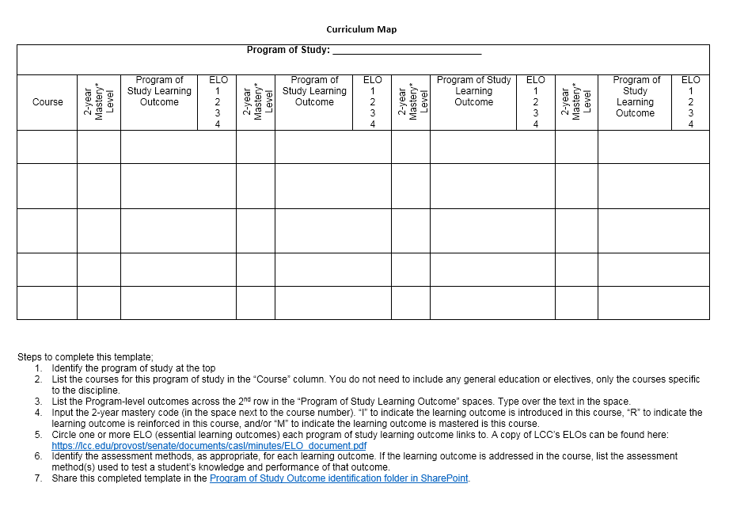

Learning Outcomes Rubric
The Learning Outcomes rubric is used to assess the completeness, quality, and alignment of student learning outcomes. This rubric may be used by faculty to conduct a self-assessment of their learning outcome statements. A blank copy of this template and directions for completing the form may be found on CASL’s web pages.
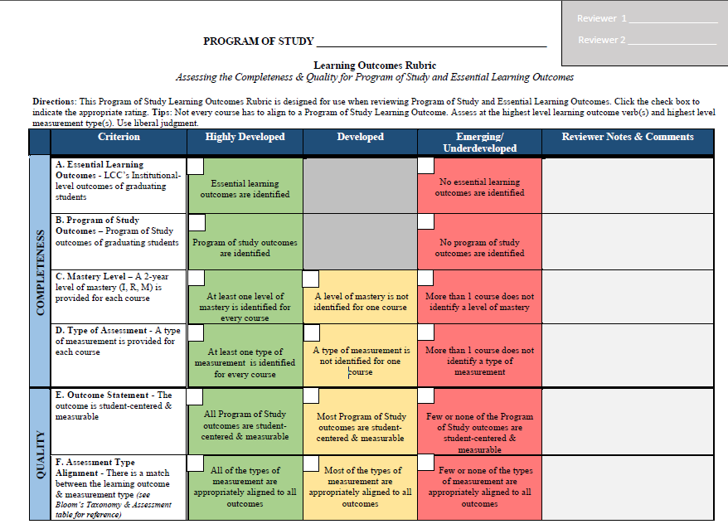

Program-Level Assessment

Program Review Questionnaire
The program review questionnaire lists the questions posed to programs of study for their program review. These questions are reviewed and updated regularly, please check the data packet you receive from the Center for Data Science prior to your program review to be sure you are using the current list of program review questions.
Note: All data referred to below will be provided by the Center for Data Science and the Finance Office, with the exception of student learning assessment data which is generated by the program of study.

- Please describe the purpose of your program, including how it assists students in reaching their goals. Be sure to note the types of students served by your program (e.g., transfer students, students seeking employment, displaced workers, and so on) and the ways in which your program serves employers and/or the community.

Include a description of how your program supports the College’s mission and vision and helps to advance the goals outlined in the College's Strategic Plan/Operation 100%. (Information about the Strategic Plan and Operation 100% can be found in the Strategic Directions tab in myLCC.)

- Explain how your program assists LCC in becoming a national leader among community colleges.

- Review the enrollment and success data for your program. The data provided should allow you to do a thorough analysis. Minimally, you will be expected to provide information on the following:

- any disparate impact related to gender, race, or age;
- general admissions: year-over-year change in declared program of study enrollment compared to overall college enrollment; and
- the programs of study that your program’s courses serve (for example, the Biology Program offering a course for nursing students).

- Regarding student retention (percentage of freshmen who re-enroll the next academic year as sophomores) and persistence (percentage of students progressing toward their goals), please provide information on the following:

- identify any disparate impact related to gender, race, or age; and
- describe and analyze any patterns or anomalies that you notice with respect to these retention and persistence data. In addition;
    - What do you make of these patterns or anomalies?
    - What actions should be taken for continuous improvement?
- compare program-specific information with institutional data.

- Regarding completion data, please provide information on the following:

- identify any disparate impact related to gender, race, or age; and
- describe and analyze any patterns or anomalies that you notice with respect to these completion data. In addition;
    - What do you make of these patterns or anomalies?
    - What actions should be taken for continuous improvement?

- Taking into account program data, as well as factors such as current program faculty areas of expertise, the program's need for specific area expertise, the present and projected needs of business and industry, and the like, please indicate:

- Are there any critical issues in staffing? For example:
  - Is there a need for additional faculty for multiple sections?
  - Are there changes in status for faculty, requiring considerations in section assignments?
  - Are faculty needed to develop/revise/teach new/different courses?
- What concrete, measureable steps/actions need to be taken to strengthen your program?

- Discuss your programs individual courses and programs of study and how they reflect currency and relevance. Provide supporting data. In addition:

- How do teaching strategies change based on course- and program-level assessments? How do faculty stay current within their disciplines? How do faculty stay current in pedagogy?
- Does your program have part-time faculty actively engaged in curriculum and assessment work pertaining to the program?

- Discuss student learning expectations in your program of study, how well students are meeting these learning expectations, and action plans for improving student learning outcomes.
- What are student learning expectations in your program of study? Attach a current curriculum map. Your curriculum map must include:
- Current program-level student learning outcome statements
- Links to one or more Essential Learning Outcomes
- A current list of courses in your program of study
- The methods you use to assess student learning in each course
- How well are students meeting these learning expectations? Select a minimum of one course to collect student learning data and provide the following:
- The time period of data collection
- The number of students assessed during this time period
- The assessment results
- Contact your Director of Assessment, a CASL member, or the Center for Data Science to assist you with responding to this section. Data tools are available and may be customized to help you collect and track student learning data.
- What are your actions plans for improving student learning outcomes?
- How did faculty interpret these student learning assessment results?
- What actions will be taken based on these results?

- How are students recruited and retained in your program?

- Explain how your program's full-time and/or part-time faculty consistently remain current and cutting-edge in their disciplines with respect to their teaching. Examples could include the following:
- Conferences or Continuing Education opportunities
- Publications
- Research
- Sabbatical activities
- Grants and awards
- Training and technology

What percentage of your faculty have engaged in these professional development activities? Provide some examples of how this education is applied in their work?

- What opportunities exist to help your program continue to strengthen and become more competitive?

- The financial worksheet you received outlines various cost components of your program. Based on your analysis of these costs and the associated revenues, should any action be taken for continuous improvement? Please support your answer with a summary of your analysis.

- Does the College provide adequate support for your program (financially, administratively, and so on)? Use relevant, specific examples of support provided and/or refer to critical needs.

- The information requested during this review process is intended to be meaningful and useful for the purpose of continuous improvement for the program. Please prepare workable, yearlong, follow-up improvement plans (use the annual improvement plan template) that will help ensure this ongoing commitment to continuous improvement.
These improvement plans should indicate:
  - specific activities and their reason for being undertaken;
  - the names of persons responsible for overseeing an activity;
  - the nature of the specified deliverables;
  - the necessary resources (money, staff, technology, and the like); and
  - the timelines for completion of the activities.

- Please prepare the Executive Summary as referenced in the Program Review Timeline document.

Annual Improvement Plan
Annual improvement plans are used to document a program of study’s plan for continuous improvements. Using the data from the program review process, programs of study coordinate and plan strategies for program and student learning improvements. A current annual improvement plan template will be included in the data packet sent to you the year of your scheduled program review.
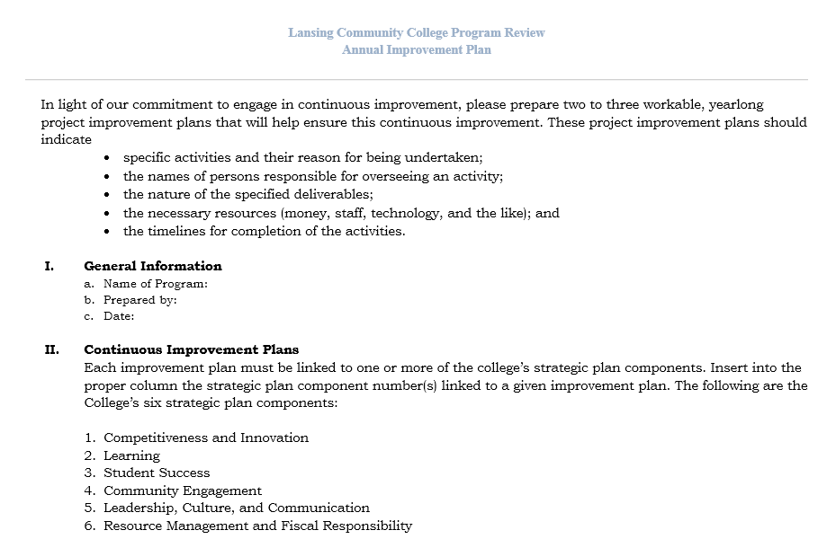
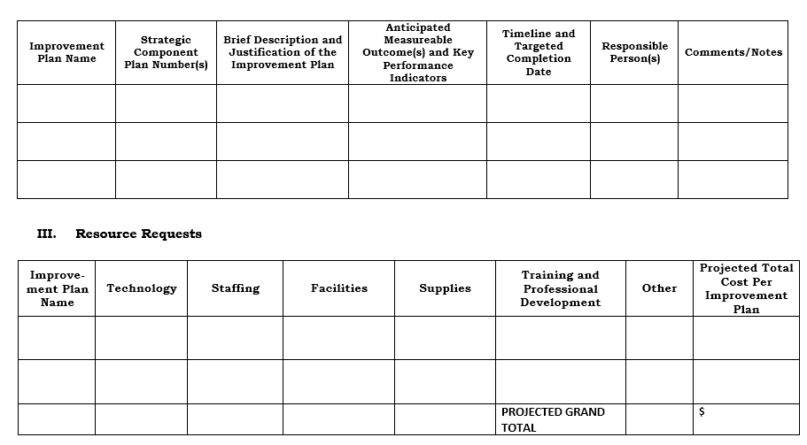

Institutional-Level Assessment

Essential Learning Outcomes Rubrics
The AAC&U provides access to rubrics that may be used to assess our institutional-level student learning outcomes, also called essential learning outcomes, or ELOs. Blank copies of these rubrics are available for download from the CASL web pages or directly from the AAC&U site.

