LCC Assessment Outcomes

2023-2024
This report prepared by:
Karen Hicks, Director of Assessment
Center for Data Science
Summer, 2024

Contents
Executive Summary 3
Essential Learning Outcomes 4
General Education Outcomes Summary 9
Cocurricular Learning Outcomes 15
Assessment Projects 2024-2025 17
Curriculum Mapping 18
Student Learning Assessment Methodologies 19

Executive Summary
Annual student learning evidence is gathered to monitor and respond to how well students are meeting institutional-level student learning goals. The following provides a summary of student learning outcomes for 2023-2024.

Essential Learning Outcomes (ELOs)
LCC adopted the Association of American Colleges & Universities (AAC&U) four essential learning outcomes (ELOs) as institutional student learning outcomes. The ELOs describe how learning in courses, programs, and activities contribute to preparing students for twenty-first-century opportunities and challenges. The AAC&U assembled faculty expert teams to collaboratively develop a set of broad skills and competencies that are applicable to students in over 5,600 colleges and universities. LCC’s Academic Senate adopted these ELOs in 2014 and the Committee for Assessing Student Learning (CASL), a subcommittee of the Academic Senate, contextualized the ELOs for LCC student learning.

To monitor student competency in each ELO, LCC established a target that ≥70% assignments collected have a score of ≥70%. The following summary of ELOs shows the percentage of assignments that had a score of ≥70%.

Summary of ELO 2023-2024 (n=24,543)
ELO 1  Knowledge of Human Cultures and the Physical and Natural World | ELO 2  Intellectual and Practical Skills | ELO 3  Personal and Social Responsibility | ELO 4  Integrative and Applied Learning
76%  (n=5,234) | 84%  (n=8,187 | 82%  (n=4,494) | 80%  (n=6,628)

General Education Outcomes
LCC’s general education program aims to develop knowledge, skills, and abilities that prepare students for advanced academic curricula and with the foundation for lifelong learning. The program is organized in six general education categories.

To monitor student competency in each general education category, LCC established a target that ≥70% assignments collected have a score of ≥70%. The following summary of general education categories shows the percentage of assignments that had a score of ≥70%.

Summary of General Education 2023-2024 (n=18,469)
English Composition | Humanities & Fine Arts | Mathematics | Natural Sciences | Social Sciences
78%  (n=4,121) | 80%  (n=2,853) | 72%  (n=3,206) | 79%  (n=3,947) | 83%  (n=4,342)

MEETS COMPETENCY  ≥70% | DOES NOT MEET COMPETENCY  ≤69%

The following pages provide a detailed view of ELO and general education assessment scores.
Introduction
This report provides institutional-level student learning outcomes (ELOs) for 2023-2024 (n=24,543). The ELOs, or essential learning outcomes, describe how learning in LCC courses, programs, and activities contribute to preparing students for twenty-first-century opportunities and challenges. They are intentionally broad to describe the wide range of learning that occurs across the diverse disciplines. LCC collects student assignments that give students opportunity to demonstrate competency of each ELO. The assignments are scored by faculty to certify competency. LCC’s goal is that at least 70% of those assignments collected scored at least 70%. The following provides a summary and disaggregated views of each ELO.

Essential Learning Outcomes
The ELO summary table below shows the percentage of students that successfully achieved competency by earning a minimum score of 70% on the assignment that assessed the ELO and includes a description of what students must successfully demonstrate to meet each learning outcome.

ELO Summary Table (n=24,543)

76% | Knowledge of Human Cultures and the Physical and Natural World  Students demonstrate competency by engaging with complex, contemporary, and enduring questions of human cultures and the physical and natural world.
84% | Intellectual and Practical Skills  Students demonstrate competency of inquiry and analysis; critical and creative thinking; written and oral communication; quantitative literacy; information literacy; and teamwork and problem solving through extensive and progressively challenging projects, problems, and standards of performance.
82% | Personal and Social Responsibility  Students demonstrate competency of local and global civic knowledge and engagement; intercultural knowledge and competence; ethical reasoning and action; and acquiring foundations and skills for lifelong learning through active involvement with diverse communities and real-world challenges.
80% | Integrative and Applied Learning  Students demonstrate competency of integrating and applying their accumulated learning by applying their knowledge, skills, and responsibilities to new settings and complex problems.

Summary Table ELO 1 Knowledge of Human Cultures & the Physical and Natural World.
ELO 1 | Meet Competency Overall
Knowledge of Human Cultures and the Physical and Natural World  LCC students demonstrate their competency in this ELO by engaging with complex, contemporary, and enduring questions of human cultures and the physical and natural world. | We collected 5,243 assignments that prompted students to demonstrate their competency in this ELO. Assignments included: assessments, exams, and tests. Of those student assignments, 3,985 (76%) scored at least 70%.  76%
Meets Competency by Gender
Analysis by gender shows all gender groupings meet the ≥70% target.

Meets Competency by Ethnicity
Analysis by ethnicity shows one ethnicity groupings does not meet the ≥70% target. Note: Some groupings may have few students which can lead to large year-to-year variances in scores.

Meets  ≥70% | Does Not Meet  <70%

Summary Table ELO 2 Intellectual and Practical Skills
ELO 2 | Meet Competency Overall
Intellectual and Practical Skills  Students demonstrate competency of inquiry and analysis; critical and creative thinking; written and oral communication; quantitative literacy; information literacy; and teamwork and problem solving through extensive and progressively challenging projects, problems, and standards of performance. | We collected assignment scores from 8,187 students that prompted students to demonstrate their competency in this ELO. Of those student assignments, 6,877 (84%) scored at least 70%.  84%
Meets Competency by Gender
Analysis by gender shows all gender groupings exceed ≥70% target.

Meets Competency by Ethnicity
Analysis by gender shows all ethnicity groupings exceed ≥70% target. Note: Some groupings may have small n which can lead to large year-to-year variances in scores.

Meets  ≥70% | Does Not Meet  <70%

Summary Table ELO 3 Personal and Social Responsibility
ELO 3 | Meet Competency Overall
Personal and Social Responsibility  Students demonstrate competency of local and global civic knowledge and engagement; intercultural knowledge and competence; ethical reasoning and action; and acquiring foundations and skills for lifelong learning through active involvement with diverse communities and real-world challenges. | We collected scores from 4,494 student assignments that prompted students to demonstrate their competency in this ELO. Of those assignments, 3,685 (82%) scored at least 70%.  82%
Meets Competency by Gender
Analysis by gender shows all gender groupings exceed ≥70% target.

Meets Competency by Ethnicity
Analysis by gender shows all ethnicity groupings exceed ≥70% target. Note: Some groupings may have small n which can lead to large year-to-year variances in scores.

Meets  ≥70% | Does Not Meet  <70%

Summary Table ELO 4 Integrative and Applied Learning
ELO 4 | Meet Competency Overall
Integrative and Applied Learning  Students demonstrate competency of integrating and applying their accumulated learning by applying their knowledge, skills, and responsibilities to new settings and complex problems. | We collected scores from 6,628 student assignments that prompted students to demonstrate their competency in this ELO. Of those assignments 5,302 (80%) scored at least 70%.  80%
Meets Competency by Gender
Analysis by gender shows all gender groupings exceed ≥70% target.

Meets Competency by Ethnicity
Analysis by gender shows two ethnicity groupings do not meet the ≥70% target. Note: Some groupings may have small n which can lead to large year-to-year variances in scores.

Meets  ≥70% | Does Not Meet  <70%

General Education Outcomes Summary

LCC’s general education program is organized into six categories. This page reflects a summary of the overall percentage of assessments that met the ≥70% minimum target assessment score for the six categories during the 2022-2023 academic year (n=18,469). The following pages show a detailed view of each general education category.

All General Education Categories
General Education Summary Table (n=18,469)

Summary Table English Composition + English (2nd Course)/ Communication
General Education Category | Meet Competency Overall
English Composition + English (2nd Course)/ Communication  We collected scores from 4,121 student assessments, final papers, tests, and exams that prompted students to demonstrate their competency in this general education category. The average score of 78% meets the ≥70% target. | Students demonstrate competency of  English Composition  78%
Meets Competency by Gender
Analysis by gender shows all gender groupings meet the ≥70% target.

Meets Competency by Ethnicity
Analysis by ethnicity shows two ethnicity groupings do not meet the ≥70% target. Note: Some groupings may have small n which can lead to large year-to-year variances in scores.

Meets  ≥70% | Does Not Meet  <70%

Summary Table Humanities and Fine Arts
General Education Category | Meet Competency Overall
Humanities and Fine Arts  We collected scores from 2,853 student assessments, tests, and exams that prompted students to demonstrate their competency in this general education category. The average score of 80% meets the ≥70% target. | Students demonstrate competency of Humanities and Fine Arts  80%
Meets Competency by Gender
Analysis by gender shows all gender groupings meet the ≥70% target.

Meets Competency by Ethnicity
Analysis by ethnicity shows one ethnicity groupings does not meet the ≥70% target. Note: Some groupings may have small n which can lead to large year-to-year variances in scores.

Meets  ≥70% | Does Not Meet  <70%

Summary Table Mathematics
General Education Category | Meet Competency Overall
Mathematics  We collected scores from 3,206 student assessments, tests, and exams that prompted students to demonstrate their competency in this general education category. The average score of 72% meets the ≥70% target. | Students demonstrate competency of Mathematics  72%
Meets Competency by Gender
Analysis by gender shows one gender groupings does not meet the ≥70% target.

Meets Competency by Ethnicity
Analysis by ethnicity shows three ethnicity groupings do not meet the ≥70% target. Note: Some groupings may have small n which can lead to large year-to-year variances in scores.

Meets  ≥70% | Does Not Meet  <70%

Summary Table Natural Sciences
General Education Category | Meet Competency Overall
Natural Sciences  We collected scores from 3,947 student assessments, tests, and exams that prompted students to demonstrate their competency in this general education category. The average score of 79% meets the ≥70% target. | Students demonstrate competency of Natural Sciences  79%
Meets Competency by Gender
Analysis by gender shows all gender groupings meet the ≥70% target.

Meets Competency by Ethnicity
Analysis by ethnicity shows one ethnicity groupings does not meet the ≥70% target. Note: Some groupings may have small n which can lead to large year-to-year variances in scores.

Meets  ≥70% | Does Not Meet  <70%

Summary Table Social Sciences
General Education Category | Meet Competency Overall
Social Sciences  We collected scores from 4,342 student assessments, tests, and exams that prompted students to demonstrate their competency in this general education category. The average score of 83% meets the ≥70% target. | Students demonstrate competency of Social Sciences  83%
Meets Competency by Gender
Analysis by gender shows all gender groupings meet the ≥70% target.

Meets Competency by Ethnicity
Analysis by ethnicity shows one ethnicity groupings does not meet the ≥70% target. Note: Some groupings may have small n which can lead to large year-to-year variances in scores.

Meets  ≥70% | Does Not Meet  <70%

Cocurricular Learning Outcomes
Cocurricular learning programs and activities are integrated with academic courses through curriculum mapping processes. Reference the Cocurricular tab on the Committee for Assessing Student Learning webpages for the cocurricular assessment handbook and instructional design and planning materials.

Office of Empowerment
The Office of Empowerment (OE, formerly Office of Diversity and Inclusion) “empowers students with knowledge and experiences that promote global citizenship and a more inclusive campus.” Learning programs and activities are designed, delivered, and assessed by OE faculty, staff, and administrators every semester. Student learning scores are collected from every course attended by students participating in ACCESS, LUCEO, MAP, or WISE each semester.

The average score for all student learning scores is summarized below. The n= the number of assignments included in the analysis.

We then examine the assignments to determine any differences in average scores, as in the example below for LUCERO.
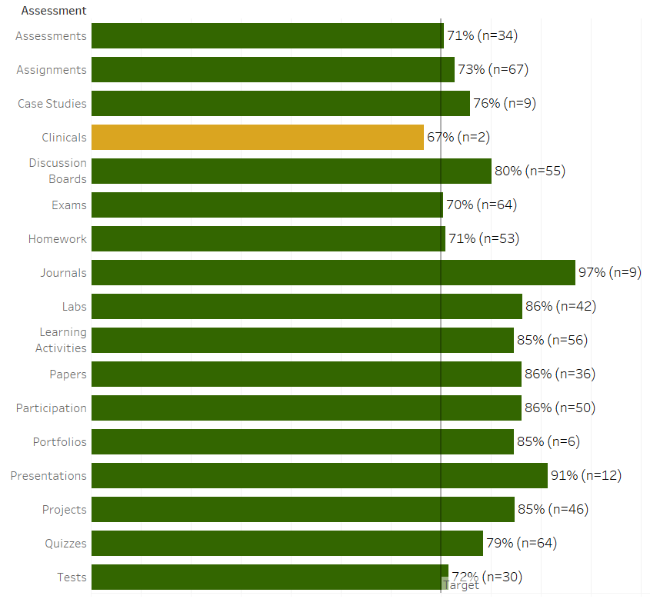
Athletics
The Athletics cocurricular participation supports student success on the field and in the classroom with alignment to institutional level learning outcomes of integrative and applied learning. Scores from assignments such as student learning activities and assessments of LCC student athletes are collected each semester. The average score of the assignments included in the analysis is summarized below by athletic program.

Additional analysis is conducted including the types of assignments and disaggregating of outcomes by student demographics. Below is a summary example showing the types of assignments by athletic program.
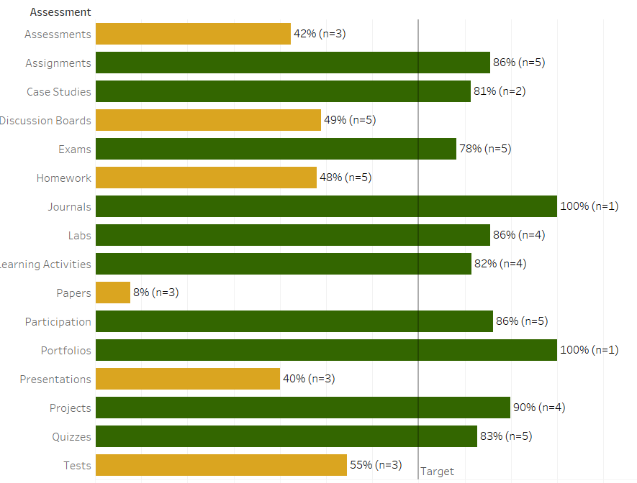

Cocurricular Inclusion List
Additional cocurricular reporting is available for English Composition I (ENGL121) and the Library integration of information literacy learning outcomes and the Cardio exercise and student success program that aligns to lifelong learning and integrated learning outcomes. Inclusion of cocurricular assessment highlighted the opportunity to enhance institutional level student learning outcome categories and statements in the next essential learning outcomes review (2024-2025).

Assessment Projects 2024-2025
The assessment scorecard below shows the alignment and measurement of LCC’s assessment progress. Assessment work is aligned to the HLC assessment criteria and LCC’s strategic plan. This ensures assessment objectives and activities are intentional and focused toward shared goals. Assessment objectives are defined to track ongoing progress, or deviation, toward these shared goals.

HLC Criteria & LCC Strategic Plan | LCC Assessment  Goals & Objectives | Indicator (Data) |  | Target | Projects
4.B.1. The institution has clearly stated goals for student learning and effective processes for assessment of student learning and achievement of learning goals | Goal 1 Quality learning design
 | - 100% LCC courses learning outcome statement rate as *meeting quality expectations | Learning outcomes quality rating |  | 100% | Curriculum Mapping project  *Quality rubric
 | - ≥25% programs of study have documented outcome to method alignment by August 2025 | Outcome alignment: ELO --> PLO --> CLO |  | ≥25% | Curriculum Mapping project  *Quality rubric
 | - 100% LCC course sections align assessment category weighting to course syllabus | Course alignment |  | 100% | Curriculum Mapping project  *Quality rubric
4.B.2. The institution assesses achievement of the learning outcomes that it claims for its curricular and co-curricular programs. | Goal 2 Systemic assessment design
 | - 100% general education courses have active assessment plans | Course alignment |  | 100% | Curriculum Mapping project
 | - 100% cocurricular inclusion list have active assessment plans by August 2025. | Cocurricular to curricular alignment |  | 100% | Curriculum Mapping project
 | - 100% programs of study align all levels of learning outcomes (ELO, PLO, CLO) | Program review learning outcomes rating |  | 100% | Program Curriculum Mapping
4.B.3. The institution uses the information gained from assessment to improve student learning | Goal 3 Learning as early alert to institutional metrics
 | - Analyze general education student learning assessment by demographics. |  | Equity gaps identified annually | 100% | GenEd Student Learning Assessment
4.B.4. The institution’s processes and methodologies to assess student learning reflect good practice including substantial participation of faculty | Goal 4 Collaborative instructional design and community learning
 | - Emphasize collaboration and teamwork with faculty through design experimentation and data agreements. |  | # Active designs | 100% | AC Program

Curriculum Mapping
Curriculum mapping is an instructional design process of connecting the course assignments with the course learning outcomes. This intentional connection shows the intentional selection of coursework and how that work facilitates learning and the successful achievement of learning outcomes.

Curriculum mapping processes are completed in three steps:
Step 1: A review of learning outcomes
Step 2: A review of course assignments
Step 3: Linking learning outcomes with course assignments in D2L

See below for an example of a general education course curriculum map that includes alignment of course learning outcomes, course units, unit sections, and test questions.

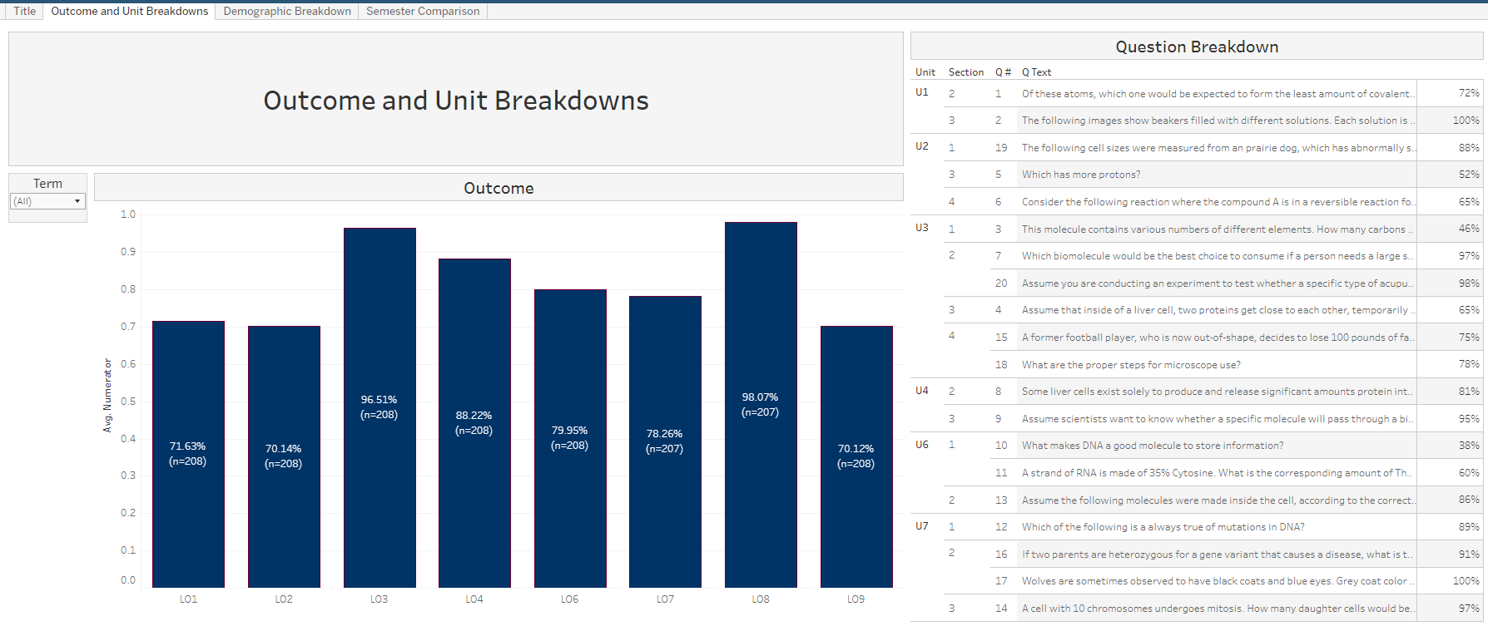

Course mapping that is designed through the Assessment Coordinator program includes learning outcomes analyzed by student demographics. An example of student average score by test question disaggregated by ethnicity is shown below.

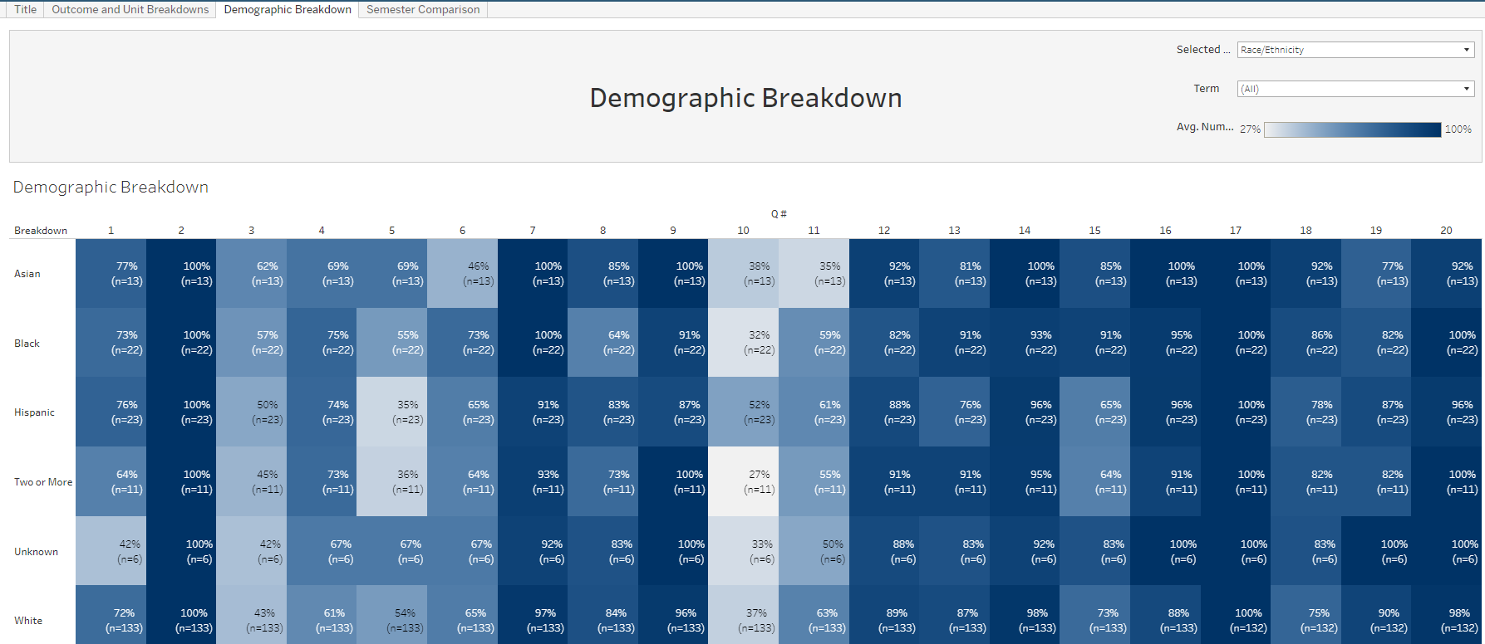

Student Learning Assessment Methodologies
The table below describes the methodology applied for each assessment group in this report.
Assessment | Description | What Data is Collected | How the Data is Collected | How Data is Analyzed
LCC Key Assessment Metrics | A set of college-wide metrics used to assess the health and progress of LCC’s system of student learning assessment | - Program of study student learning outcome statements  - Assessment methods used to assess student learning  - Plans for ongoing student learning assessment within curriculums | - Program Review process  - Requests for changes to courses or curriculums | - Percentage of outcomes to criteria
Essential Learning Outcomes (ELOs) | College-wide student learning outcomes | Student assessment scores | - Grades are pulled from gradebooks during summer for previous spring and fall semesters  - Curriculum maps (stored in SharePoint and updated every 4 years during Program Review) identify methods  - Inclusion determined by ELO rotation | - Percentage of student scores ≥70%  - HS results excluded  - Zeros excluded
General Education | Students assessed in General Education and General Education- applied courses | Student assessment scores | - Grades are pulled from gradebooks during summer for previous spring and fall semesters  - Curriculum maps (stored in SharePoint and updated every 4 years during Program Review) identify methods  - Inclusion determined by general education course list | - Percentage of student scores ≥70%  - Top 10 by # of assessments  - HS results excluded  - Zeros excluded
Co-Curricular | Students assessed in Co-curricular programs and courses | Student assessment scores | - Leadership Academy: gradebooks  - Library: ENGL121 assessment process in D2L  - Cardio: student questionnaire | - Pass rate= percentage of student scores ≥70%  - Satisfaction= percentage liked activity
Lansing Community College is committed to providing equal employment opportunities and equal education for all persons regardless of race, color, sex, age, religion, national origin, creed, ancestry, height, weight, sexual orientation, gender identity, gender expression, disability, familial status, marital status, military status, veteran's status, or other status as protected by law, or genetic information that is unrelated to the person's ability to perform the duties of a particular job or position or that is unrelated to the person's ability to participate in educational programs, courses services or activities offered by the college.

The following individuals have been designated to handle inquiries regarding the nondiscrimination policies: Equal Opportunity Officer, Washington Court Place, 309 N. Washington Square Lansing, MI 48933, 517-483-1730; Employee Coordinator 504/ADA, Administration Building, 610 N. Capitol Ave. Lansing, MI 48933, 517-483-1875; Student Coordinator 504/ADA, Gannon Building, 411 N. Grand Ave. Lansing, MI 48933, 517-483-1885; Human Resource Manager/Employee Title IX Coordinator, Administration Building, 610 N. Capitol Ave. Lansing, MI 48933, 517-483-1879; Student Title IX Coordinator, Gannon Building, 411 N. Grand Ave. Lansing, MI 48933, 517-483-9632.

