LCC Assessment Results
  - 2015-2018
Prepared By: Karen Hicks, Director of Assessment
Under the direction of the Committee for Assessing Student Learning (CASL)
Last updated 08/2018
ADA update for accessibility 06/2019
Table of Contents
Executive Summary 1
Assessment Scorecard 2
LCC Assessment Results 3
Institutional-Level Assessment Results 3
Program-Level Assessment Results 5
Assessment Plan Measurement Strategy 12
References 13

Executive Summary

This report describes Lansing Community College (LCC) student learning outcomes assessment results for the 2015-2018 academic years. This reporting period captures data collected during the fall 2015 through spring 2018 semesters in alignment with the three-year assessment plan (2015-2018). Comparisons are offered to show progress and areas of improvement for this three period.
During the 2015-2018 assessment reporting periods, programs of study were asked to report program-level learning outcomes, methods of assessment, and connections from program-level learning outcomes to a common set of institutional learning outcomes. This evidence was analyzed by the Center for Data Science (CDS) with oversight of the Committee for Assessing Student Learning (CASL) to gain insight into:
- How we align program curriculums to a common set of institutional learning outcomes
- What we expect our students to learn and to what degree
- How we assess our students’ learning throughout a curriculum
- How well those assessment methods are aligned to our learning expectations
A summary of the assessment results follows:
Result 1: 93% of LCC Programs of Study report curriculum alignment to a common set of institutional student learning outcomes. An increase of 15% from 2015 to 2018 reporting periods and 8% higher than the AAC&U benchmark of 85%.
Result 2: 98% of LCC Programs of Study report program-level learning outcome statements for associate-level awards. An increase of 11% from 2015 to 2018 reporting periods and 10% higher than the AAC&U benchmark of 87%.
Result 3: Over half (59%) of program-level student learning outcomes require students to use moderate-level cognitive skills, with the greatest emphasis on applying or transferring learning from the classroom to other contexts. An increase of 9% from 2015 to 2018 reporting periods.
Result 4: 90% Programs of Study report one or more methods of assessment for each student learning outcome statement. An increase of 5% from 2015 to 2018 reporting periods and 5% higher than the AAC&U benchmark of 85%.
Result 5: 95% of identified assessment methods selected by LCC faculty are aligned to the Program of Study learning outcome statement. An increase of 15% from 2015 to 2018 reporting periods.
Result 6: Less than half (40% for 2017 and 41% for 2018) programs of study present documented plans for collecting, compiling, analyzing, and using student learning outcome evidence at program review. This measure was introduced during the 2016-2017 academic year and is discussed further in this report (page 11).

Assessment Scorecard

The assessment scorecard shows results by the percentage that met the target and by color coding those results for a quick view of the current status. The targets are established through benchmarks of AAC&U member institutions. The green represents results at or above the target. The yellow represents results that fall within ten percentage points below the target. These results are within range of the target, and are monitored for improvement. The red represents results that fall eleven or more percentage points below the target. These results are outside the range of the target and may require priority improvement.
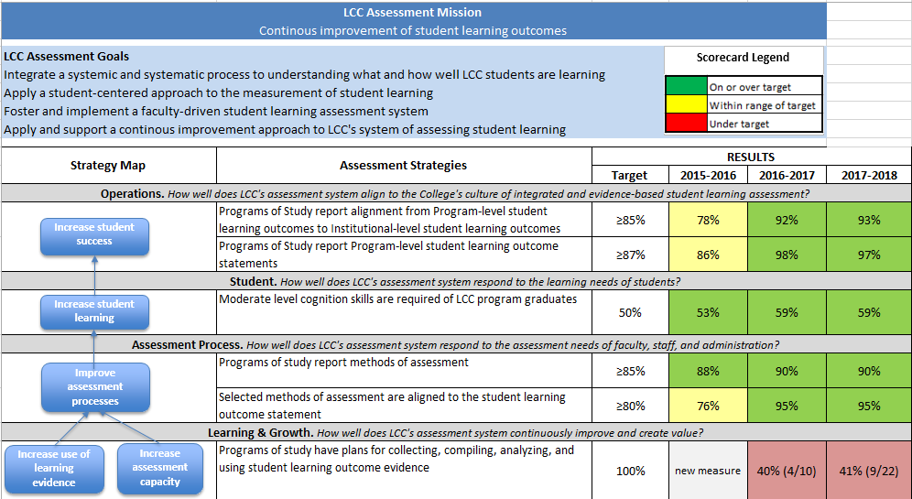

Performance Targets and Ranges Legend
Assessment Metric | Target | Green | Yellow | Red
ELO Reported | 85% | ≥85% | 75% - 84% | ≤74%
PROS Reported | 87% | ≥87% | 77% - 86% | ≤76%
Cognitive Skill Level | 50% | ≥50% | 40% - 49% | ≤39%
Assessment Method Reported | 87% | ≥87% | 77% - 86% | ≤76%
Aligned Assessment Method | 80% | ≥80% | 70% - 79% | ≤69%

LCC Assessment Results

Institutional-Level Assessment Results

Result 1: 93% of LCC Programs of Study report curriculum alignment to a common set of institutional student learning outcomes. An increase of 15% from 2015 to 2018 reporting periods and 8% higher than the AAC&U benchmark of 85%.
LCC adopted the Association of American Colleges & Universities (AAC&U) four essential learning outcomes (ELOs) as institutional outcomes. ELOs describe LCC’s shared outcomes of student learning with 92% of our Programs of Study identifying how they uniquely contribute to preparing students for twenty-first-century challenges. Our result is currently above a benchmark of 85% of AAC&U member institutions that report “a common set of intended learning outcomes for all undergraduate students” (AAC&U, 2016).
DIVISION | AAC&U Member Institutions | LCC Programs of Study Reporting Links to ELOs
DIVISION | AAC&U Member Institutions | 2015-2016 | 2016-2017 | 2017-2018
LCC OVERALL | $≥$ 85% | 78% | 92% | 93%
Arts & Sciences | $≥$ 85% | 65% | 87% | 87%
Technical Careers | $≥$ 85% | 100% | 100% | 100%
Health & Human Services | $≥$ 85% | 92% | 92% | 100%

Performance Target and Range Legend
Assessment Metric | Target | Green | Yellow | Red
ELO Reported | 85% | ≥85% | 75% - 84% | ≤74%

The four essential, or institutional-level, student learning outcomes LCC adopted from the AAC&U include:
Essential Learning Outcome 1: Knowledge of human cultures and the physical and natural world
Essential Learning Outcome 2: Intellectual and practical skills, including:
- Inquiry and analysis
- Critical and creative thinking
- Written and oral communication
- Quantitative literacy
- Information literacy
- Teamwork and problem solving
Essential Learning Outcome 3: Personal and social responsibility, including:
- Civic knowledge and engagement – local and global
- Intercultural knowledge and competence
- Ethical reasoning and action
- Foundations and skills for lifelong learning
Essential Learning Outcome 4: Integrative and applied learning

Programs of study are required to address each of the four institutional-level student learning outcomes across their curriculums.
78% programs of study address ELO 1
96% programs of study address ELO 2
87% programs of study address ELO 3
98% programs of study address ELO 4

Program-Level Assessment Results

Result 2: 98% of LCC Programs of Study report program-level learning outcome statements for associate-level awards. An increase of 11% from 2015 to 2018 reporting periods and 10% higher than the AAC&U benchmark of 87%.
Program-level learning outcome statements define what we expect students to achieve in the Program of Study by defining what LCC students can be expected to know, do, or be like upon successful completion.
Results reflect the analysis of the number of Programs of Study that offer associate-level awards divided by the number of Programs of Study reporting program-level student learning outcome statements.
DIVISION | AAC&U Member Institutions | LCC Programs of Study Reporting Links to ELOs
DIVISION | AAC&U Member Institutions | 2015-2016 | 2016-2017 | 2017-2018
LCC OVERALL | $≥$ 87% | 86% | 98% | 97%
Arts & Sciences | $≥$ 87% | 77% | 96% | 94%
Technical Careers | $≥$ 87% | 100% | 100% | 100%
Health & Human Services | $≥$ 87% | 100% | 100% | 100%

Performance Target and Range Legend
Assessment Metric | Target | Green | Yellow | Red
PROS Reported | 87% | ≥87% | 77% - 86% | ≤76%

Result 3: Over half (59%) of program-level student learning outcomes require students to use moderate-level cognitive skills, with the greatest emphasis on applying or transferring learning from the classroom to other contexts. An increase of 9% from 2015 to 2018 reporting periods.
Each reported learning outcome was analyzed to demonstrate the learning expectations of LCC students as defined by faculty. Bloom’s Taxonomy was used to classify the level of cognition identified for each outcome.
Cognitive Skills Required of LCC Students

Moderate Level Cognition = 59%

Lower Cognitive Skill Levels |  |  | Higher Cognitive Skill Levels
Knowledge | Comprehension | Application | Analysis | Synthesis | Evaluation
12% | 9% | 47% | 12% | 12% | 8%
68% |  |  | 32%

Performance Target and Range Legend
Assessment Metric | Target | Green | Yellow | Red
Cognitive Skill Level | 50% | ≥50% | 40% - 49% | ≤39%
Result 4: 90% Programs of Study report one or more methods of assessment for each student learning outcome statement. An increase of 5% from 2015 to 2018 reporting periods and 5% higher than the AAC&U benchmark of 85%.
An assessment method is required for each program-level student learning outcome statement. Analysis was performed by dividing the total number of program-level student learning outcome statements with assessment methods identified for each.

DIVISION | AAC&U Member Institutions | LCC Programs of Study Reporting Links to ELOs
DIVISION | AAC&U Member Institutions | 2015-2016 | 2016-2017 | 2017-2018
LCC OVERALL | $≥$ 87% | 88% | 90% | 90%
Arts & Sciences | $≥$ 87% | 84% | 88% | 88%
Technical Careers | $≥$ 87% | 100% | 100% | 100%
Health & Human Services | $≥$ 87% | 100% | 95% | 100%

Performance Target and Range Legend
Assessment Metric | Target | Green | Yellow | Red
Assessment Method Reported | 87% | ≥87% | 77% - 86% | ≤76%

Result 5: 95% of identified assessment methods selected by LCC faculty are aligned to the Program of Study learning outcome statement. An increase of 15% from 2015 to 2018 reporting periods.
The majority of the assessment methods selected by faculty are aligned to the learning outcome statements. This may be interpreted as the selected type of assessment is matched to the learning expectations of students. Research demonstrates when there is an alignment between the learning outcome and the assessment method, students show evidence of deeper learning and an increase in skill development. Likewise, when students perceive this alignment, they perceive their learning to be more authentic (Gulikers, et al., 2006).
Each cognitive level and assessment type of was analyzed to determine the match (or alignment) rate. The match rate is determined by analyzing the possible number of learning outcome statements divided by the number of identified and aligned assessment methods. The highest cognition level and highest assessment method was used in the analysis. The following table shows the percentage of match by Division and for LCC total.
DIVISION | AAC&U Member Institutions | LCC Programs of Study Reporting Links to ELOs
DIVISION | AAC&U Member Institutions | 2015-2016 | 2016-2017 | 2017-2018
LCC OVERALL | $≥$ 87% | 76% | 95% | 95%
Arts & Sciences | $≥$ 87% | 69% | 92% | 92%
Technical Careers | $≥$ 87% | 100% | 100% | 100%
Health & Human Services | $≥$ 87% | 95% | 100% | 100%

Performance Target and Range Legend
Assessment Metric | Target | Green | Yellow | Red
Aligned Assessment Method | 80% | ≥80% | 70% - 79% | ≤69%

The following pie chart shows the methods of assessment that are used across the curriculums by LCC faculty and the percentage of use for each method of assessment.

Types and Percentage of Use of LCC Assessment Methods
*Other assessment methods include: Demonstration, Jury, Internship, Presentation, Case Study, Group/Role Play, and Observation
Top Assessment Method(s) by Division
Arts & Sciences | Technical Careers | Health & Human Services
Project (37%) | Capstone (100%) | Clinical Evaluation (29%)
Exam/Quiz/Test (20%) |  | Demonstration (20%)
Portfolio (10%) |  | Lab (10%)

Analysis was then conducted to determine the percentage of assessment methods that are performance-based, compared to those than are non-performance-based. Results are presented in the table below.
Use of Performance-Based Assessment by Division
DIVISION | % Performance-Based Assessment | % Non-Performance-Based Assessment | LCC Total
Arts & Sciences | 80% | 20% | 83%  Performance-Based Assessment
Technical Careers | 100% | 0% | 83%  Performance-Based Assessment
Health & Human Services | 93% | 7% | 83%  Performance-Based Assessment

Authentic, or performance-based assessments, require students to be active participants in their learning by demonstrating knowledge, skills, abilities, and learning processes. Some examples of how LCC faculty may use performance-based testing in the classroom include:
- Projects that enable the use of critical thinking, problem solving, and decision-making skills
- Capstones to assess the students’ achievement of program-level learning outcomes
- Collections of students’ work and demonstrate learning progression throughout the curriculum
- Demonstrations that give students the opportunity to show their mastery of the learning content

Result 6: Less than half (40% for 2017 and 41% for 2018) programs of study present documented plans for collecting, compiling, analyzing, and using student learning outcome evidence at program review. This measure was introduced during the 2016-2017 academic year.
During the 2016-2017 academic year, the metric “programs of study have plans for collecting, compiling, analyzing, and using student learning outcome evidence” was added to the assessment scorecard. During the 2015-2016 academic year, four of the ten programs of study that participated in program review met the metric. During the 2016-2017 academic year, five of the eleven programs of study met the metric. Combined, nine of the 22 (or 41%) programs of study met the metric over the two year period.
Results one through six of this assessment report demonstrate strong outcome statements and the use of aligned assessment methods. They do not, however, capture plans for how programs of study design, implement, or use assessment results to inform instructional design or delivery decisions. The new metric is used during the program review process where programs of study share their plans for collecting, compiling, analyzing, and using student learning evidence. Programs of study are made aware of the expectation through program review kick off meetings and with changes to the program review questionnaire that more explicitly state this expectation. Consultations are offered to every program of study prior to program review to work directly with the Center for Data Science, the Director of Assessment, and/or the Committee for Assessing Student Learning to design, develop, and implement assessment plans and use student learning assessment data so that meaningful and useful student learning data may be continuously generated and used to improve student learning outcomes.

Assessment Plan Measurement Strategy
CASL: Committee for Assessing Student Learning CDS: Center for Data Science CC: Curriculum Committee CTE: Center for Teaching Excellence
Measures | Sources | Methods | Analysis
OPERATIONS
% Programs of Study report alignment from Program-level student learning outcomes to Institutional-level student learning outcomes | CASL, Faculty, Staff, Administration | ELO Template | # Programs of Study/# Programs of Study reporting alignment to ELOs
% Programs of Study report Program-level student learning outcome statements | CASL, Faculty, Staff, Administration | Program of Study Learning Outcomes Template | # Programs of Study/# Programs of Study reporting learning outcomes
STUDENT
% Cognitive level of student learning outcome statement | CASL, Faculty, Staff, Administration | Program of Study Learning Outcomes Rubric | Bloom’s Cognitive level/# of learning outcomes; Aligned with Program Review cycles
ASSESSMENT PROCESSES
% Programs of Study report assessment methods | CASL, Faculty, Staff, Administration | Program of Study Learning Outcomes Template | # Reported Programs of Study learning outcomes/# Programs of Study reporting learning assessment methods
% Selected methods of assessment aligned to student learning outcome statement | CASL, Faculty, Staff, Administration | Program of Study Learning Outcomes Rubric | Bloom’s cognitive level/# assessment method alignment matches
LEARNING & GROWTH
% Program of Study plans for collecting, compiling, analyzing, and using student learning evidence | CDS, CASL, Faculty, Staff, Administration | Focus Groups; Data Collection Worksheet; Annual Improvement Plan Template; Program review meeting | # Program of Study/# Programs of Study assessment plans; Aligned with Program Review cycles

References

Association of American Colleges & Universities (2008). College learning for the new global century. National Leadership Council for Liberal Education & America’s Promise: Washington, DC.
Association of American Colleges & Universities (2016). Trends in learning outcomes assessment: Hart Research Associates.
Gulikers, J. T. M., Bastiaens, Th. J., Kirschner, P. A., & Kester, L. (2006). Relations between student perceptions of assessment authenticity, study approaches and learning outcome. Studies in Educational Evaluation, 32 , 381-400

