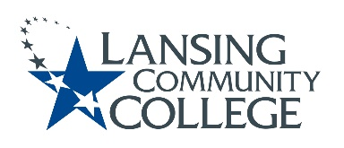

AGENDA: Committee for Assessing Student Learning
Friday, December 2, 2022, 12:30 – 2pm, via Webex
- Approval of the 12/02/22 Agenda
- Approval of the 11/18/22 Minutes
- CTE PA Days – Thursday January 5, 2023
  - Idea to present: Assessment methods and standardizing assignment name entry in D2L
    - Panel, people give examples of what they use – volunteers requested
      - Set up follow up meeting in December to go over with panel members
    - Potential title: Methods of learning about student learning
- CASL Senate Presentation – format for 1/13/22
  - Work through small group discussion questions
  - CASL members that are available to facilitate a small group discussion on the 13th
- Professional Development and Collaboration Opportunities follow-up
  - Discussion of CASL members shared ideas
    - Collected by Tim between meetings
  - Beginning discussions with CTE
- Future agenda items
  - Possible anonymous survey of Senate members
- Adjourn
- Next meeting Friday January 13, 2023 from 12:30 – 2pm, via Webex

Lansing Community College is an equal opportunity, educational institution/employer.

