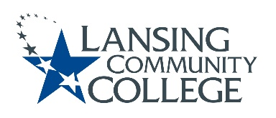

AGENDA: Committee for Assessing Student Learning
Friday, February 10, 2023, 12:30 – 2pm, via Webex
- Approval of the 2/10/23 Agenda
- Approval of the 1/27/23 Minutes
- HLC tasks: Co-curricular Assessment Handbook & Co-curricular Student Catalog
  - Karen to discuss the handbook draft work
  - Discussion of Student Catalog/website continued
  - Subcommittees formed as needed to proceed with work
- CASL Assessment webpage.
  - Adding Assessment Coordinator tab on existing CASL web pages
  - Assessment Coordinator Purpose Support – subcommittee development
  - Adding an assessment reference area
- ChatGPT implications for assessment.
- Future agenda items
  - D2L – assessment capabilities that exist and potential expansion areas/budget needed
  - Assessment verses grades, CASL and Curriculum Committee discussions
  - Reexamine CASL Charter
- Adjourn
- Next meeting Friday February 10, 2023 from 12:30 – 2pm, via Webex

Lansing Community College is an equal opportunity, educational institution/employer.

