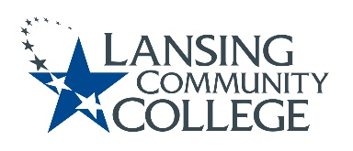

AGENDA: Committee for Assessing Student Learning
Friday, November 18, 2022, 12:30 – 2pm, via Webex
- Approval of the 11/18/22 Agenda
- Approval of the 11/4/22 Minutes
- CASL vision and feedback – Tim
- Possible anonymous survey of Senate members
- Professional Development and Collaboration Opportunities follow-up
  - Member idea sharing (whiteboard)
  - Organize list and develop plan
- HLC Quality Initiative: Co-curricular assessment plan update – Karen
- Adjourn
- Next meeting Friday December 2, 2022 from 12:30 – 2pm, via Webex

Lansing Community College is an equal opportunity, educational institution/employer.

