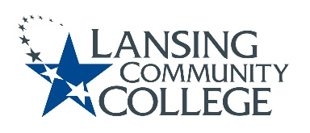

AGENDA: Committee for Assessing Student Learning
Friday, November 4, 2022, 12:30 – 2pm, via Webex
- Approval of the 11/4/22 Agenda
- Approval of the 9/23/22 Minutes
- Professional Development and Collaboration Opportunity, Karen
  - Student Learning Assessment in Michigan (SLAM) Consortium Event
  - OCC Leads Higher Education Student Assessment Consortium in Michigan
- Annual Assessment Outcomes report – Senate Response update & action planning, CASL Members
  - Recap Senate Group Notes
  - Prepare for future Senate presentation/discussion
  - How do CASL members see their role as assessment facilitators?
    - What are ways CASL can be more involved during Senate meetings?
- Adjourn
- Next meeting Friday November 18, 2022 from 12:30 – 2pm, via Webex

Lansing Community College is an equal opportunity, educational institution/employer.

