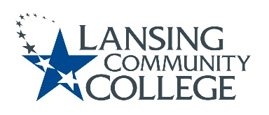

AGENDA: Committee for Assessing Student Learning
Friday, January 27, 2023, 12:30 – 2pm, via Webex
- Approval of the 1/27/23 Agenda
- Approval of the 1/13/23 Minutes
- Gradebook Alignment Resolution
- HLC tasks: Co-curricular Assessment Handbook & Co-curricular Student Catalogue
- Future agenda items
  - Assessment Coordinator Purpose Support
  - Reexamine CASL Charter
  - Potential website or other assessment reference area creation
  - Other ways to engage with Senate
- Adjourn
- Next meeting Friday February 10, 2023 from 12:30 – 2pm, via Webex

Lansing Community College is an equal opportunity, educational institution/employer.

