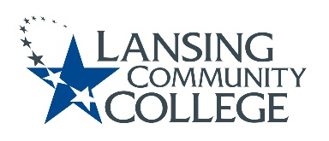

AGENDA: Committee for Assessing Student Learning
Friday, January 13, 2023, 12:30 – 2pm, via Webex
- Approval of the 1/13/23 Agenda
- Approval of the 12/02/22 Minutes
- Debrief CTE PA Days – Thursday January 5, 2023
- Discuss how CASL engages with Senate in future?
  - Do we want to be more active with Senate as a committee?
    - If yes what are our goals with that activity?
  - Possible college-wide research project?
  - ELO discussion follow-up
  - What does CASL need from Senate?
- Question to group: Does CASL want to create a CTE Spring 2023 Workshop?
  - Perhaps a subcommittee could be formed to apply and create workshop over an assessment topic they feel strongly about?
  - Submission deadline: Friday, February 3, 2023
    - Link for Workshop found in latest STAR Newsletter
- Professional Development and Collaboration Opportunities follow-up
  - From previous agenda, discussion of CASL members shared ideas
  - Beginning discussions with other campus partners such as CTE and eLearning?
  - Possible Dynamic CASL Website?
- Future agenda items
  - Possible anonymous survey of Senate members
- Adjourn
- Next meeting Friday January 27, 2023 from 12:30 – 2pm, via Webex

Lansing Community College is an equal opportunity, educational institution/employer.

