Committee for Assessing Student Learning (CASL) - Notes
Meeting Held Friday, September 24, 2021, from 12:30 – 2pm – via Webex

Team Members:

Present:
Timothy Deines, Heidi Jordan, Lyndia Klasko, Mark Kelland, Mark Khol, Zack Macomber, Rob McLoone, Dale Moler, Tracy Nothnagel, Chuck Page, and Danielle Savory.

Absent:
Patti Ayers, Dana Cogswell, Sandra Etherly-Johnson, Karen Hicks, Rafeeq McGiveron, and Kara Wiedman.

Guest:
Cheryl Garayta

Action Items:
- Terri to check and see if LCC has a preference between committees using workplaces or SharePoint for their shared information storage.
- Tim and Karen meet to discuss next steps of breakout sessions before next CASL meeting.
- Breakout groups requested to let Tim and Karen know of any informational needs they have as they occur – don’t need to wait until a CASL meeting to reach out.

Approval of 9/24/21 Agenda
- Call for approval of agenda.
- Hearing no objections, the agenda stands approved.

Approval of 9/10/21 Notes
- Call for correction/approval of minutes.
- Hearing no objections, the notes stand approved.

Visualization of CASL AY 21-22 Projects
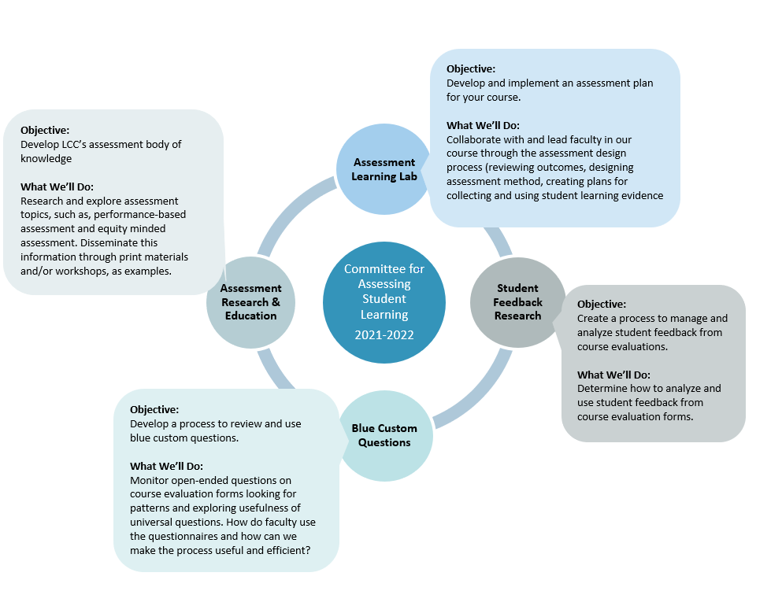

Additional Project: Co-Curricular Assessment Group
- Had been working on in 2019/20 but once moved to remote work due to COVID this group’s meetings slowed down considerably.
- HLC requirement for Accreditation, we have 2 years to finalize.
  - Mark Kelland would like to get everything done this year so he can write it up over the summer and have time for a final review before need to submit to HLC
    - Would like to update CASL as progress
  - Programs and leadership have transitioned since this project started
- Goal is to create a flexible template based on 5 pilot programs.
  - The flexibility should allow other programs to join as determined
- Definitions:
  - Co-curricular: Refers to the activities, programs, and learning experiences that complement what students learn in the classroom. These are the learning experiences that are connected to academic curriculums (Adapted from The Glossary of Education Reform: edglossary.org/co-curricular/)
    - These have elements of assessment tied to them and specifically support an academic program
  - Extra-curricular: Are activities that, while being supportive of our LCC mission, do not specifically support an academic curriculum
  - A course might be co-curricular for one curriculum and extra-curricular for another
    - Example: Athletics
      - A course that might be co-curricular for a Kinesiology curriculum is probably extra-curricular for a Math curriculum

Workspaces vs. SharePoint as our CASL Project Information Repository – Group Discussion
- LCC Preference?
  - Chuck, dealing with library files, had heard the College preferred documents on the N drive which would be “Workspaces.”
  - Mark Kelland, dealing with Board of Trustee issues, had heard the opposite – that SharePoint is preferred by LCC.
  - Terri will check and see if LCC prefers one or the other.
- Director of Assessment, Karen, will need to keep an eye on this information – the group also deferred to her opinion.
- Question: If we use workspaces do we want to migrate all of the CASL information there?

Discussion – What do we mean when we use language like “authentic” and “performance-based” to describe assessment techniques?
- Tim shared and article titled, “What’s the Difference Between Authentic and Performance Assessment?” from May 1992. Full article can be found in SharePoint.
- Danielle also share information from the Indiana University Bloomington website.
- Definitions from the document Tim shared:
  - “In a performance assessment, the student completes or demonstrates the same behavior that the assessor desires to measure. There is minimal degree, if any, of inference involved.”
    - Example: If behavior is writing the student writes, they do not take a multiple choice test about sentences and paragraphs.
  - “In an authentic assessment, the student not only completes or demonstrates the desired behavior, but also does it in a real-life context. ‘Real life’ being the student (for example, the classroom) or adult expectation.”
    - Example: A writing assessment, with the significant criterion being authenticity, would give control to the student in that they would determine the topic, time allocated, pacing, and the conditions under which the writing sample is generated.
- The take away here is that “authentic” and performance-based” assessment terms are common in the literature and have been around for a long time.
  - No offense is meant to be given, or implied, when these are used to describe assessment techniques
- Many articles and books discussed, noted that perhaps we should create a repository for these that CASL members can use and share with others as issues arise.

Breakout Groups
- Groups broke into 3 breakout sessions for 20 minutes.
  - Assessment Learning Lab
  - Assessment Research and Education
  - Blue

Assessment Research and Education summary
- Identified 2 tracks to follow:
  - Looking into what it means to be an equitable assessment
  - Exploring the differences, pros and cons, of performance based versus authentic assessment.
- Then determined this work group will act as a support system, providing feedback and multiple perspectives on shared work as well as holding each other accountable for their planned action items.
- Next step to come back with mini action plans on ideas to best use future 15 minute times together during CASL breakout sessions.

Blue Group
- Plan to organize existing Blue information on both selected and created custom questions.
  - Look for frequency of types
    - Should a selected question be added to the universal ones if used often
    - Should a created question be added to the selection choices if used often
  - Screen created custom questions on the off chance they written in a way that some people may find offensive
- Have questions to follow up on existing materials to work with.

Assessment Learning Lab Group
- People shared what courses they are thinking of using for this lab.
  - Sharing possible assessment tools for their specific course
    - Each course is so individual the tools need to be customized for each
- Discussed challenges of building authentic assessment into an online course.

General Note
- Not sure will have breakout sessions for each CASL meeting.
  - Tim and Karen to meet to discuss next steps before next CASL meeting
- Breakout groups requested to let Tim and Karen know of any informational needs they have as they occur – don’t need to wait until a CASL meeting to reach out.

New Business and Future Agenda Items
- None.

Meeting Declared Adjourned at 1:45 pm
- Next meeting Friday, October 8, 2021 from 12:30pm to 2:00pm, via Webex.

Respectfully submitted by Terri Christian

Lansing Community College is committed to providing equal employment opportunities and equal education for all persons regardless of race, color, sex, age, religion, national origin, creed, ancestry, height, weight, sexual orientation, gender identity, gender expression, disability, familial status, marital status, military status, veteran's status, or other status as protected by law, or genetic information that is unrelated to the person's ability to perform the duties of a particular job or position or that is unrelated to the person's ability to participate in educational programs, courses services or activities offered by the college.

