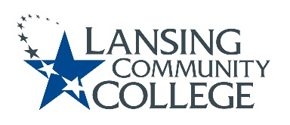

Committee for Assessing Student Learning (CASL) - Minutes
Meeting Held Friday, April 22, 2022, from 12:30 – 1:30pm – via Webex

Team Members:
Patti Ayers, Timothy Deines, Melinda Hernandez, Karen Hicks, Heidi Jordan, Mark Kelland, Mark Khol, Zack Macomber, Rafeeq McGiveron, Rob McLoone, Tracy Nothnagel, Laura Orta, Chuck Page, Danielle Savory, and Kara Wiedman.

QUORUM NOT MET – MEETING NOT HELD

Next meeting Friday, May 6, 2022 from 12:30pm to 2:00pm, via Webex.

Respectfully submitted by Terri Christian

Lansing Community College is committed to providing equal employment opportunities and equal education for all persons regardless of race, color, sex, age, religion, national origin, creed, ancestry, height, weight, sexual orientation, gender identity, gender expression, disability, familial status, marital status, military status, veteran's status, or other status as protected by law, or genetic information that is unrelated to the person's ability to perform the duties of a particular job or position or that is unrelated to the person's ability to participate in educational programs, courses services or activities offered by the college.

