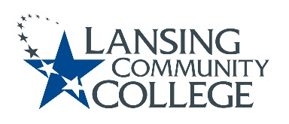

AGENDA

Committee for Assessing Student Learning
Friday, December 3, 2021
Webex
12:30pm – 2:00pm

- Approval of the 12/03/21 Agenda
- Approval of the 11/19/21 Notes
- PA days Formative Midterm Evaluations January 5, 2021 afternoon presentation discussion
  - James Allen, Mark Kelland and Heidi Jordan panelists – hoping other CASL members come to presentation to show support
- HLC Quality Initiative update
- Workgroup check-ins – open for discussion
- New Business & Future Agenda Items
- Adjourn to workgroups
  - Request groups put their goals for Spring in SharePoint Project Plan document
- Next Meeting
  - Friday January 14, 2022 from 12:30-2pm, via Webex

