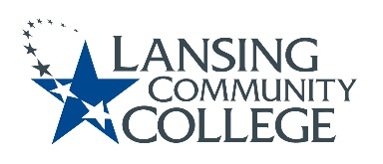

AGENDA

Committee for Assessing Student Learning
Friday, November 5, 2021
Webex
12:30pm – 2:00pm

- Approval of the 11/05/21 Agenda
- Approval of the 10/22/21 Notes
- Housekeeping
  - Interpretation and meaning making of educational learning outcomes (ELOs)
  - CC + CASL workgroup
- Workgroup check-ins
- SharePoint project plan and discussion board
- New Business & Future Agenda Items
- Adjourn to workgroups
- Break out into workgroups:
  - Assessment Learning Lab
  - Assessment Research & Education Group
  - Blue Review
- Next Meeting
  - Friday November 19, 2021 from 12:30-2pm, via Webex

