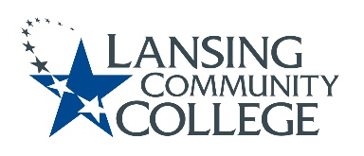

AGENDA: Committee for Assessing Student Learning
Friday, April 8, 2022, 12:30pm – 2:00pm via Webex
- Approval of the 4/08/22 Agenda
- No 3/25/22 Notes
- Approval for the 2/25/22 Notes
- PA Day, sharing plans
- Assessment Integrity, guests and group discussion
- New Business & Future Agenda Items
- Next Meeting
  - Friday April 22, 2022 from 12:30-2pm, via Webex
  - Then last meeting of AY 21-22 is Friday May 6, 2022 from 12:30-2pm, via Webex

