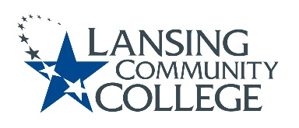

AGENDA: Committee for Assessing Student Learning
Friday, February 25, 2022, 12:30pm – 2:00pm via Webex
- Approval of the 2/25/22 Agenda
- Approval of the 2/11/22 Notes
- Blue User Guide update – Terri
  - Walk through Formative Evaluation “Opt In”
- New Business & Future Agenda Items
- Adjourn to Workgroups
  - Research (Karen)
    - Integrate the work of 2 research teams with Assessment Training Modules (CTE partnership)
  - Blue (on own)
    - May PA day session planning and/or review Formative Evaluations
  - Assessment Learning Lab (Tim)
    - Values Checklist
- Next Meeting
  - Friday March 25, 2022 from 12:30-2pm, via Webex

