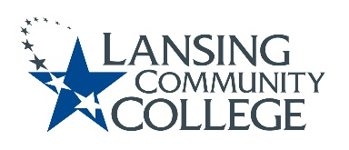

AGENDA: Committee for Assessing Student Learning
Friday, February, 2022, 12:30pm – 2:00pm via Webex
- Approval of the 2/11/22 Agenda
- Approval of the 1/28/22 Notes
- Workgroup Check In
  - Continue, adjust or reimagine?
Continue | Adjust or Reimagine
No changes to workgroup objectives | Blue group – Lead: ____TBD__________  Coordinate, design, facilitate May PA days session  Research group- Lead: Karen__________  Apply research to assessment training (module 2: Ways to Assess Student Learning)  Learning Lab: Lead: Tim______________  ?  *New Ideas*  Equitable Assessment Checklist: Lead: _TBD_______  Checklist faculty can use to assess the equitability of their learning outcomes and assessment methods  Student Involvement in Assessment: Lead: __TBD____  Materials, activity, and so on to increase transparency of assessment design and administration  Assessment Integrity: Lead: __TBD____ CoLeads: Karen, Tim  Create content for assessment training program (module 4: Assessment Integrity); collaborate with Academic Senators

- Assessment Values
- New Business & Future Agenda Items
- Next Meeting
  - Friday February 24, 2022 from 12:30-2pm, via Webex

