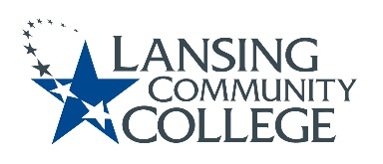

AGENDA: Committee for Assessing Student Learning
Friday, January 28, 2022, 12:30pm – 2:00pm via Webex
- Approval of the 1/28/22 Agenda
- Approval of the 1/14/22 Notes
- Oakland Community College Visit – Tim and Karen
- “A New Decade for Assessment: Embedding Equity into Assessment Praxis” – Presentation of Article
- Discussion
- New Business & Future Agenda Items
- Adjourn to Workgroups
- Next Meeting
  - Friday February 11, 2022 from 12:30-2pm, via Webex

