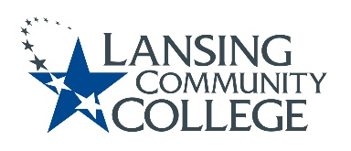

AGENDA: Committee for Assessing Student Learning
Friday, January 14, 2022, 12:30pm – 2:00pm via Webex
- Approval of the 1/14/22 Agenda
- Approval of the 12/03/21 Notes
- Assessment’s role in HLC Accreditation and Federal Agenda – Mark Kelland
- Workgroup breakout session – 20 minutes
  - Review written goals from 12-3-21 Project Plan
    - Handout with all goals copied from that plan for quick review
  - Discuss general focus and purpose of the workgroup
    - Lessons learned from experiences over the last year and a half
      - Instructional Design, Delivery Methods, Assessment Methods
    - Brainstorm how CASL can be supportive to faculty colleagues
- Spokesperson to share summary of workgroup discussions
- Larger group continue discussion
  - Determine next steps
- New Business & Future Agenda Item
- Next Meeting
  - Friday January 28, 2022 from 12:30-2pm, via Webex

