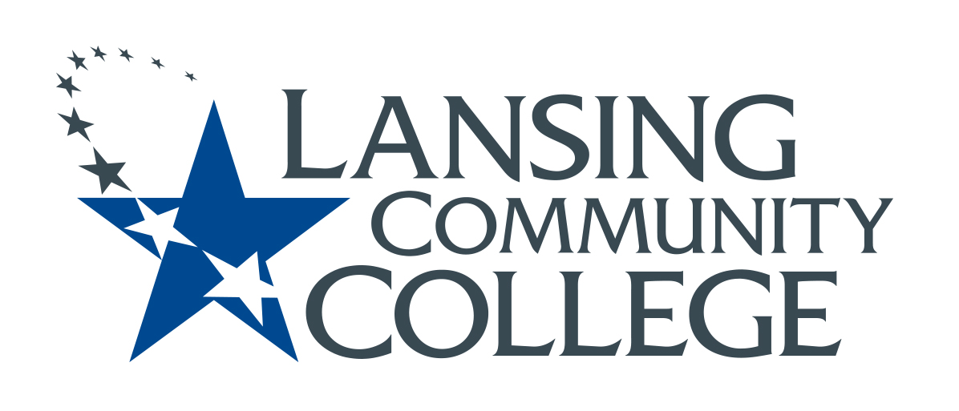

MEETING minutes

Budget Committee
Friday, October 7, 2022
8:10-9:00 AM

Present:
Alexandra Beard, Nancy Dietrich, April Dreeke, Gerard Haddad, Andrea Hoagland, Eva Menefee, Jean Ramirez, Kabeer Ahammad Sahib, Mark Stevens, Denise Warner

Guests Present:
Sally Welch, Laura Bishop, Melissa Kaplan, Jeff Hamlin, Lee Gardner, Bo Garcia, Robert Edwards, Dawn Cousino, Chad Borodychuk, Brian Bishop

- Innovation Award Q & A with Provost Welch.
Most of our meeting was spent in discussion with LCC faculty and staff who wanted to learn more about the Innovation Award.

- Review our plan for budget discussion at Oct. 21 Senate meeting
  - After all of the guests left, the committee spend the last 15 minutes discussing questions to send out on Oct. 21 (submit to Eliza by 10/16.) Denise will send questions out to the committee for review before submitting them to Eliza.
- review POPs in their area and/or talk with lead faculty
- budget needs and priorities in their areas
- input on cost savings or greater efficiencies in their areas
  - Proposed Schedule:
- Oct. 21 meeting: Short BC presentation and questions go out to senators

- Nov. 4 meeting: Budget Discussion (breakout sessions) at senate meeting. BC then "digests" feedback from groups and prepares a set of questions for Don. We submit the questions to Don by Nov. 11.

- Nov. 18: Don W comes to senate meeting

Next Meetings: October 21, Nov. 4, 18, Dec. 2

