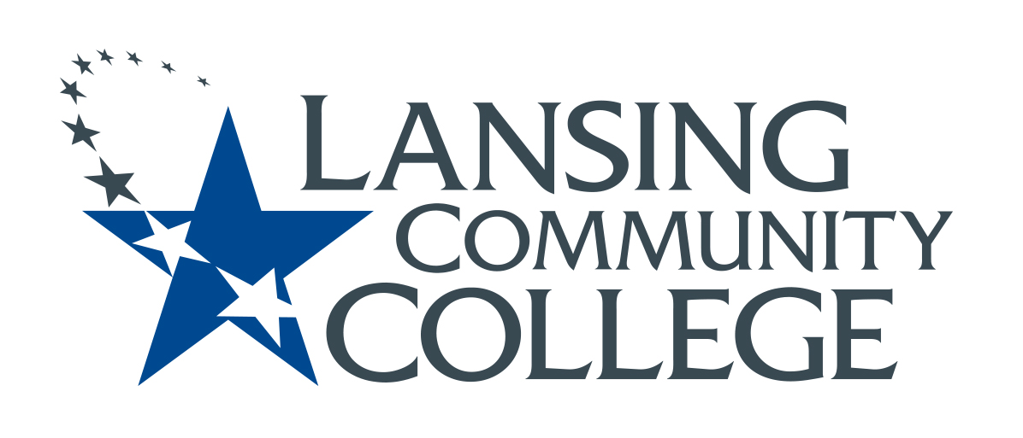

minutes

Budget Committee
Friday, December 3, 2021
8:00-9:00 AM

Members Present:
Alexandra Beard, Nancy Dietrich, Gerard Haddad, Andrea Hoagland, Tamara McDiarmid, Eva Menefee, Sally Pierce, Jean Ramirez, Kabeer Ahammad Sahib, Denise Warner

- Approved November 19 meeting minutes
- Program Operating Plan template was approved (Nancy and Eva).
The task force approved the revised POP template at their meeting last week. Eva and Nancy reviewed the changes, which were few. The committee especially liked the “Tips” section. Eva noted that it was a very collaborative process between faculty, administration and HR. Nancy and Denise will discuss the new template at the SAALT (Student and Academic Affairs Leadership Team) meeting on December 6. The new template will be shared across campus in January. Denise will contact Sally Welch to find out where the template will be housed.

- Innovations Grant Application
We reviewed the documents Sally W shared with us and two example grant or award applications. Nancy agreed to contact Jean Donado for other grant applications that we can review. Sally P, Alexandria, and Denise agreed to form a subcommittee to draft an application to be shared at our first meeting in January. The application can then be used to develop a scoring rubric.

- Program Review update

We discussed how to reach out to programs and what kind of help we can offer. Andrea is encouraging departments/programs to have meetings and suggested that we send a representative of this committee to those meetings. The contact list for each area is in the Sharepoint folder. We need to draft an email to send out to each area asking that we be invited to their meetings and explaining the type of assistance we can offer. Eva would like us to encourage programs to dream and think “outside of the box”. Gerry discussed the importance of making the plans public by listing what they want.

We should get onto the Program Review Kickoff meeting agenda to notify programs that we are available to come to their meetings and to discuss what kind of support we can offer. We can follow-up with an email to the contact person for each program.

Programs listed in SharePoint-Interdivisional-Program Review 2022-23
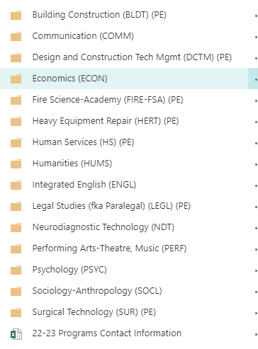
- Other Topics:
The issue of communication was discussed. Gerry suggested the need for an easy way for programs to contact us other than having to go to the Provost’s page to find our committee.

We discussed creating a new email account, something like budgetcommittee@star.lcc.edu. (This would be a Help Desk request.) We will consider options, such as
- would this email be automatically forwarded to all committee members, to the chair and co-chair, or someone else?
- would we all be able to read and reply to email from this account. In this case, anyone could reply, and we would have to keep an eye on the “reply” arrow to see which messages had been replied to.
- Maintenance of the account- changes would need to be made as membership in the committee changes. Who would be responsible for cleaning up this email account (i.e. filing messages into folders, etc.), making sure emails were responded to in a timely fashion, adding any relevant topics that arise in the email to our meeting agendas, etc.

- Future Agenda Items/Next Steps
  - Innovation grant draft application, Jan. 14
  - Decisions about email account, Jan. 14
  - Plan a presentation for Program Review Kickoff and follow-up email

Next Meetings: January 14

Meeting ended at approximately 8:55 am.
Respectfully submitted by Denise Warner.

