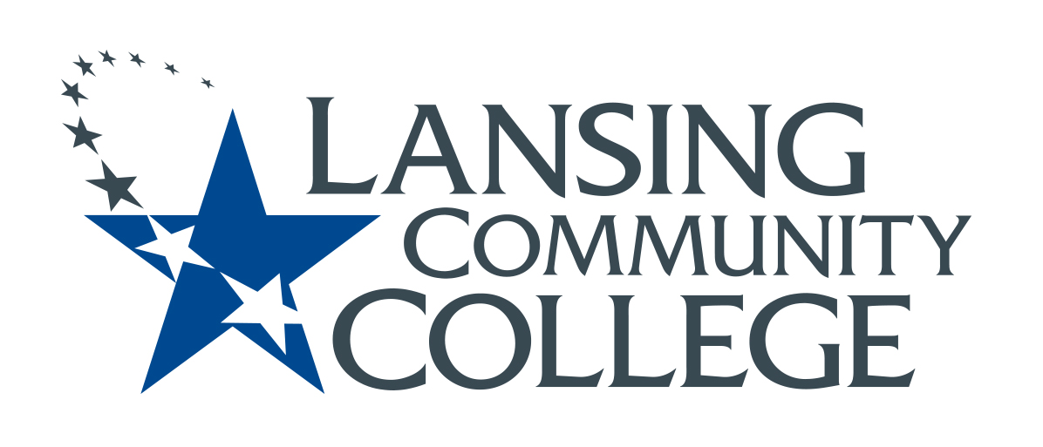

Approved Minutes

Academic Senate Budget Committee
Friday, February 25, 2022
Members present: Alexandra Beard, Nancy Dietrich, April Dreeke, Gerard Haddad, Andrea Hoagland, Eva Menefee, Sally Pierce, Jean Ramirez, Kabeer Ahammad sahib,
Mark Stevens, Denise Warner

Guest: Melinda Wilson (PIE Team Workgroup)
Meeting Called to order at: 8:10 am
- Introductions for new and newish members.
- Feb 11 Meeting Minutes were approved
- Approval of Feb. 11 meeting minutes approved without changes,
- POP form – Noted signatures section including the procedure for disputing anything on the form—be aware of timelines on the new POP form—Eva explained this was added at the HR level—general agreement about substantive changes that this should just improve and clarify the process. This should result in things being in writing.
- Division Budget Meetings
  - Tech Careers—unclear exactly what happened there—Mark is following up with Tim Baker—reported large expenditures at West Campus on for welding and other supply budgets beyond budgeting for people.
  - HHS- email from Betsy Burger, Interim Dean of HHS—it sounds like not a lot of direct faculty involvement. Not a whole division meeting. More back and forth between leads and dean for each area—noted our continued need for a representative from that area.
  - A&S- Meetings were held Feb. 16 and 17- Report from attendees—the budget process was explained. The copy budget and student employees has not been spent because of the pandemic, but there has been no problem so far to get back line items when needed. Three newly created positions in Anthropology, Sign Language, and Communication—History adjunct pay has increased to cover part-time participation. Some creativity using travel budget to pay for certifications linked to curriculum in Accounting to help with data analytics. Think about re-thinking and re-framing travel budget. How will things change in the fall when we go back.
- Brief discussion of the College Financial Projections from the Feb. 21 BOT Meeting—wondering if there will be some unprojected money found again for next year, but expecting a drop in money for 2024. How do we get in the rooms where things are dispersed? Internal posting for the director of advisors—will make less $ than advisors.
- We talk about the idea that the dispersal of more $ will once again happen and so Eva and Sally became the letter drafting committee. Andrea will let Sally W. know we are drafting a letter. We are considering who we should send it, too.
- Melinda Wilson (a guest today) gave us some history of—back stage work groups from the Forums—the workgroup on completive innovation. A lot of curriculum work and the need for structures to carry out the work to support faculty to actualize the strategic plan and PIE teams are the program level strategic plan goals. She helped us clarify the distinctions between those proposing Innovation Grant Applications who might end up being PIE teams.
Mindy is worried about potential confusion if we put too much on the application about PIE teams. Melinda shared the Innovations web-site page with us as well.
- Grant Scoring Rubric—discussion Denise will bring draft to our next meeting for approval.
- In addition, we agreed to discuss in the future--
  - Program Review: How to support programs going through the process.
- Consensus to start the meeting at 8:00 AM
Meeting adjourned: 9:03 am
Minutes Respectfully submitted on March 25, 2022—by Sally Pierce—English—note our department voted for a name change last week. I’m not sure when it will become official.

