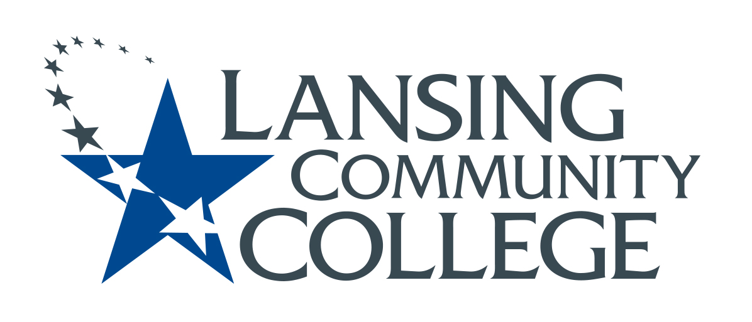

Minutes

Budget Committee
Friday, January 28, 2022
8:00-9:00 AM
Present: Alexandra Beard, Nancy Dietrich, Gerard Haddad, Andrea Hoagland, Eva Menefee, Sally Pierce, Jon Ten Brink, Kabeer Ahammad Sahib, Mark Stevens, Denise Warner

Guests: Mindy Wilson and Sally Welch joined us for item III below.

- Jan. 14 meeting minutes were approved.
- The group welcomed new member, Mark Stevens, Professor of Criminal Justice in Public Service Careers to represent Tech Careers, replacing Tamara McDiarmid. We are still looking for a rep from HHS.
- Members discussed FY 2021 Financial Briefing/FY 2023 Budget Launch presentations that took place Jan. 26 and 27.
  - Denise will ask Don Wilske to share the Financial Dictionary with our committee.
  - This committee will encourage programs to get budget requests to their deans by mid-February ahead of the college deadline of Feb. 28. This information will inform budgetary baseline for the upcoming fiscal year.
  - Number of sections and miscellaneous adjunct pay especially important as they comprise the majority of the budget.
  - Andrea (Dean of A&S) will follow-up with informational sessions for faculty in February
- Review Draft of Innovations Grant Application
  - Sally Welch complimented the group on our good work developing the application form and the speed in which it has come together.
  - We clarified questions about the process and revised a few other details.
  - The subcommittee will meet again next Wednesday to complete work on the form and begin developing the rubric.
  - Denise will update the senate on the grant application during today’s budget committee report.
- Program Review
  - Andrea suggests doing a survey of faculty in April or early May to ask about the new POPs form and budget process. What could we improve? How is the new form working?
- Future Agenda Items/Next Steps
  - Innovations Grant subcommittee to finish working on the application form next Wednesday and then work on a rubric.
  - Create POPs form/budget info survey for faculty to distribute in late April/early May.
Meeting adjourned at 8:57 AM.
Today’s minutes respectfully submitted by Denise Warner.

Next Meeting: Feb. 11

