Lansing Community College
Academic Senate Meeting
November 20, 2020, 9-11 am, Virtual Via WebEx

Present: Kabeer Ahammad Sahib, Alex Azima, Alandis Baker, Joe Barberio, Mark Bathurst, Matt Boeve, Michelle Curtin, Tim Deines, Monica Del Castillo, Paige Dunckel, Sarah Garcia-Linz, Bill Garlick, Courtney Geisel, Gerry Haddad, Leslie Johnson, Heidi Jordan, Mark Kelland, Lyndia Klasko, Frances Krempasky, Eliza Lee, Megan Lin, Melissa Lucken, James Luke, Tamara McDiarmid, Tricia McKay, Vern Mesler, Ronda Miller, Joann Silsby, Tedd Sperling, Mark Stevens, Leigh Szedlak, Jon Tenbrink, Matt Van Cleave, Denise Warner, Nancy Weatherwax, Sally Welch, Kent Wieland, Veronica Wilkerson-Johnson, Richard Williams, Melinda Wilson

Absent: Marvin Argersinger, Mackenzie Caksackkar, Nancy Dietrich, Amalia Gonzales, Dawn Hardin, TeAnna Taphouse,

- Call to order – 9:00AM
- Roll call – 9:02AM
- Approval of agenda – 9:02AM
  - Addition of Vern Mesler at Item X
  - Budget Committee Charter postponed to next meeting.
  - Approved as amended.
- Approval of minutes – 9:03AM
  - Approved without objection
- Public comments
  - Senator Megan Lin – Future agenda item. At TAC meeting, policy on whether students have cameras on during ORT classes. Also during monitored tests. Online strategic planning committee discussed this. Should be some type of college policy that we cannot make a broad requirement that all students have camera on. Want the Senate to think about it.

- President’s report – Michelle Curtin
  - First meeting of Spring semester will be January 29th.
  - Request for input on milestones from Rafeeq. Please get feedback to Rafeeq back to him in next two weeks. See Mark Kelland email for more information.
  - Follow up on Student Senators topic last week. Linda Hamlin from e-learning met with student senators. Going to increase reminders, exploring different ways to communicate. Want to bring back a student panel early next year to the Senate.
- Provost’s report – Sally Welch
  - Dr. Robinson sent out an email referring to mental health challenges. Recommend looking at it and seeing if there is something helpful. Does talk bout Employee Assistance Program.
  - Sunday the Governor made a new order. All classes going remote except medical, police academy, and fire academy. See Provost’s email for more details.
  - Enrollment is down. Remind students to register for classes in the Spring. Students are not liking online experience and thinking of taking a break. Encourage them not to fall behind.
  - New Dean of Health and Human Service, Jan Karazim.

- Consent agenda
  - Curriculum committee
    - Prop Proposed New Program(s) of Study:
      - None
    - Proposed New Courses:
      - None
    - Proposed Course Revisions:
      - DANC 100 – Intro to Dance Technique
      - LEGL 210 – Litigation Procedures
      - THEA 141 – Acting I-Contemporary
      - THEA 143 – Stage Voice for the Actor
      - THEA 173 – Movement for the Actor
      - THEA 210 – Theatre History
      - THEA 233 – Studio Theatre Performance III
      - THEA 240 – Acting-Shakespeare
    - Proposed Expedited Course Revisions:
      - THEA 110 – Introduction to Theatre
    - Proposed Program of Study Discontinuations:
      - None
    - Proposed Course Discontinuations:
      - None
  - Approved without objection

- Update on preferred name initiative: Bill Garlick
  - Interim solutions for allowing students to make sure of some systems. Communication is being drafted and should go to students in a week.
  - Work was done so name shows up in D2L but will also show up in CRM system so all faculty will see preferred name.
  - Implements modules for 2 new applications. Automation of preferred name for interim solution. Integration for real time system exchange between banner and D2L.
  - Full group meeting next Wednesday.
  - How do we bring focus on to this initiative? Looked at other things where had a lot of success and broad campus approach. Large chunks of time and dedicated focus happened. See what buy-in we can get from larger campus. Going to recommend more than one person working on this project.
  - When talking about preferred name it is implied that preferred pronoun is also involved. Just say preferred name as shortening. Preferred name involved everything that exists but preferred pronoun isn’t always involved.
  - Senator Sarah Garcia-Linz – Ask the Academic Success Coaches be included in the meetings.

- Welding – Senator Vern Mesler
  - See Appendix I.
  - Revised Hybrid course. Presentation of new, imaginative, and interactive teaching.
  - Senators thanked Vern Mesler for a fun and informative presentation.
  - Many Senators suggested future presentations similar to this.

- ATD steering committee
  - Steering Committee in charge of what college will be doing in ATD. 12 members including Academic Senate president and 3 senators. This will be a standing committee of the college, not of the senate. There will be sub committees dealing with various areas.
  - Came up with short application for expression of interest. 3 questions for people to apply. Want to get a consensus today on questions so we can have a deadline by December 7th. We would have a committee by December to start work in January. Spring semester will be a lot of the start up process. Officially sign on once we have those components.
  - Senator Mindy Wilson – Will disciplines we represented on the steering committee? Some of the solutions ATD offers could be more discipline specific. Needs of English versus science versus nursing are different. Make sure discipline specific input on decisions.
    - Senator Michelle Curtin - Once components are picked we will have smaller work teams. Input will be gathered from different areas. Steering committee is making the decisions but it won’t be in a bubble. Decisions will be made based on the input of everyone in the college.
    - Provost Sally Welch - Steering committee like the top of a pyramid. There will be work groups below. Way to streamline communication. Before, people were voluntold to be on committee. Want people who want to be there.
  - Faculty Martine Rife – Suggestion presentation of video of what ATD is for the whole college. Only the Academic Senate knows what ATD.
    - Senator Michelle Curtin - This is college wide. It would be helpful to start with a description of what we are trying to accomplish and what ATD is.
  - Senator Mindy Wilson – Will there be a charter or documentation on what the committee’s purpose is?
    - Senator Michelle Curtin – Good idea.
  - Senator Paige Dunckel – Are you putting out there that we want this committee to be a good representation from each division or area? We don’t want 5 from one area. Should say upfront we want different areas.
    - Senator Michelle Curtin – We should consider what division they are from as well as the questions. Another idea is to go just by who answers the questions and make sure the smaller work groups are better represented by different areas.
  - Senator Leslie Johnson – Whatever we do with ATD will affect developmental. Should be spots saved for developmental math and integrated English and writing.
    - Provost Sally Welch – Definitely could have someone from dev math and dev English. Hopefully we have that many applications.
  - Senator Richard Williams – How are we sending out application?
    - Senator Michelle Curtin – Employee email, Star, Operations email, and senators will send to their constituents.
  - Faculty Anne Heutsche – How will you encourage and compensate adjunct participation? Some areas make adjuncts ask supervisor if they can participate.
    - Provost Sally Welch – Have to work through those details. Adjuncts are important and will be compensated. Will check into putting a statement on the questionnaire about what adjuncts need to do.
  - Senator Jim Luke – Full time faculty are booked. Anyone involved should have their 32 days adjusted. We can’t just dump it on full timers. Need to add this for faculty.
    - Provost Sally Welch – Just need to talk to HR. Will talk to Deans that adjuncts need to be paid and full time faculty will need their 32 days adjusted.
  - Adding a general statement about compensation at the beginning.
    - Approved without objection.

- Assessment percentages on course proposals
  - In the Curriculum Committee often have this dilemma, look at range of percentages for different assessments. 50-60% exams, 20-30% quizzes, etc. Goal is to balance flexibility with the purpose of the CC which is to ensure good pedagogy. Consistency across sections. Saw proposal option 0-100% test, or 0-100% projects. Can one section have 100% tests and a different course have 100% projects?
  - Senator Matt VanCleave – How can curriculum committee override that? Maybe a meeting with a program. Program should be clear about why they want those percentages. How can the curriculum committee say no?
  - Senator James Luke – Programs will see best for that Course. CC isn’t in a position to make a lot of those judgements. Equity gap exists because assessment in higher ed in general with racists roots. Very hesitant. Trust the people hired to teach.
  - Senator Michelle Curtin – Think the CC can help with unintentional bias.
  - Senator Kabeer Ahammad Sahim – Not having some king of constraint on percentages. Some instructors may want 10 quizzes, some may want 4 test and a project. How do we know these students are competent?
  - Senator Matt VanCleave – Uniformity isn’t necessarily a bad thing. It seems to depend on the discipline. Shouldn’t be a top down decision. A lot of reasons why it might make sense to move towards uniformity. Could be a function of the curriculum committee. Giving it back to the program. CC could end up having the effect of helping pedagogy simply by asking these questions. Programs should be able to give that rationale of why they aren’t consistent.
  - Senator Tricia McKay – Child development is small. Communicate within ranges of grading. Provide flexibility to learn about their teaching strategies.
  - Senator Tedd Sperling – What are the specific learning outcomes of each course. Don’t know how to explain everything he is doing to a CC committee.
  - General consensus that these decisions should be left to the programs. However, huge variation in grading between courses should be justifiable.

- Potential future agenda items
  - Senator Megan Lin suggested policy on whether students have cameras on during class. Guiding policy.

- Motion to Adjourn
  - Motion by Senator Michelle Curtin
  - Second by Eliza Lee
  - Adjourn 10:37AM

Purpose: The purpose of the Academic Senate will be to provide faculty input and advice to the administration concerning issues of College-wide educational philosophy, College-wide academic policy, and priorities in the College-wide deployment of capital or financial resources, except as covered by the scope of collective bargaining. The Senate will be proactive and collaborative in its approach, seeking consensus whenever possible, and will foster and support effective and transparent communication with the college community. Student learning is the ultimate goal of this body.

Respectfully submitted by Academic Senate Secretary, Eliza Lee, with special thanks to Penny Tucker.
Appendix I

Senate comments from Senator Vern Mesler, November 20, 2020
I’m following up on Michelle’s comments last week for senators to speak up.
I would like to take this opportunity to tell the senate what a group of craftsmen educators are doing during this COVID-19 crisis. Lansing Community College West Campus is usually an active hub of students, faculty, and staff, but since March of this year that has dramatically changed with the onslaught of COVID-19.
After weeks of shut down and a reorganization for hybrid instruction, a strict and limited opening of West Campus took place during the summer and has continued (up until this week) for Fall semester so that students can develop the hands-on skills required for many of the Technical Careers programs.
In preparation for the revised hybrid format, the welding staff was required to take an online eight-week LCC course for teaching online certification during the summer. There were limited online examples for teaching skilled trades during the TOC training, but with the skills the instructors did learn in TOC they set out to work within the hybrid F2F and on-line format. Their main objective was to teach the craft of welding through demonstrations and observation of students’ manual skills. These craftsmen educators communicate with their hands, they instruct with their hands. As Roger Morrison says, “In our fields you can’t get the feel, comfort, and knowledge of these skills online.”
These industrial craftsmen educators faced many challenges, and the COVID-19 crisis brought out some student learning and technical issues. For some, WebEx ORT does not work well, especially for students with no tech savvy or unreliable internet. Not having good internet access, this seems to be a serious issue for both students and faculty, even those who live just a few miles from the LCC campus.
Jeff Haynes points out that “Students come in with the expectation to do hands-on. That is what they signed up for, and it’s hard to get them to do online work. Some students chose not to enroll at all Fall 2020 because it included an online component.” Some craftsmen feel that hands-on people think differently, they see things differently which requires at times a different approach to teaching skilled trades. Jeff Haynes and the other welding instructors have adapted to the restrictive lab setting for hands-on instruction with the COVID protocols. Roger often reminds students “Let’s just do what we’ve got to do. If we don’t do it, we can’t be here, and you can’t finish your work.”
It is the online obstacles they have encountered that are more challenging. They have been working to address these issues. Jeff Seelye found some students “lack the ability to self-learn,” and he has been determined to find a solid educational approach to reach these students. A classroom at West Campus was set up with video and microphone and whiteboard so instructors can film their lectures and show students visually things like electrodes and other welding equipment. It’s a system Jeff Seelye has been working with to create Kaltura videos to post in D2L to help students develop self-learning skills.
Scott Poe found issues with “participation in online work and attention span.” To address some of these issues Scott developed skills using Kaltura to video himself talking about PowerPoint presentations he is using and posting the videos on D2L, instead of just asking students to view the PowerPoint. Scott was able to see improvement in his students’ progress. Scott also says his “colleagues were a big help in problem-solving on how to use Kaltura and how to make videos.”
All the welding instructors recognize that as welding students advance in the welding program, they are required to go beyond the manual skills of welding and develop professional skills that prepare them for advanced positions in the welding field. Pre-COVID-19 this was done through lectures, reading assignments and examinations. Today, instructors are finding videos a promising mode for both hands-on instruction and online lecture material. To quote an article in a special TIME edition The Science of Learning, The New (Virtual) Reality: “However engaging you are in real life, you’d better be a lot more engaging online,--it’s necessary to find other means of stimulation, whether that’s a well-crafted instructional video, an impromptu poll or a cameo from a special guest star.”
With the recognition that videos are beneficial for student success in both the hands-on and online instruction, working with a professional film and video editor assisting instructors with script, filming and film editing for quality training video would enhance the welding program. Filming electric arc welding processes requires specialized and high-quality cameras. Roger commented “I was really amazed what we can do with videos.” These industrial craftsmen educators are enthusiastic about the types of high-quality videos that show details students need to see to understand how each welding process works.” The COVID-19 crisis will end, but the popularity for educational videos, especially for those designed for teaching in the skilled trades, will continue to grow. LCC West Campus welding instructors would like to work with those responsible for producing well-crafted instructional video at LCC to assist them with script, filming and film editing of quality training videos.
This semester I chose to do my Print Reading for Welders class using the Real-Time-Online format with WebEx meetings twice a week. There is no demonstration of manual skills required in this class, and this format worked well for this course. Fifteen students signed up for the class and fifteen finished, most with excellent attendance at the WebEx sessions. During the twelve-week course students are required to complete 10 open book reading assignments set up through D2L quizzes and attend and participate during lectures scheduled as class participation sessions. A F2F session was arranged for the very first meeting for introductions and for a proctored final examination on the last scheduled day of the course. All the students received good passing grades for the course.
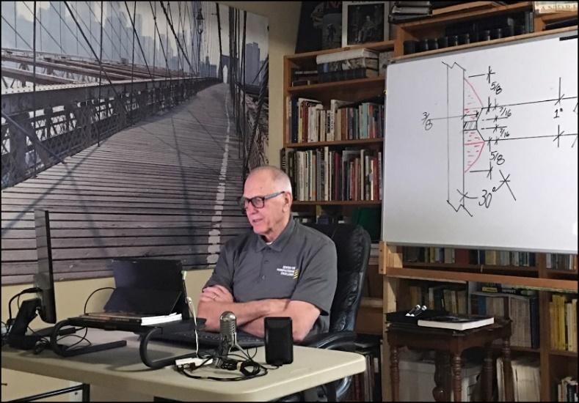 | 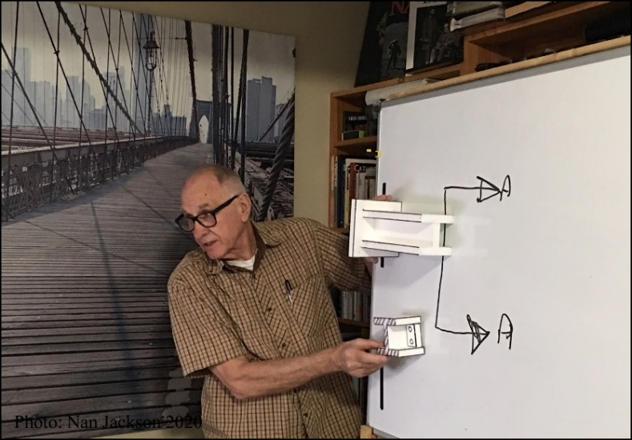
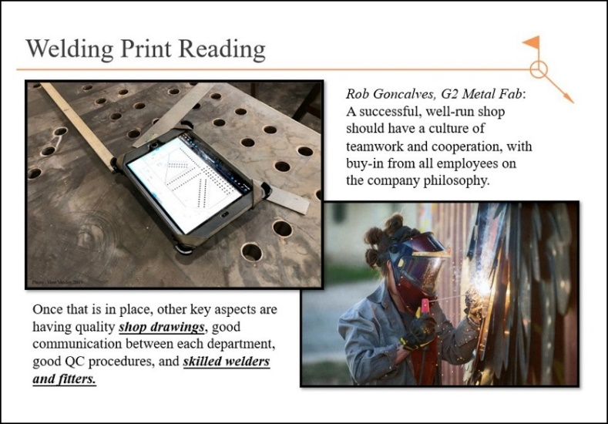 | 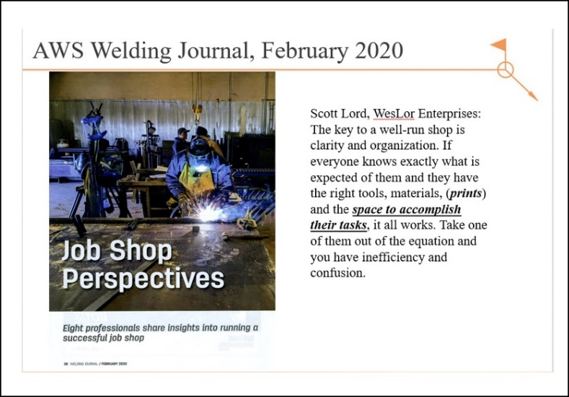

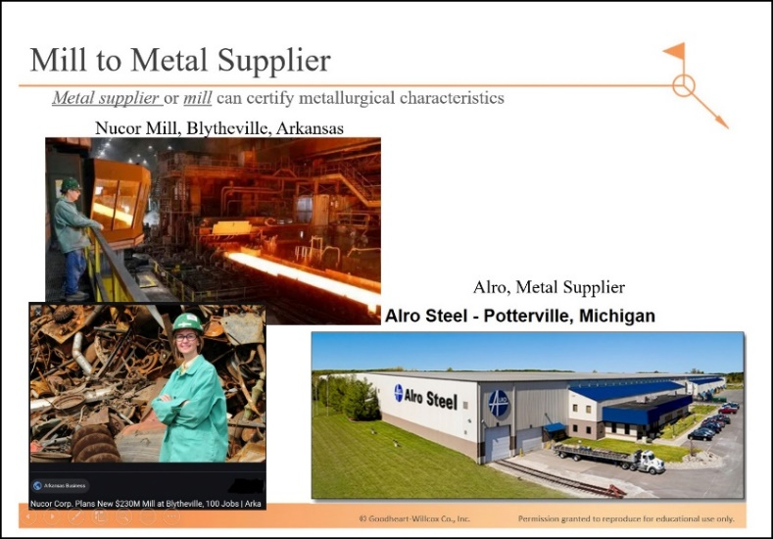 | 
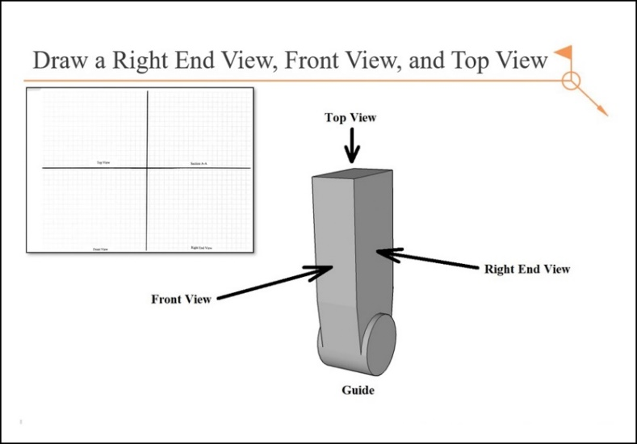 | 
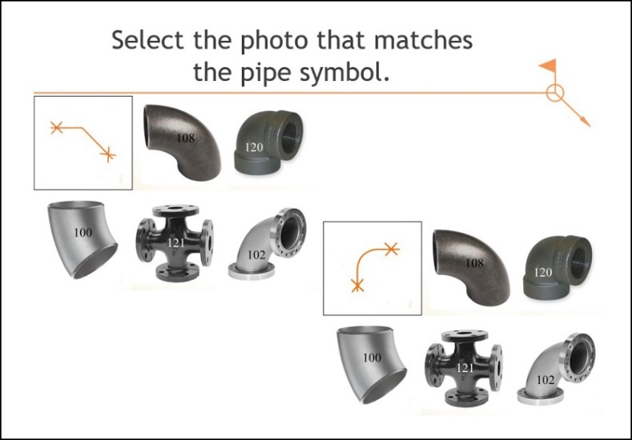 | 

