Example 1:
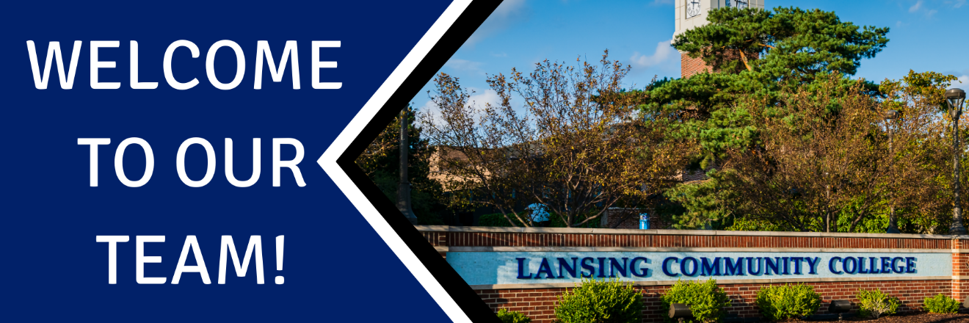
Welcome, {New Employee Name}!

First, I want to share just how excited I am that you accepted our offer and will be joining our team in {Department Name} ! I am very excited for you to get started and for us to work together.

Work Hours: Our hours are typically {Department Hours} with a one hour lunch.

Location: {Use this section to identify where their work location will be and where they should arrive on their first day and who will be there to meet them also include information on parking}

Dress: {Dress Code}. The first Wednesday of every month is LCC Spirit Day and welcome everyone to wear their LCC gear!

First Day: I have your start date as {Start Date} and will make sure we have everything ready for you. On the first day, we will spend some time getting you all settled in and set up. This will include meeting with IT and such. We will get you a StarCard, parking pass, and any keys you need and do a tour of campus. You will also have some times to get started on new hire training.

Attached is our technology form that I will need signed and returned to me. It’s so we can go ahead and get your laptop and such requested for you. Please sign it and return to me as soon as you can.

Again, I am very, very excited for you to join our team and look forward to you starting on Monday. If you need anything at all, please let me know.

Welcome again!

Example 2:
Welcome, {New Employee Name} to the {Division/ Department}! We are glad to have you join our team and want to make sure you set settled in as smoothly as possible. As discussed, your first day will be [date]. Please arrive to {location information} by [time] and dress [dress code]. You can park in the {parking information}.
On your first day, we will focus on getting you settled in and making sure, you have everything that you need. This will include a tour, introductions to the rest of the team, setting up your computer as well as getting your StarCard, parking pass and keys. {Use this section to include lunch information, i.e. if lunch will be provided, if there is a refrigerator/breakroom or local lunch options}
Below is your pertinent employee information that will beneficial for you to familiarize yourself with as you are getting settled in:
BANNER ID
USERNAME
LCC EMAIL ADDRESS
OFFICE PHONE NUMBER
COPY MACHINE CODE
DIVISION
DEPARTMENT
SUPERVISOR
SUPERVISOR CONTACT INFORMATION

Again we are very excited to have you join the team and are looking forward to seeing you on {start date}! If you need anything before then or have any questions, please do not hesitate to reach out.

