Visit www.LCC.edu, select “myLCC” from the menu at the top of the page.
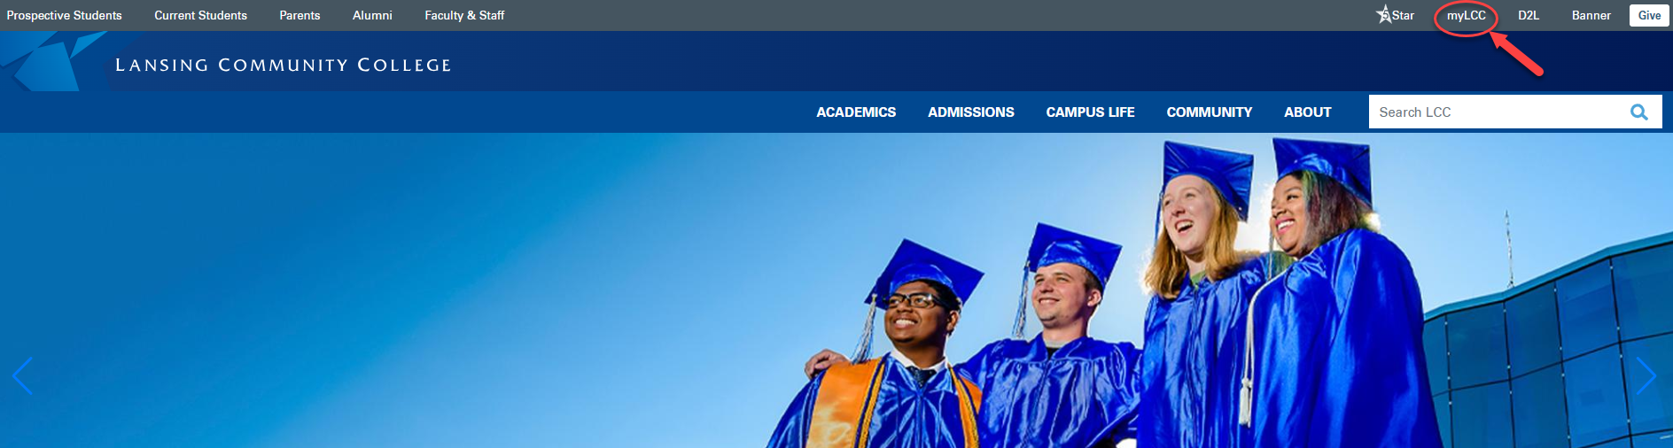

Select the "Activate your account” link located below the Username and Password boxes.
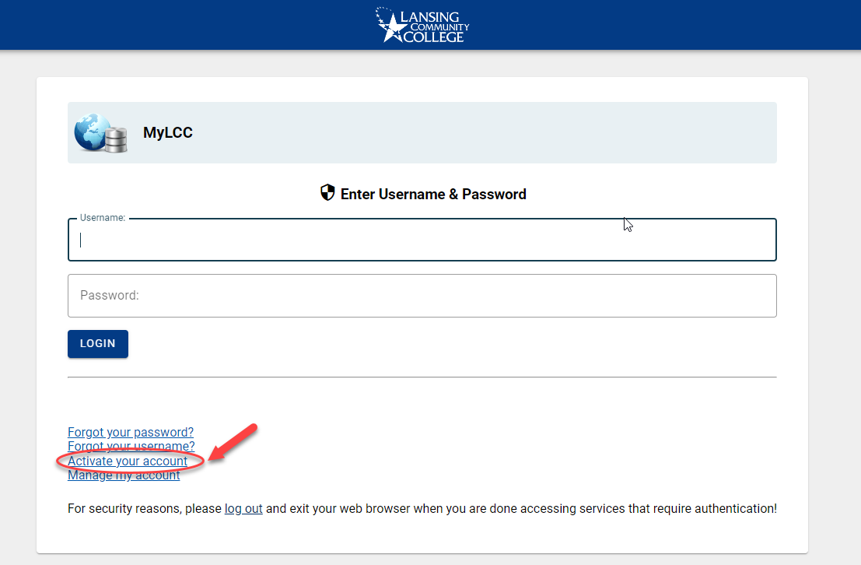

In the Unique ID field, enter your LCC Username. In the Personal Data field, enter either your date of birth, or the last 4 digits of your SSN. Click “Find Me.”

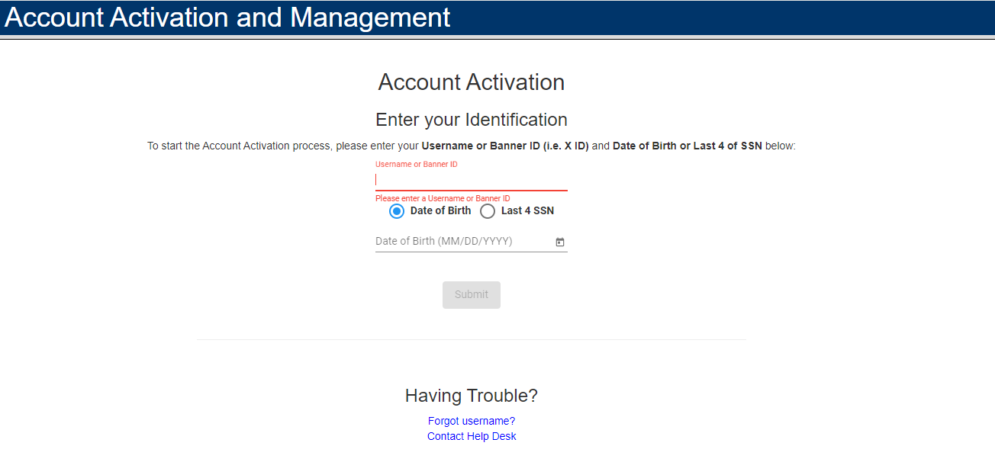
Before gaining access to our systems, you must accept the Acceptable Use Policy (AUP). After reviewing, please check the box at the bottom of the page indicating that you agree to the terms and conditions.
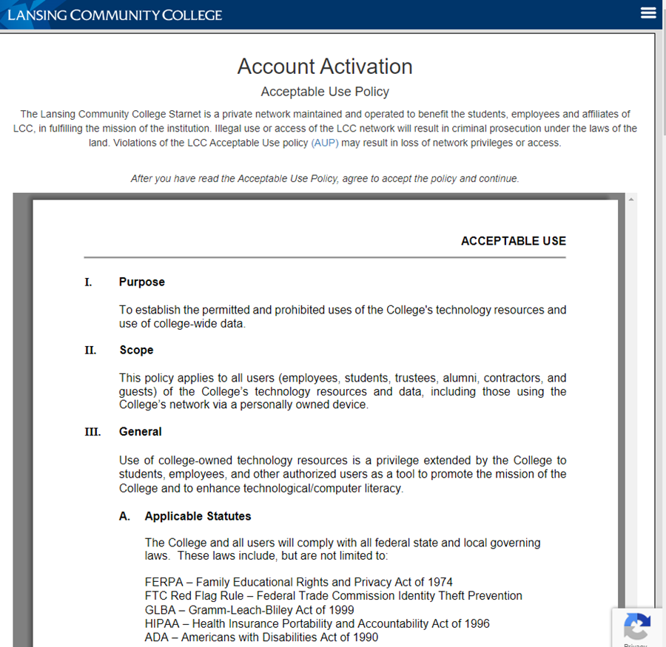

After agreeing to the AUP, you will be asked to set your recovery email. This is how you will be able to reset your password in the future.
You cannot use a LCC address to recover your password. If you do not see, this message check your Promotions, Junk, or Spam folders.
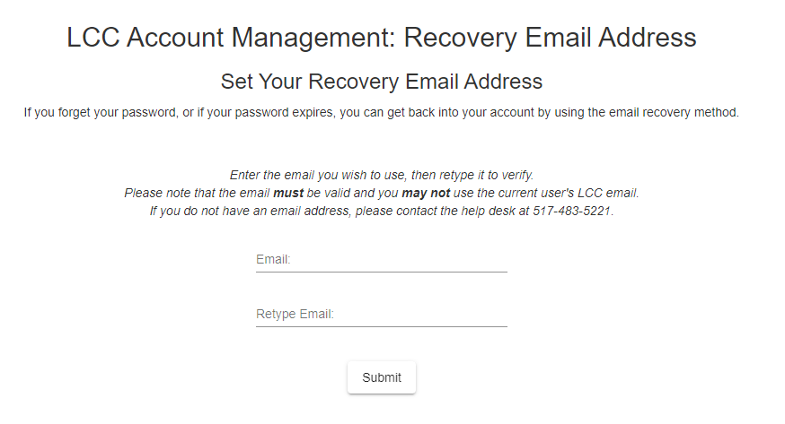

After submitting the email address, a link is sent to the address. The email is from LCC's "no-reply" account. The subject starts with "LCC Account Activation and Management."
Set a new password that meets LCCs Password Policy Guidelines (opens in new window). Then click Submit.
Password Rules:
- Between 8 and 20 Characters long
- At Least 3 of the following:
- One Upper case
- One Lower case
- One Number
- One of these Special Characters !@#$%^&*()=
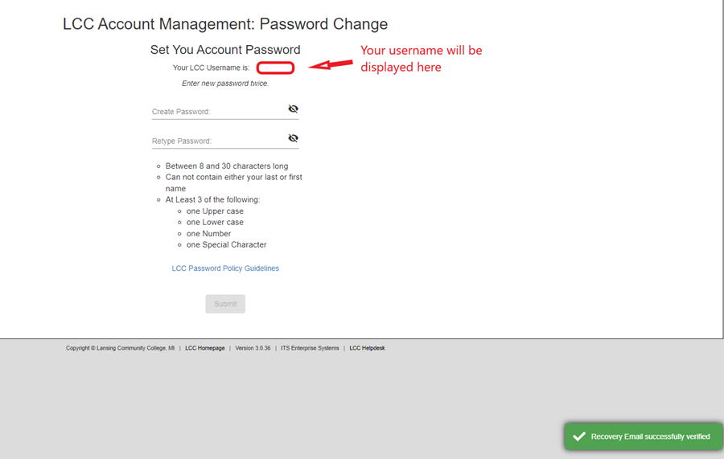
Once all password requirements are met the Submit button will become active.
When you click Submit, you are taken back to the Account Activation and Management system. Note that your username is displayed here as well.
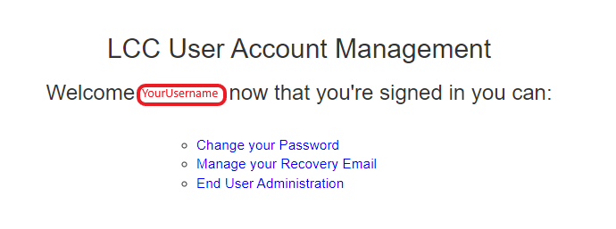

Once your password has been accepted, log out of the system by clicking the three lines in the upper right corner and choosing log out. You can then return to myLCC (opens in new window) and use your LCC username shown on this page, along with the password you just set. This username and password will also work on your LCC email, and any other LCC Single Sign-on (SSO) services.
If you experience problems activating your account, please contact the 5Star Service Center at (517)483-5221. They will be able to assist.

