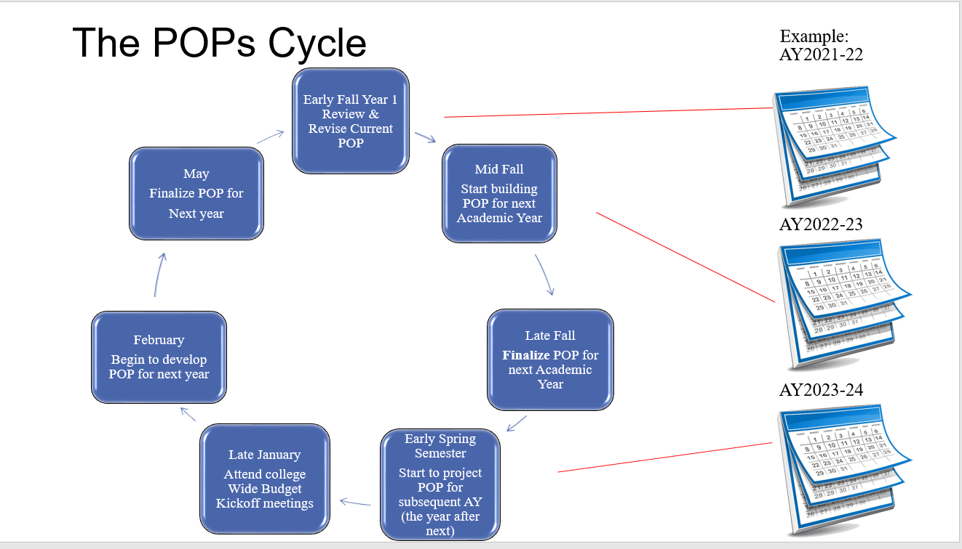

Instructions:
This Program and/or Department Operating Plan should be used semi-annually to document operating plans or substantial changes in operating plans for each academic program, student services program, or department to which faculty members are regularly assigned, in accordance with Article IX. C of the 2021-2024 MAHE Contract.
All operating plans shall be for a two-year duration and shall be reviewed annually by the Dean or responsible ELT member, and updated, if needed, at least once each fall and spring semester by the Program/Department Faculty and Administrators (and as needed) at dedicated meeting times.
Operating plans must be reviewed and updated as the program/department makes decisions related to substantive changes, such as Department reorganization, new programs, program evolution in curriculum or staffing, etc.
Please attach additional documentation to this form as needed, indicating in the selection box to “see Attachment (name)".

Tips:
- The use of a Program Operating Plan and/or Department Operating Plan would depend on the structure of the area.
- Use a narrative style to tell the story of your Program and/or Department
- Be thorough. Don’t leave any areas blank and be specific. Note any sections that are not applicable.
- Have ongoing dialogues during Department/Program meetings. Revisit this plan often. This is a living document.
- Review your POPs at the beginning of each fall and spring semester.
- Plan for a few years ahead and implement plan in stages. For example, curriculum and course changes might take one to two years to implement.
- Keep in mind that budget allocations for the college are due at the end of February or early March, so review/update POPs in the late fall and/or early spring semester every year.
- Operating Plans should align with the Academic Master Plan and Program Review.
- Program and Department Faculty Professional Activities and Duties Plans should align with the Operating Plans.
DIVISION: Click or tap here to enter text.
Program/Department: Click or tap here to enter text.
PLAN YEARS: Choose an item.
Operating plans for each academic or student services program or department to which faculty members are regularly assigned will be documented, reviewed annually by the Dean, and will consist of:
- Program/department assessment, review and analysis of student success, effectiveness and vitality:
Click or tap here to enter text.

- Program/department action/improvement plans:
Click or tap here to enter text.
- Program/departmental/division/College schedules, and individual workloads and assignments including work days for Academic Professionals in the department/program and “red days,” which are days where no Academic Professional is allowed a non-work day. For example, Departments with Academic Advisors and Counselors have “red days”.
Click or tap here to enter text.

- Procedures for summer scheduling of work assignments:
Click or tap here to enter text.
- Program/Department standards for submission of documentation for use in Change of Status peer reviews under Article XIV.
Click or tap here to enter text.
- Program/department regular meeting procedures and schedules. Consider things like program review, curriculum revision and other things that may impact how often you need to meet.
Click or tap here to enter text.
- Program/department budget requests. Be as detailed and specific as possible.
  - Equipment and materials needs
Click or tap here to enter text.
  - Professional development- for full-time and part-time faculty, including travel. Consider various kinds of professional development, conferences, bringing in speakers, etc.
Click or tap here to enter text.
  - Personnel needs consideration of personnel/hiring needs for the program/department.
Click or tap here to enter text.
- Additional Items:
Click or tap here to enter text.

Signatures
This plan was reviewed in regular / special meeting on Click or tap here to enter text..
Please list all participating faculty members and administrators at the meeting:

Participating members by proxy were:

The plan ☐did / ☐did not include any substantial changes, such as Department reorganization, new programs, program evolution in curriculum or staffing, etc.
If the plan did include substantial changes:
- The supervising administrator and the majority of participating faculty ☐did / ☐did not reach agreement to approve this proposed substantial change on Click or tap here to enter text.
- If agreement was reached, the Dean approved the revised plan on _______.
- If agreement was not reached, the two-week time period for submitting alternate recommendations was from Click or tap here to enter text. to Click or tap here to enter text., and a collaborative problem-solving method session was scheduled for __________.
- The disposition of this plan or proposed change was communicated by the Dean to all Program/Department Faculty and Administrators on Click or tap here to enter text.
- If an alternate recommendation was not adopted, the Dean provided the rationale the recommendation was not adopted to the faculty who submitted the recommendation on _________.
- The decision of the Dean ☐was / ☐was not appealed to the Provost.
- The Provost made and communicated the decision regarding the appeal on _______.

Submitted By: Click or tap here to enter text.
Dates of Each Review (Add each date when this plan was reviewed): Click or tap here to enter text.

This form is consistent with applicable provisions of the 2021-24 LCC-MAHE collective bargaining agreement, and does not provide any additional rights or obligations in addition to those specified in this collective bargaining agreement.

