Updating Your Health Savings Account (HSA) Contributions
Employees enrolled in one of the college’s high deductible medical plans can contribute pre-tax dollars to a Health Savings Account (HSA) through payroll deduction. To start, cancel, or update deductions from your pay to this account, log in to your myLCC portal and access Banner Self-Service.
Within Banner Self-Service, select "Employee" and you will see an option for "Benefits and Deductions."
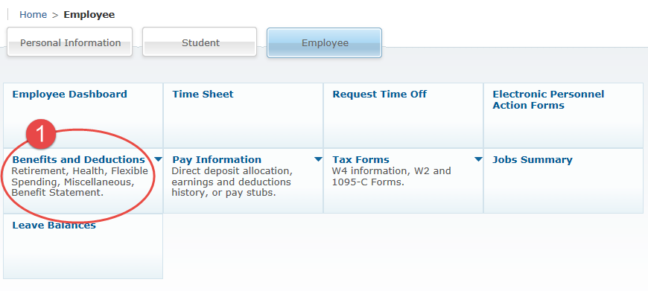
By selecting "Benefits and Deductions," you will see an option for "Health Benefits."
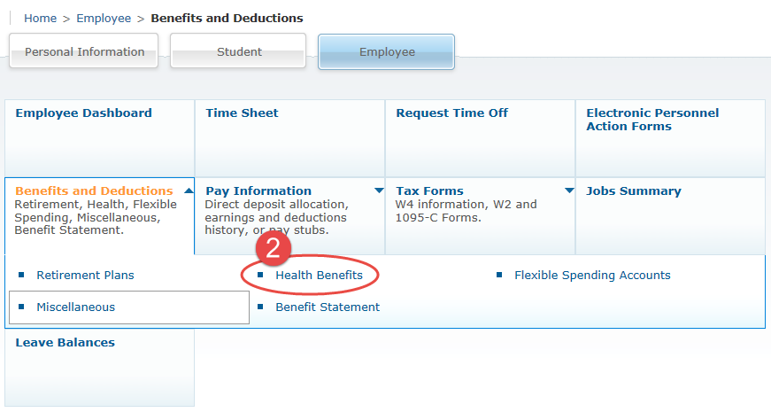
By selecting “Health Benefits,” you will see a list of the benefits that you are enrolled in (e.g. medical, dental, etc.). Under "Health Savings Account EE," you will see your current employee contribution amount. All employees initially enrolled into the HSA will have a defaulted contribution amount of zero. Select “Update” to start, cancel, increase or decrease your employee contribution to your HSA.
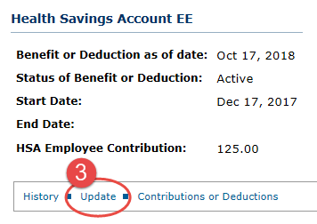
When you select "Update," you will see the following fields to complete for your HSA contribution update.
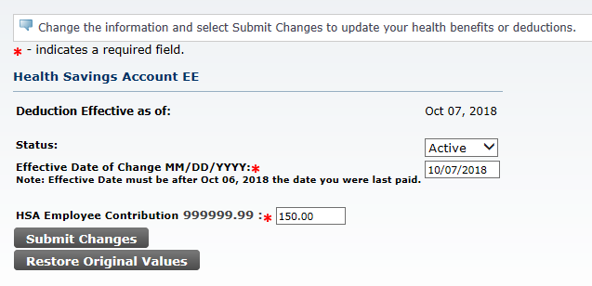
The effective date for any update must always be the start date of a pay period and after your last date paid, as noted on the update page.
The dollar amount that you choose as the “HSA Employee Contribution” is the amount that will be deducted out of every paycheck until you change it. The system will automatically track when you reach the IRS designated annual maximum contribution amount for each tax year.
Select “Submit Changes” for your updates to be applied to your payroll deduction.
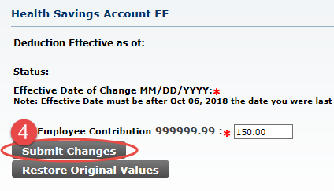
Please contact Human Resources at 517-483-1870 if you have any questions regarding this information.

