Key Features of the PlanSource Benefits Portal

Home Page
- When Open Enrollment starts on November 1, the “Update My Benefits” button on the Home page will change to allow you to enter the shopping experience and make Open Enrollment changes.
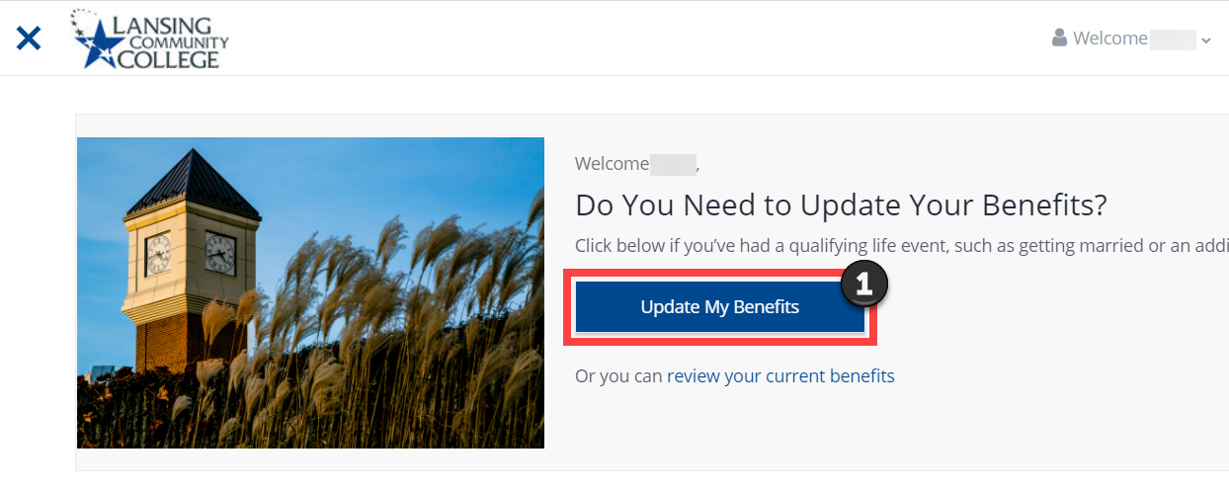
- The Home page also contains helpful videos and information to learn about benefits topics like the 1095-C, which comes to medical-eligible employees during tax season.
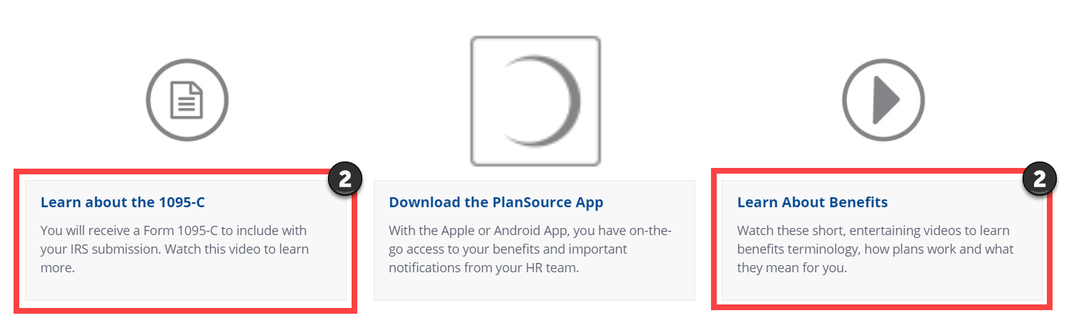
- The Cart displays your current total of insurance deductions per pay period and will update as you make changes during Open Enrollment.
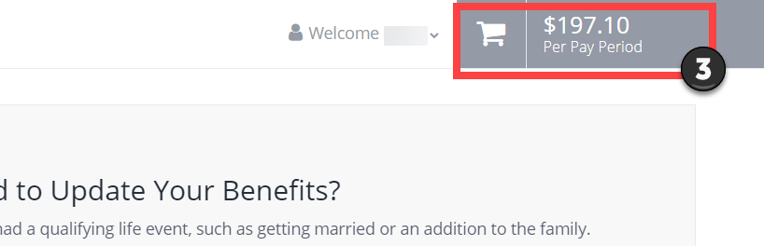
- The navigation bar will allow you to explore more features of the portal like your profile information and your currently enrolled benefits.
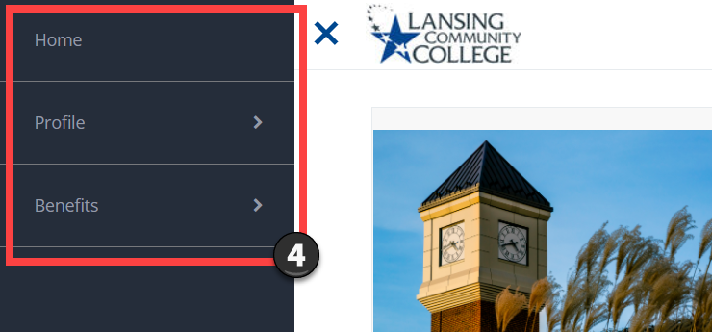

Navigation Bar
- My Profile shows your demographic information. Some data fields are not required or used currently in the PlanSource system, like Marital Status and Preferred Language. So you will notice that these fields are either blank or unreported. Human Resources manages this data. If something does not look correct, please reach out to your LCC HR Benefits team by emailing lcc-hr-benefits@star.lcc.edu.
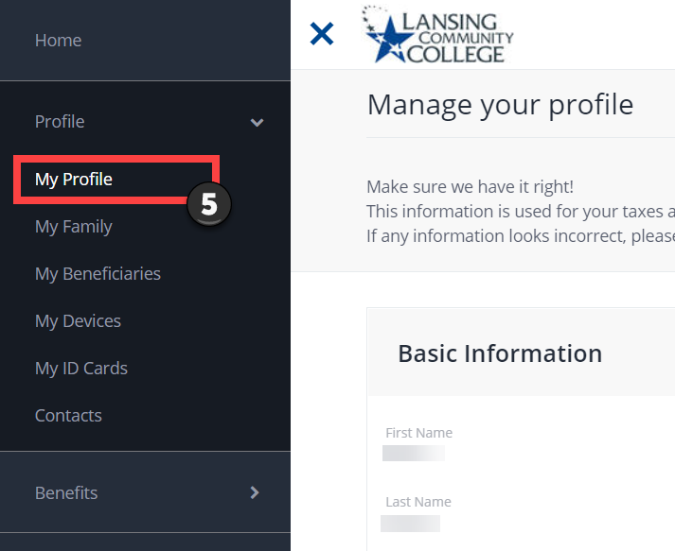
- My Family shows your family members who are currently covered and who were previously covered on your insurances. Previously covered dependents remain here to maintain historical coverage data.
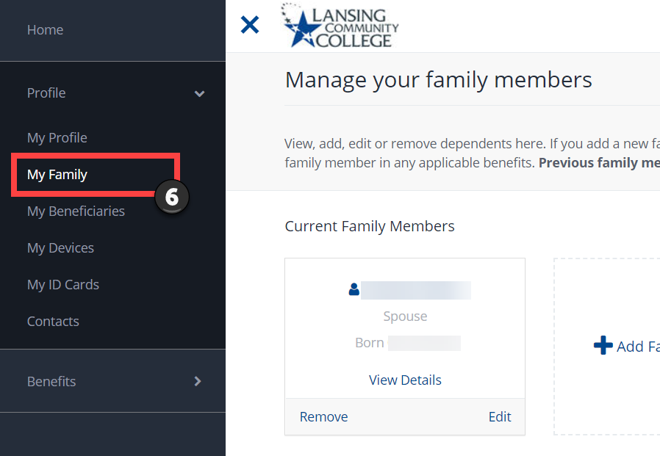
- My Beneficiaries shows full-time employees their beneficiary information for insurances like Life and AD&D insurance. You can update your primary and secondary beneficiary information anytime through the portal. When adding a new beneficiary, you will need to know their address and telephone number to complete the required fields. You will then select the allocation amount or percentage of the benefit you wish to designate for that individual.

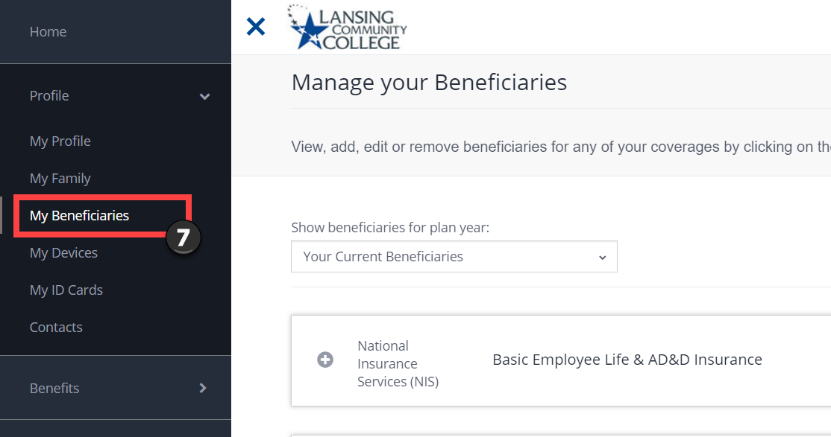
- My Devices shows you how to download the PlanSource Benefits Portal app through the Apple AppStore or Google Play. You can even register your device for security purposes.

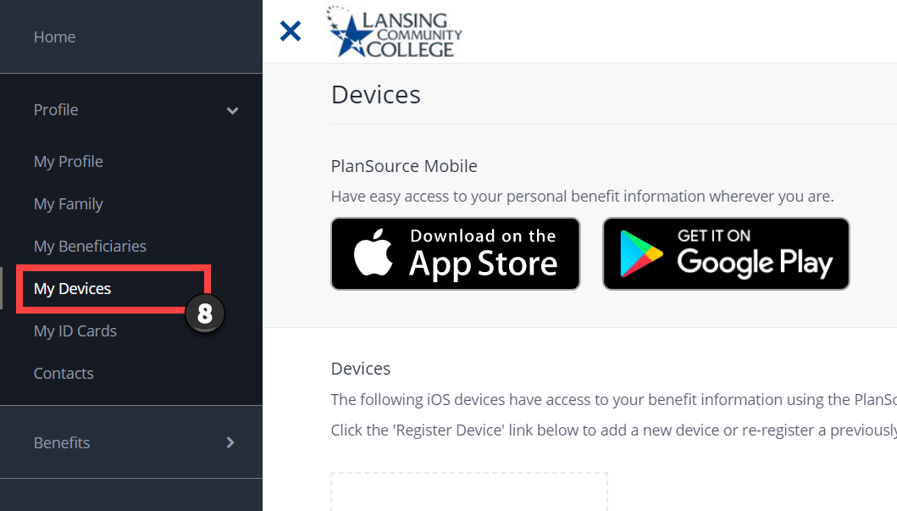
- My ID Cards allows you to upload images of your insurance cards, so they are all stored digitally in one location. You can even share these images with your providers through the portal!

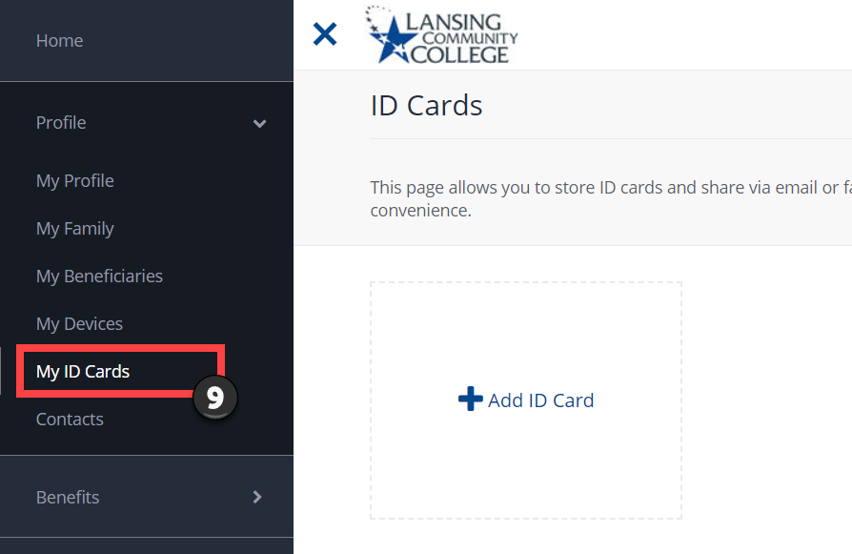
- Contacts allows you to conveniently add and store important contact information related to your benefits, insurance, and providers all in one location.

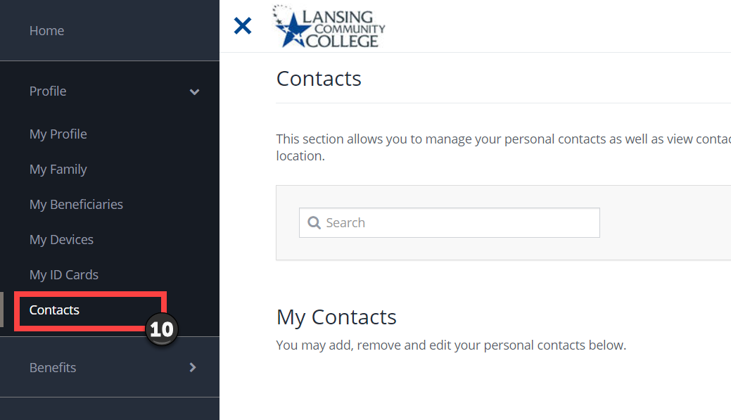
- Current Benefits shows you all of your currently enrolled benefits and the cost to be enrolled. You can expand each benefit to see details by selecting the “+” image next to a benefit. You can also select “View Plan” to see coverage details of a benefit. Select download, print, or email to access a summary statement of your benefits.

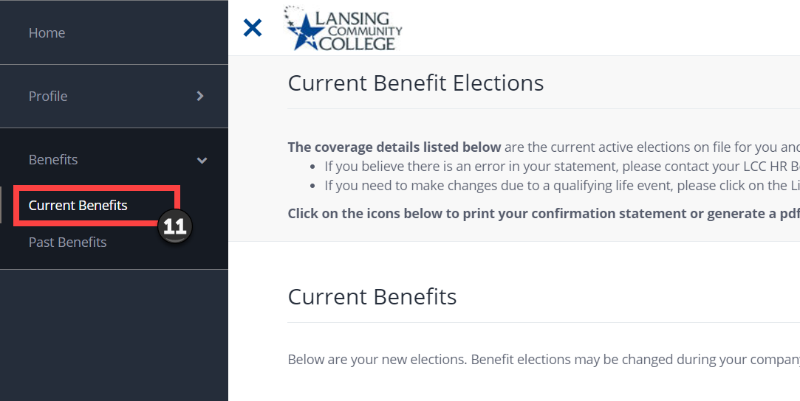
- Past Benefits shows benefits from previous plan years. LCC was only using the portal to house medical insurance and HSA information before 2020, so this section will not display all of the benefits you were enrolled in from previous years. In future years, this section will display correct historical data starting with 2020.
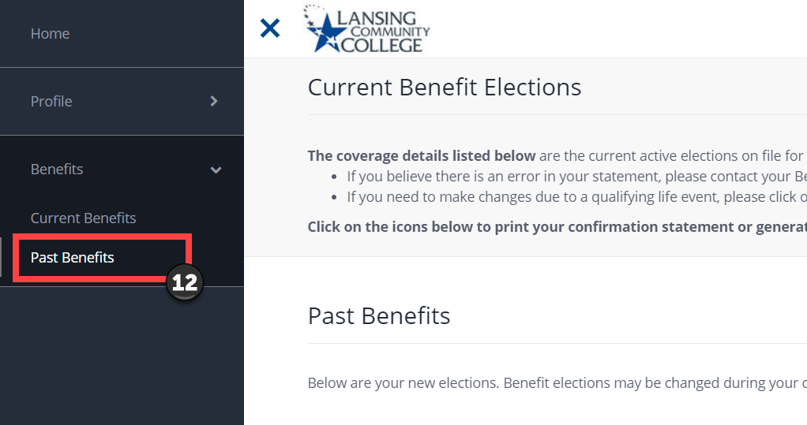

Logging Out
- You can log out of the portal by selecting the down arrow in the upper right hand corner next to your cart total. 